Chapter 1

Procedures

PROCEDURES

Organizational Structure
The Needs Assessment project, which was implemented from November 2001 through June 2002, was developed and guided by the Joint Needs Assessment Group (NAG). The NAG is a planning group comprised of individuals affected by HIV/AIDS and providers of medical and other health-related and psychosocial services and includes representatives from programs funded by each of the Ryan White CARE Act Titles I-IV and HOPWA (Housing Opportunities For Persons with AIDS). The tasks of the NAG were distributed among four working groups that are referred to as “joint” groups in order to reflect the partnership among these programs. These groups include the:
Joint Epidemiology Group: This group was responsible for overseeing development of the Houston Area 2002 Epidemiological Profile and for determining the components of the survey sampling frame, i.e., assigning as a goal the number of individuals who should be surveyed in each of the demographic and HIV exposure categories. (See Appendix A, Sampling and Data Weighting)
Joint Data Collection Group: The tasks of this group included developing the client survey instrument, recommending and approving the populations to be recruited and topics to be included in focus groups, recommending and approving the procedures and locales for the collection of data from hard-to-reach populations (transgender individuals, sex workers, homeless individuals, and substance users) through the modified RARE method (Rapid Assessment, Response and Evaluation). (See Data Collection Methods, below). The group also reviewed the data generated by the these methods.
Joint Resource Inventory Group: This group was responsible for developing the provider survey instrument and reviewing the data generated by this survey.
Joint Gap Analysis Group: This group was responsible for reviewing the overall report for content, accuracy, and presentation documenting the biases and confounders that affect the findings of the study.

Data Collection Methods
Three types of data were gathered for this Needs Assessment: 1) survey data from both clients and service providers; 2) focus groups; and 3) Rapid Assessment, Response & Evaluation (RARE) interviews/surveys. The following discussion details the instruments, types of participants, and procedures involved in the collection of each of these types of information.

SURVEY
Survey Instrument
Two surveys were administered: a client survey, for individuals who are HIV positive and/or their caregivers and a provider survey for those agencies that offer medical, health-related and/or psychosocial services to those affected by HIV/AIDS. (Information about the provider survey is found in Chapter 7.) The survey instrument used in the Needs Assessment was an adaptation of an instrument developed for the State of Texas through the Statewide Coordinated Statement of Need (SCSN). The Houston project was the first large-scale administration of this survey. As is the case with any survey instrument, some limitations were found in this document. Among these were:
- The possibility of selecting contradicting responses;
- Leading questions;
- Use of terms that may have been unclear or indistinguishable to respondents;
- Forced selection of responses without the options of “not applicable” or “do not know”;
- Confusing formatting of questions; and
- The inappropriateness of the document for pediatric or adolescent respondents.

Several measures were undertaken to lessen the effect of these limitations, including:
- The use of facilitators at all survey sites;
- Two qualitative data collection methods (focus groups and street interviews) to validate data;
- Comparison of ambiguous responses in a survey with other questions to clarify meaning, whenever possible; and
- Analytical methods that addressed as many of the limitations as possible.

Despite these limitations, a rich resource of information was generated by the survey. It is noteworthy that the SCSN development team has since included several modifications in the instrument based on recommendations from Houston’s working groups.

The client survey, which was available in both English and Spanish versions, consists of 50 questions, several of which were tables, or questions with several components. A list of the topics covered in the survey questions are detailed in Appendix H.

Survey Sample
Based on the findings of the Joint Epidemiology Group, a goal of 500 client respondents was established for the survey. In order to conform both to HRSA (Health Resources and Services Administration) guidelines that establish target populations for Needs Assessment and to the proportion of those populations in the Houston EMA/HSDA area, sampling goals were set as illustrated in Appendix A.

The community response to the Needs Assessment was optimal and 644 respondents completed surveys. Four of the surveys were eliminated because they were later determined to be invalid. As is typical in such studies, the number of respondents did not fully align with the goals by client category; therefore, the analysis used a weighted data set. (See Appendix A: Sampling and Weighting). The percent of respondents by client category is also found in this Appendix. As can be seen, respondents were recruited from each of the demographic and exposure categories. The respondent population was generally ambulatory and healthy enough to travel to a survey site and complete the one-hour survey. Therefore the survey may not adequately reflect the needs of bed-bound or end-stage AIDS patients.

Survey Administration
Twenty-three sites were chosen for administration of the client survey, which was conducted from December 9 through December 22, 2001. These included institutional providers, community-based organizations, county jails, a state prison and social service agencies. Telephone surveys were carried out for several caregivers of pediatric clients and for young adolescents, in response to requests from the referral sources of these clients and in an attempt to provide the most convenience and minimal discomfort to these respondents.

Thirty-four percent (34%) of the respondents were surveyed at one site, which could have potentially introduced a sampling bias in the data. However, the respondents were referred to this site from agencies and organizations throughout the EMA/HSDA and thus the sample was not comprised solely of clients from this provider. Further, analysis of the data confirmed that these respondents received services from the broad range of providers. A list of the survey sites is found in Appendix E.

Respondents were recruited primarily by flyers posted at major service provider sites. The flyer, included in Appendix F, indicated the dates of the study, purpose, partners and the $35 incentive. No targeting was pursued during the first week of survey administration in an attempt to include as many interested individuals as possible. As the sample population became known, an effort to target groups under-represented in the sample was adopted.

Survey administration was conducted in groups, with facilitators provided to:
- Assist respondents with the technical aspects of completing the survey;
- Validate the survey upon completion; and
- Distribute the $35 gift certificate.

Most of the facilitators were Social Work graduate students from the University of Houston, staff from the Ryan White Planning Council Office of Support and specially trained community volunteers. Spanish translators were available at each administration site and sign language interpreters were available upon request.

Prior to completing surveys, respondents were given consent forms to read (or to have read to them) and acceptance and completion of the survey was interpreted as consent. The surveying process was conducted anonymously and at no time in the processes of consent, survey completion, or data analysis were respondents asked their names.

Focus Groups
As discussed in the “Purpose” section, a goal of the qualitative (narrative) data collection phase of the Needs Assessment is to better illustrate the meaning of the quantitative (numerical) data as well as to provide greater insight into the actual experiences of PLWH/A as they participate in various care systems. An important source of narrative information was generated by focus groups. Focus groups are meetings in which volunteers, assembled by specific categories, participate in semi-structured group interviews. Two facilitators conducted each of the meetings. Sessions were audio taped and transcribed and, as in the surveying, client identity was kept confidential. Fourteen groups were held for clients and 2 for service providers. Participants received a $25 gift certificate to a grocery store as an acknowledgement for their involvement in the groups. The following table lists and defines the focus group categories and indicates the number of participants in each.

Table 1-1: FOCUS GROUPS
CLIENT FOCUS GROUPS
CATEGORY | DEFINITION | ATTENDEES
African American MSM | African American men who are HIV+ and report that they are primarily homosexual or bi-sexual | 10
Anglo MSM | Anglo men who are HIV+ and report that they are primarily homosexual or bi-sexual | 9
Disabled | Individuals who are HIV+ and report that they have physical or emotional disabilities either related or unrelated to HIV | 9
Incarcerated | Women who are HIV+ currently in custody in a State prison | 5
Long-term survivors | Individuals who were diagnosed with HIV in 1992 or before | 9
Older Adults | HIV+ individuals who are at least 45 years old | 8
Rural residents (North) | HIV+ individuals who reside in the counties north of Houston | 6
Rural residents (South) | HIV+ individuals who reside in the counties south of Houston | 6
Substance Users | HIV+ individuals who report current drug and/or alcohol use | 4
Women  (Not currently pregnant) | HIV+ women between the ages of 15 and 45 who are not pregnant | 9
Women  (Currently pregnant) | HIV+ women between the ages of 15 and 45 who were pregnant at the time of the focus group | 4
Youth (13 - 19) (2 groups) | HIV+ adolescents | 10
Youth (20 - 24) | HIV+ young adults between the ages of 20 and 24 | 6
PROVIDER FOCUS GROUPS
General Providers | Service providers to HIV+ individuals | 10
Providers to Immigrants | Service providers who target HV+ recent immigrants | 7
Modified RARE
Among the goals in conducting a Needs Assessment is a means to ensure that the interests of as many clients as possible are included. A particular challenge to this goal is the ability to gain access to individuals who are reluctant or unable to participate in such activities. A data collection program, known as “Rapid Assessment, Response and Evaluation (RARE)” method, has been promoted by HRSA and the CDC to overcome this challenge. RARE consists of 4 techniques:
- Focus groups
- Street interviews: individuals who reside in or near the geographical areas with high HIV prevalence are specially trained by the RARE team to conduct Individual interviews with volunteers at community sites where individuals at greater risk for HIV exposure might congregate. During the interviews, volunteers are questioned about HIV-related risk behaviors and service use, needs, barriers, and gaps among individuals with HIV.
- Rapid Assessment Surveys: 3-5 question surveys that solicit information about HIV-related risk behaviors, conducted with volunteers at community sites.
- Direct Observation: Visits to relevant community sites, with attention paid to observation of conditions consistent with:
- Occurrence of HIV-related risk behaviors
- Potential barriers to HIV-related services
- Gaps in HIV-related service

The effectiveness of the RARE model centers on training residents of the locales where hard-to-reach individuals live and work to serve as “field researchers.” The three men recruited as field researchers conducted numerous direct observations, 20 key informant interviews, and 20 rapid assessments in two Houston neighborhoods known for a high incidence of HIV, Montrose and the Third Ward. With permission from the participants, the interviews were audio taped and transcribed. The interviews and surveys were conducted anonymously.

Methods of Analysis
QUANTITATIVE DATA
Data sources
The quantitative (numerical) data consists of counts and percentages calculated from responses to the client survey. From the 50 questions, 938 variables were created and stored in 2 statistical analysis software databases (SPSS and SAS).

Analysis
Data for this study was analyzed using descriptive statistical techniques (i.e., counts, percentages and cross-tabulations). Table 1 in Chapter 4 delineates the specific survey questions and equations used to determine the demographic and special study variables reported in the Needs Assessment findings.

Service use, needs, barriers and gaps reported by survey respondents were calculated at 2 levels: service category and individual services. Tables in Questions 47 and 48 in the client survey asked respondents to report on their use, perceptions of needs, availability and barriers of all services funded by the various Ryan White CARE Act sources.

Services are grouped in 17 service categories, which are segmented into 63 individual services. These are designations developed by HRSA. In the following table, service categories are listed in bold type, with individual services in italics.

Table 1-2: SERVICE CATEGORIES AND INDIVIDUAL SERVICES
Ambulatory/Outpatient Medical Care  Primary Care  OB/GYN  Pediatric  Vision Care  Specialty Care  Infectious Diseases  Medical Case Management  Social Case Management  Dental Care  Emergency Medical Services  Primary Care  OB/GYN  Pediatric  Vision Care  Specialty Care  Infectious Diseases  Medications/Pharmacy  Home Health Care  Para-Professional Care  Professional Care  Specialized Care  Durable Medical Equipment  Hospice  Home-Based Hospice Care  Residential Hospice Care  Inpatient Services  Primary Care  OB/GYN  Pediatric  Vision Care  Specialty  Infectious Diseases  Medications/Pharmacy  Long Term Care  Nursing Homes  Assisted Living Facility  Hospice Care  Transitional Facility  Medications and Therapeutic  Medications/Pharmacy | Research  Clinical Trials  Mental Health Therapy/Counseling  Psychological & psychiatric treatment and  Counseling Services  Support Groups  Nutritional Services  Education, counseling and/or direct therapeutic  nutritional / supplemental food products and/or  services  Rehabilitation Care  Physical Therapy  Speech Pathology  Low Vision Training Services  Substance Abuse Treatment / Counseling  Substance Abuse Counseling  Substance Abuse Treatment  Support Services  Adoption / Foster Care Assistance  Adult Day or Respite Care  Alternative Treatment / Therapies  (Acupuncture, massage therapy, natural meds)  Buddy/Companion Services  Childcare  Client Advocacy / Legal Services  Counseling (Other)  Direct Emergency Financial Assistance  Food Bank/Home-Delivered Meals  Health Insurance Payments  Housing  Housing Payment  Mental Health Services (licensed, clinical)  Transportation (to required services)  Translation/Interpretation  Exercise/Fitness/Strength Training  Patient Education Services  HAART  Health Education  Information Clearinghouse/Library  Patient Education Center  Prevention Education Services  Street Outreach  Information Clearinghouse/Library  Prevention/Health Education Services
The following table illustrates how use, needs, barriers, and gaps were calculated.

Table 1-3: CALCULATING USE, NEEDS, BARRIERS & GAPS
Service  Status | Analysis | Survey  Question
Use | Count of the number of “yes” responses to the statement: “Check the box that indicates if you have used this service.” | 47
Need | Count of the number of “yes” responses to the statement: “Check the box that indicates if you currently need the service.” | 47
Barrier | Count of the number of “Hard to get” responses to the statement: “Check the box that describes how easy it was for you to get the service.” | 47
Gap | Sum of respondents who responded “yes” to need and “no” to the statement: “Check the box that indicates if you believe that this service is available to you.” | 47

The findings of these analyses are reported in each of the sections in Chapter 6: Focus Group Analysis, Chapter 7: Provider Survey Findings, and in Chapters 8-13: Special Study Populations.

QUALITATIVE DATA
Focus group and RARE data were transcribed and analyzed using methods that counted the frequency of the occurrence of responses and methods that sought to determine not only the details of a situation, but also the meaning that clients assign to these situations. For purposes of the Needs Assessment, the content analysis provides central themes in the data as well as lists of client priorities.

The findings were analyzed and are included throughout the Needs Assessment in the chapters that address Services Categories (Chapter 4), Special Studies (Chapters 8-13), and Central Themes (Chapter 2).

SECONDARY DATA SOURCES
In addition to the quantitative and qualitative data collected during the Needs Assessment, three other sources inform this study: the 2002 Houston Area Epidemiological Profile, the Centralized Patient Care Data Management System (CPCDMS), and the CD4 Online Management and Patient Information System (COMPIS).

Houston Area 2002 Epidemiological Profile

This profile is a description of the status of the HIV epidemic in the Houston area. In order to provide both data and context, the document includes not only HIV/AIDS data but also general social, economic, and other health-related information that might effect HIV planning. This information is provided for both the EMA and HSDA. The 2002 Epidemiological profile begins on page 1 of this document.
Centralized Patient Care Data Management System (CPCDMS)
The CPCDMS is a real-time client-level database linking Ryan White Title I service providers in the Houston EMA using advanced data management and communications technology. Service providers enter registration, encounter and medical update information for each client, including de-identified demographic, comorbidity, health outcomes and service utilization data. The CPCDMS went “live” in June of 2000. As of April 2002, there were 7,820 HIV+ Ryan White-eligible clients registered in the system and 25 HIV/AIDS service providers entering client data.

For the purposes of this Needs Assessment, the CPCDMS provided unduplicated client service utilization data for the time period of March 1, 2001 through February 28, 2002. For all categories except Case Management, Mental Health Therapy and Housing Assistance, the data includes Title I clients only. For these three service categories, the data includes Title I and Title II/State Services clients.

Please note that clients using services covered by funding streams other than Titles I, II and TDH State Services are NOT reflected in CPCDMS data. These funding sources may include Title III, Title IV, Medicaid, Medicare, TCADA, HOPWA and CDC. Some of these funding streams may be the primary source of funding for a particular service in the Houston EMA/HSDA. For example, TCADA is the primary funding stream for substance abuse treatment in the Houston area. Therefore, as reflected in the service utilization data provided in this report, Ryan White-funded substance abuse treatment services serve only a small number of clients with HIV.

CD4 Online Management and Patient Information System (COMPIS)
COMPIS is an unduplicated client level database used to report demographic and service utilization data for clients served under Ryan White Titles II, III, and IV and TDH State Services. Client and utilization information is entered into COMPIS by providers at their individual sites and then merged and unduplicated at the master site. To date, 21 service providers have captured 13,112 clients in the COMPIS system.

For this Needs Assessment, COMPIS provided unduplicated client service utilization data for the time period of March 1, 2001 through February 28, 2002. For all service categories, these data provide information on those clients receiving services funded by Titles II and IV and TDH State Services that were not included in CPCDMS. As stated above, other funding streams may be the primary source of funding for a particular service.

Both CPCDMS and COMPIS use the same algorithm for the CLIENTID and IDSTRING. This is done with the first and third letters of the first name, the first and third letter of the last name, the birth date in MMDDYY and the gender. Since these are the same, the service utilization data can be unduplicated based on this information.

Chapter 2

Central Themes
CENTRAL THEMES
The following is a summary of findings from the quantitative and qualitative analysis of Needs Assessment data. Section 1 outlines general findings, in Section 2 findings are grouped by service category, and Section 3 provides summary findings grouped by special study.

Section 1: General Findings
- Increase awareness of the portals of entry into the HIV/AIDS service delivery system, sensitivity towards and knowledge of the HIV/AIDS service delivery spectrum and instruct providers about specific means of referral.
- Emphasize the intertwined nature of substance abuse and almost any other risk factor for HIV/AIDS - homelessness, comorbidities, housing issues and a tendency to avoid/evade the HIV/AIDS delivery system so as not to be ‘caught’.
- Resolve the erratic treatment regimens of the incarcerated with:
- Longer provision of medications upon release;
- More cohesive re-entry into the community; and
- Addressing the provision of care within the penal system.

- Incarceration is the most common situation faced by those abusing substances, so the risk factors are tremendous, with many of these individuals at high risk for homelessness.
- Utilize the services of nationally renowned institutions to educate medical providers (especially non-ASOs) regarding antiretroviral contraindications with medications related to treatment of comorbidities (hypertensive drugs, diabetic medication).
- Work with transportation services and METRO to resolve two of the most challenging issues that complicate adherence and access to services - housing and transportation.
- Develop a better response to coordinate insurance, particularly for young adolescent females with children.
- Proactively address the needs of new entrants into the system, with specific education of shuttle drivers who many cited as their most knowledgeable and accessible resource on service delivery capabilities.
- Address client concerns about block scheduling for dental services while recognizing the high rate of ‘no shows’.
- Educate clients about the importance of THEM knowing their viral load for efficacious treatment and disease resolution.
- Better address the need for rural clients to have local or more centralized services.
- Consider screening and referral for depression at intake and throughout the course of treatment.
- Recognize the importance of educating and sensitizing the general community about HIV/AIDS with specific reference to prevention, risk factors, treatment and resources. Key channels are churches and public information campaigns, with providers ranked first, largely because many respondents do not have recourse to other means of information.
- Expand use of and access to the Internet as a tool for disseminating information.

Section 2: Service Summary
Primary Care Providers
- The primary care provider was consistently referenced as the main source of information for HIV services and clinical information.
- Respondents complimented the quality of services provided by their HIV/AIDS clinic providers, with some concerns voiced about the attitude or bureaucratic attitudes of private providers.
Vision Care
- Most concerns about vision care focused on three interrelated issues: 1) access to general optometric care; 2) need for CMV screenings; and 3) limited choice of providers associated with health insurance plans.
Obstetrics/Gynecology
- Women respondents cited neither gynecology nor obstetrical care as a significant need unless they were pregnant or recently pregnant.
- Young women who were currently or recently pregnant were enthusiastic in their praise of obstetrical providers, and linked their emotional attachment to their clinicians with expectations that prenatal care would assure that their children would be HIV negative.
- Women expected that providers understand HIV and its impact on pregnancy.
- Women who were currently or recently pregnant consistently indicated their primary motivator for adherence to HIV treatment regimens was concern for their children.
Pediatric Care
- Caregivers of HIV+ children indicated that care for PLWH/A is provided by the healthcare clinicians with a Pediatric/Infectious Disease background.
- Respondents with children who are sero-negative did not specify needs for pediatric care.
Specialty Care
- Clients expected that their primary care provider would provide treatment for comorbidities. They talked about the frequency of primary care provider visitation and the fact that they are overwhelmed with the time and energy demand if they are referred to another provider.
Infectious Disease Care
- Seventy-seven percent of survey respondents who indicated use of primary care, also reported use of infectious disease care.
- Although focus group and RARE respondents consistently reported the importance of medical care to their well-being, they did not differentiate between infectious disease and primary care.
Case Management
- Case management is one of the most widely used services and relationships with case managers can be among the most interpersonally involving for the client.
- According to providers, the goal of social case management is client independence; the goal of medical case management is an ongoing relationship with clients to assist them in implementing their medical care plan and to overcome barriers both to receiving care and adhering to treatment regimens.
- In discussing case managers, respondents were more likely to offer comments about level of satisfaction than with any other service. Of note is that every possible level of satisfaction was reported. Many praised their case managers, especially those new to the system or younger clients. Long-term survivors or those experienced in the system stated that they had experienced a significant decline in the quality of case managers with less awareness by many of available services or services for which clients were eligible. Many respondents reported no case manager, with some stating because they did not have need for their services and others because they had trouble being assigned a case manager.
Nutrition Education
- Respondents associate nutritional supplements with enhanced physical energy and a lessening of medication side effects.
- Because of the perceived value of supplements, respondents indicated a preference for a purchasing assistance program similar to those used for the purchase of medications.
Buddy/Companion Services
- Across special study populations, the reported need and gap for Buddy/Companion services is higher than for the entire survey sample, with the greatest need cited by those who are incarcerated or recently released from jail or prison.
Childcare
- As would be expected, women reported the highest use of childcare services. That youth indicated the highest need and the highest gap is likely reflective of the fact that the preponderance of that group is young mothers, who may have limited awareness of or resources to secure childcare. Although women in all focus groups discussed childcare as essential for them to access medical and support services as well as employment, many reported that children were being cared for by family members, most often grandmothers and sisters.
Client Advocacy/Legal Services
- Approximately twenty to twenty-five percent of adult respondents indicated use of Client Advocacy services. Although there were no specific discussions in focus groups or explanations in the survey, experience from the community-at-large and comparable EMAs would suggest that clients would require the service for several possible reasons, among these: immigration concerns, issues related to incarceration (the survey sample included 17% who reported current or recent incarceration), family law situations, probate issues and permanency planning for children.
Direct Emergency Financial Assistance
- With the exception of youth, 26.8% - 31.8% of respondents noted use of Direct Emergency Financial Assistance in the entire sample and in the special study groups and as many as 45% designated a need for the service. Further, this service was ranked as the primary gap.
- Throughout each phase of the data collection, respondents raised financial issues directly or in relation to obtaining needed medical or support services, as well as the more basic services such as food, housing and transportation. Respondents were consistent in their linkage of poverty with the potential for compromised health status.
- Data from survey respondents support the assumption that financial issues are central to those served by Ryan White Care Act providers. When questioned about household income in the last year, respondents indicated that:
- 73% earned less than $10,000 per year
- 90% earned less than $20,000 per year
Food Bank/Home-Delivered Meals
- Access to food/meals was ranked second by survey respondents when asked to indicate from a list of services which ones they required. However, respondents ranked food first when asked to list their 10 most pressing needs. Approximately half of the entire sample (all respondents) and half of the adults in the special study populations cite food as a need.
- Among PLWH/As who take antiretroviral drugs, concerns were raised about the relationship between nutrition and treatment side effects, especially those related to digestion.
Health Insurance Payments
- Respondents voiced that a strong gap (#4) existed between need and need being met for health insurance premium, deductible and co-pay payments despite low use and need rankings.
Interpretation
- As immigration patterns in the region have continued to shift from primarily Latin nations to African and Asian nations, so have the range of interpreter services. While the need for Spanish interpreters continues, there is increasing need for interpreter services from Asian and African nations for all dialects.
- Youth reported the highest barriers to interpreter services though use was much more pronounced among females and the incarcerated/recently released.
Outreach Services
- Providers in a focus group indicated that while several agencies offer street outreach, they suggested that improvements might include clearer information about which services were available at each agency and what follow-up services could be provided.
- Despite low use and gap statistics, the survey respondents ranked need at the mid-range and barriers in the top half.
Referral
- Respondents indicated the following referrals at the time of diagnosis:
- 46.7% - Medical Care for HIV
- 31.7% - Case Management
- 14.7% - Mental Health
- 13.0% - Treatment for other medical condition
- 13.0% - Substance Abuse Treatment
These percents add to more than 100% due to multiple referrals.
Transportation
- Transportation was cited in all focus groups as a significant barrier to access medical and support services. It was specifically strong in the focus groups with disabled, rural, older adults and young women with children.
Dental Care
- As is evident by the use and need statistics among all survey respondents, special study populations and focus group findings, access to dental care is a significant concern. Respondents frequently articulated their understanding of their increased vulnerability to conditions such as thrush (oral candidacies), cavities (dental caries) and the secondary and systemic effect these conditions have on their general health.
- Populations eligible for Ryan White funding have often been Medicaid clients prior to HIV infection. Many individuals from this group have poor oral health due to continued lack of dental services by Medicaid and thus, have more urgent need for dental care when they enter the HIV continuum of care system.
- The interplay of access to transportation, perception of a limited choice of providers and client understanding of scheduling policies were reported by respondents to present a significant barrier to care.
Substance Abuse Treatment/Counseling
- Alcohol and drug use were extensive among survey respondents.
- 37% of survey respondents reported using drugs and/or alcohol within the past 6 months, 26% injected substances in the past, and 33% had been in substance abuse treatment.
- While 36.7% of the survey respondents indicated that they have participated in substance abuse counseling or treatment and 22% attest to the need for the services, gap ranking are 79th of 80, despite the perceptions of barriers to the service.
- Substance use was reported in each of the focus groups and in all street outreach interviews. Respondents were very clear that substance use was a significant contributor to HIV risk behavior and a deterrent to medication adherence.
- Incarcerated individuals in surveys and in focus groups reported higher levels of substance use than any other subset of respondents. (See Chapter 12, Special Study: Incarcerated Recently Released)
- Individuals with self-identified substance abuse difficulties also reported current high-risk behaviors.
- Access to safe and affordable housing was cited frequently in focus groups as an essential condition to recovery from substance abuse.
Drug Reimbursement Program
- Survey respondents ranked drug reimbursement as a high-use, high-need service. This was validated by focus group participants who stressed the importance of access to medication, which they specified to be access to drug reimbursement, in each of the groups.
- Nearly one-half of survey respondents reported using the Texas Department of Health (TDH) HIV Medication Program or AIDS Drug Assistance Program (ADAP) (47.5%).
Mental Health Services
- PLWH/As in this study consistently recounted experiences where they felt isolated as a result of their diagnosis. Many had not confided their HIV status to even their closest family or friends. As a result, participants frequently cited the need for counseling services and support groups.
- Due to lack of screening at points of entry, situational depression frequently goes undiagnosed and untreated.
- Those who identified a need for support groups, expressed a strong preference for groups that were organized by demographics or interest, i.e. groups for Hispanic women, or African American MSM, Anglo MSM, etc.
- Providers cited an increase in the number of clients who present with severe mental health disorders. Commonly reported were bipolar disorder, paranoid schizophrenia and major depression.
- Substance abuse remains a persistent problem as reported in the client survey (74% prevalence) as well as in focus groups and street interviews. Providers further confirmed this.
- Of individuals who were homeless within the last two years, 71% indicated receiving psychosocial services.
Adult Day Care
- With the increases in the client population of individuals with severe mental illness, as reported by providers, it is likely that the need for adult day care may also increase.
- This service was ranked in the lower half of services in use, need and gap, but in the upper half for barriers.
- Because survey respondents were primarily young or middle aged, ambulatory clients, there may be under-reporting of the need for services such as adult day care.
Hospice ¹
- The need for hospice has dramatically decreased even since the last Needs Assessment. This is likely due in part, to conversion of HIV/AIDS from an acute, catastrophic illness to a chronic condition with the advent of antiretroviral medication.
- Survey respondents indicated a clear preference for home-based hospice care, rather than residential care. However, women and African American MSM, reported a slightly higher need for residential care.
Home Health Care ¹
- Although use of these services was reported by survey respondents to be quite low, 20% indicated a need for the service category, 10% reported a gap and barriers were ranked in the upper third except for Professional Care.
Rehabilitation
- 38% of the survey population reported a disability other than HIV.
- 38.3% reported use of rehabilitation services, though use of the three individual services ranged from 17% (physical therapy) to 7.9% (speech therapy). Some of the discrepancy may be explained by the possible misunderstanding of the services included in the HRSA definition of the service category. The definitions of the service categories were not included in the survey for participants to reference.
- Increased risk of hypertension, diabetes and cardiac conditions associated with anti-retroviral therapies may cause an increase in the need for rehabilitation services.
Early Intervention Services
- While 61% of respondents reported receiving treatment within three months, 16.9% did not enter treatment for more than one year, as the following illustrates:
- 61% received medical care within 3 months of diagnosis
- 8.6% within six months
- 6.6% within a year
- 16.9% over a year
Section 3: Provider Summary
Within the 2 provider focus groups several themes emerged. Reviewing these adds context to the survey findings and can be used to support the community’s efforts to enhance the service delivery system.

Service Needs
- Similar to clients, providers expressed the importance of ambulatory outpatient medical care and support services to their clients
- Providers rank mental health and preventive services higher than do clients, although both groups list them as essential
- Focus group participants added that their clients are reporting an increasing need for dental and vision care. Dental care needs involved prevention, treatment and prosthedontics. Vision care needs to include preventive care, corrective lenses and CMV screening. This may be related to the disparities between Medicaid coverage and the availability of these services to those in the HIV continuum of care.
- Rural clients indicated a need for satellite service centers in both the northern and southern communities in the EMA/HSDA, which was confirmed by providers.
Service Barriers
- Participants in the focus groups corroborated the survey respondents description of service barriers.
- The system-related services, transportation and client data sharing, are being addressed, according to participants, by the community. New transportation options are being created, including increasing the number of providers and developing options to using transportation services.
- Client data sharing methods will continue to improve as region-wide data systems are upgraded and as the issue is addressed through provider collaborations.
- Issues in medication adherence and client substance use/abuse, both of which are client-related factors were recognized by participants and are being responded to with more flexible structures and delivery systems.
- Providers also stressed the need for multicultural competence in the delivery of services.
- Both clients and providers report that limited access to insurance further compromises access to care for many clients.
Prevention services
- Providers indicated that they are diversifying their prevention efforts to include more targeted populations, more sites and a wider range of methods. Secondary and tertiary prevention efforts were especially noted.
- Clients, especially African American women, were adamant about the need for primary prevention services to women of color.
- Rural clients requested community-wide prevention and general HIV-related information.

Chapter 3

Demographics

HOUSTON EMA IN NATIONAL CONTEXT
Houston ranks eighth in the nation in the number of AIDS cases from 1981 through June 30, 2000. The Houston EMA received the 8th largest Ryan White Title I grant of all Eligible Metropolitan Areas (EMA) commensurate with its rank in the AIDS population. Harris County receives approximately 3.2% of all Ryan White Title I funds spent by the federal government.

HIV and AIDS in EMA
Harris County leads the state in number of annual HIV cases reported and HIV rate.

Table 3-1: REPORTED HIV CASES AND RATE BY COUNTY, 1999
County | # HIV cases reported (1999) | HIV Rate
Harris | 918 | 28.1/100,000
Dallas | 551 | 25.4
Bexar | 153 | 11.2
Tarrant | 127 | 8.4
Travis | 116 | 17.9
El Paso | 55 | 7.3
Texas Department of Criminal Justice | 387 | 13.5

Similarly, the AIDS rate follows the size of these metropolitan areas with the notable exception of Travis County:

Table 3-2: REPORTED AIDS CASES AND RATE BY COUNTY, 1999
County | # AIDS cases reported (1999) | AIDS Rate
Harris | 680 | 20.8/100,000
Dallas | 536 | 24.7
Bexar | 204 | 15.0
Tarrant | 134 | 8.9
Travis | 247 | 38.2
El Paso | 87 | 11.5
Texas Department of Criminal Justice | 387 | 8.2

GEOGRAPHIC ‘HOT SPOTS’
Mapping HIV rates by area in the Houston EMA/HSDA display the following ‘hot spots’ for HIV/AIDS.

Figure 3-1: HOUSTON SERVICE AREA AND HIV RATE PER 100,000 POPULATION
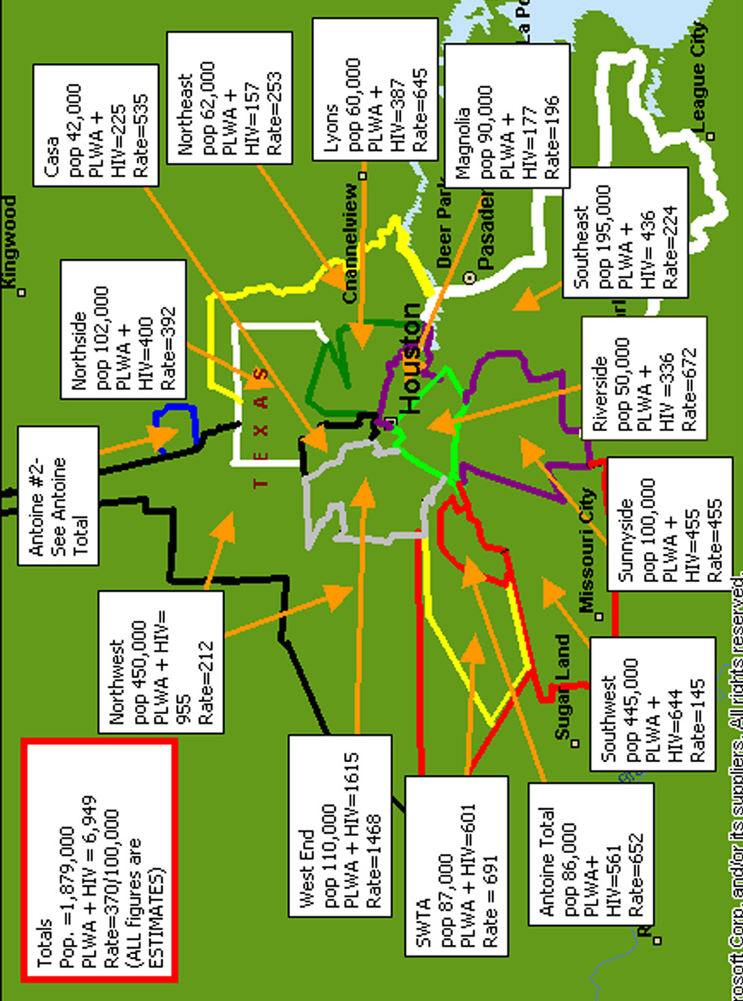

RYAN WHITE CLIENT CHARACTERISTICS
This Needs Assessment completed in April 2002 addresses HIV/AIDS care and prevention needs for the Houston Eligible Metropolitan Area (EMA) and the Houston Health Services Delivery Area (HSDA). The Houston EMA is a six-county area in southeast Texas that consists of Chambers, Fort Bend, Harris, Liberty, Montgomery and Waller counties. The Houston HSDA consists of these same six counties and four others—Austin, Colorado, Walker and Wharton. The 2000 census-based population for these counties as a whole is 4,324,572.

Each of these counties experienced a growth in population since the last census in 1990. The percent change in population ranged from 3.1% in Wharton County to 61.2% in Montgomery County. The average percent change across all counties was 29.6%. In addition to Montgomery County, the other four counties bordering Harris County also saw significant growth: Chambers had a 29.6% increase, Fort Bend County 57.2%, Liberty County 33.1%, and Waller County 39.7%. Harris County itself showed a 20.7% population increase (similar to that for the state, 22.8%).

Figure 3-2: MAP OF EMA AND HSDA
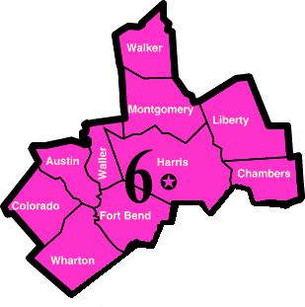
Table 3-3: POPULATION, SQUARE MILES, AND POPULATION DENSITY, BY GEOGRAPHIC AREA
County | Population | Square miles | Population Density  (per square mile)
Austin | 23,590 | 653 | 36
Chambers | 26,031 | 599 | 43
Colorado | 20,390 | 963 | 21
Fort Bend | 354,452 | 875 | 405
Harris | 3,400,578 | 1,729 | 1,966
Liberty | 70,154 | 1,160 | 60
Montgomery | 293,768 | 1,044 | 281
Walker | 61,758 | 788 | 78
Waller | 32,663 | 514 | 64
Wharton | 41,188 | 1,090 | 38
EMA | 4,177,646 | 5,921 | 706
HSDA | 4,324,572 | 9,415 | 459
TOTAL | 4,324,572 | 9,415 | 459

The median age for the entire area is 34.13 years, with half of the population older and half younger. This is slightly over the median age of 32.3 years for the entire state. The median ages for the individual counties fell within the 30 to 40 year age range. Fort Bend County has the largest percentage of people under 18 years old (32%). Walker County had the smallest percentage of people under 18 (18%). Males and females are distributed almost equally in each county, except Walker, where the split is 39.8% female vs. 60.2% male.

The population in all of the counties is predominantly Anglo, ranging from 57.0% in Fort Bend County to 88.3% in Montgomery County. African Americans are the largest minority group in each county, ranging from 3.5% in Montgomery County to 29.2% in Waller. The largest Asian/Pacific Islander (API) population, 11.2%, resides in Fort Bend County. The American Indian/Alaskan Native population consistently is in the 0.3% to 0.5% range across all counties. The “Other” category includes those who designated themselves as multiracial, with the highest percentage (3.0%) in Harris County. The Hispanic population is considered separately because this profile follows Federal guidelines and treats Hispanic as an ethnic categorization, rather than as a race. This means that the Hispanic category is not mutually exclusive of the racial categories; in other words, a person could be both Hispanic and White or Hispanic and American Indian. With that in mind, the average percentage of Hispanics across all counties is 18.9%. Harris County has the largest proportion of Hispanics at 32.9%, with the majority (80.1%) of Mexican origin. Chambers County has the lowest proportion of Hispanics (10.8%). Overall, Harris County and neighboring Fort Bend County are the most racially/ethnically diverse counties in the area.

Most of the residents in the 10-county area live in Houston, the largest city in Texas and the fourth largest city in the United States (behind New York, Los Angeles and Chicago). Within the city limits, the estimated population is 1.8 million, with the gender distribution equally split– 50.1% female and 49.9% male. The median age is slightly younger than the surrounding areas (30.9 years). The city also is racially and ethnically diverse, with 49.3% of Houston’s population Anglo, 25.3% African American, 5.4% Asian/Pacific Islander, 0.4% American Indian, and 16.5% listing another race (with 3.1% multiracial). Over a third of the city’s total population (37.4%) is Hispanic.

ECONOMICS
Economic information was derived from the 2000 U.S. Census. The 1997 estimated median household income for the area ranged from under $29,000 to over $55,000, with an average of approximately $37,000. This compares favorably to the statewide median of $34,478.

The number of people living below the poverty level is significant. The percentage of people below the Federal Poverty Limit (FPL) ranges from 8.0% in Fort Bend County to 20.9% in Waller County, with an average for all counties of 15.0%. For children, the range is from 10.6% in Fort Bend to 26.9% in Waller, for an average of 20.0%. The statewide rates were 13.3% overall and 19.9% for children. Table 3-4 presents this information by county and includes additional estimates for 1999 from the Texas Health and Human Services Commission. The percentage of poverty for all people and for children increased in all but a few counties: Harris, Walker, and Waller counties decreased for all people and in Harris, Liberty, Walker, and Waller counties, poverty decreased for children. Statewide, the majority of those living in poverty in 1997 were female (55.3%) and Hispanic (53.2%).

Table 3-4: Poverty Estimates, by County
County | 1997 Median Household Income | 1997  % Persons below poverty | 1997  % Children below poverty | 1999
 |  |  |  | Total  (%) | Children (%)
Austin | $33,945 | 13.1 | 17.7 | 15.9 | 22.3
Chambers | $43,345 | 10.8 | 16.5 | 13.9 | 17.2
Colorado | $28,966 | 17.1 | 23.9 | 20.1 | 28.9
Fort Bend | $55,164 | 8.0 | 10.6 | 10.5 | 14.3
Harris | $39,037 | 15.2 | 20.9 | 12.6 | 20.0
Liberty | $31,683 | 17.2 | 22.9 | 17.8 | 22.3
Montgomery | $46,292 | 10.3 | 14.6 | 11.6 | 15.4
Walker | $30,971 | 19.9 | 22.5 | 18.3 | 20.0
Waller | $29,832 | 20.9 | 26.9 | 18.9 | 25.7
Wharton | $30,531 | 17.4 | 23.0 | 18.5 | 25.2

Commensurate with the significant percent of people living at or under the Federal Poverty Level is the high percentage of uninsured.

Table 3-5: ESTIMATED PEOPLE WITHOUT INSURANCE, BY COUNTY, 1999
County | % All people | %Children  (0-18 years old) | % Adults  (19-64 years old)
Austin | 19.9 | 22.7 | 24.4
Chambers | 20.3 | 20.8 | 23.7
Colorado | 20.8 | 24.0 | 26.7
Fort Bend | 22.7 | 22.4 | 24.6
Harris | 25.5 | 25.5 | 28.1
Liberty | 22.4 | 22.8 | 26.2
Montgomery | 20.1 | 21.0 | 22.6
Walker | 25.4 | 22.9 | 29.5
Waller | 25.4 | 25.1 | 30.1
Wharton | 23.1 | 25.0 | 27.5

Unemployment by county is high, though it has decreased slightly in six of the counties in the EMA/HSDA from 1998 to 2001:

Table 3-6: Unemployment Rate, by County
County | 1998 | December 2001
Austin | 3.3% | 2.7%
Chambers | 4.2% | 4.2%
Colorado | 3.9% | 3.2%
Fort Bend | 2.9% | 3.2%
Harris | 4.2% | 4.6%
Liberty | 6.5% | 6.3%
Montgomery | 3.4% | 3.7%
Walker | 2.2% | 2.0%
Waller | 4.3% | 4.0%
Wharton | 5.6% | 4.8%
Texas | 4.0% | 5.1%

Population Characteristics

Client Survey
The majority of client survey respondents (“All Respondents”) were male, (70.3%), African American (62.7%), over 20 years old (93.9%), had incomes under $10,000 (73.1%), possessed at least a high school education (70%), and were heterosexual (55.8%). The age distribution of the 640 unweighted respondents is grouped around the 31 - 49 age bracket with bimodal distribution clustered around 36 and 42 years of age, respectively.

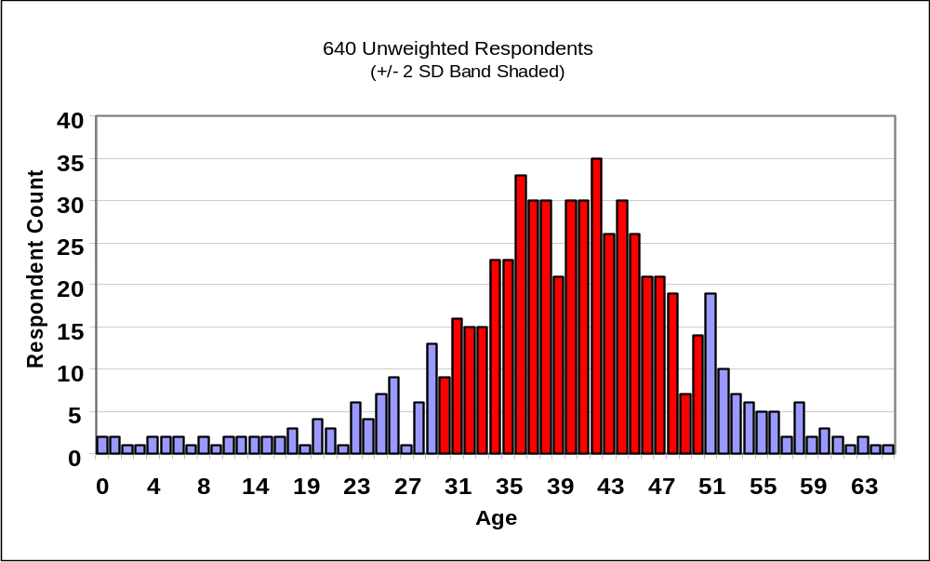Figure 3-3: AGE DISTRIBUTION OF CLIENT SURVEY RESPONDENTS

The male/female gender ratio of the survey respondents closely matches the 2002 Epidemiologic Profile estimate of the adult PLWH/A gender ratio (75% male/25% female). It represents an important shift in the surveyed population since the 1999 Needs Assessment at which time 81% of surveyed individuals were male and the Epidemiologic Profile estimated 83% male and 17% female PLWH/A in the Houston EMA. This suggests that the surveyed individuals truly reflect the changing epidemiology of the African American epidemic in the Houston HSDA. 22% of the overall respondent population was Hispanic.

The surveyed population was 44% homosexual and 39% heterosexual. Of importance is the additional 13% who identified themselves as bisexual. Bisexuality was reported in higher fractions by those not receiving care, the incarcerated, and the African American (AA) and Anglo Men Who Have Sex with Men (MSM) populations. A theme explicitly noted in a focus group addressed this issue:
“People are just not addressing the fact that there’s this whole bisexual thing going on - there’s a lot of bisexuality going on. It should not be focused on homosexual or heterosexual but on sex, period.”

Details of client survey respondent demographics and epidemiology are presented in the following table.

Table 3-7: CLIENT SURVEY RESPONDENT DEMOGRAPHICS AND EPIDEMIOLOGY
Characteristic |  | Consumer Survey  Non-Weighted Respondents (N=640)** |  |  | Consumer Survey  Weighted Respondents  (N=561.73)** |  | Population Estimates (2002)  (Houston EMA/HSDA Epidemiologic Profile)
 |  | Respondents | % of Total |  | Respondents | % of Total | % of Total
Sex
Male |  | 418 | 65.3% |  | 394.73 | 70.3% | 75.4%
Female |  | 216 | 33.8% |  | 161.00 | 28.7% | 24.6%
Transgender |  | 6 | 0.9% |  | 6.00 | 1.1% | NA=Not Available

Race
Black/African-American |  | 401 | 62.7% |  | 253.73 | 45.2% | 46.5%
White |  | 140 | 21.9% |  | 209.00 | 37.2% | 35.6%
Other |  | 70 | *10.9% |  | 70.00 | *12.5% | *17.9%
American Indian or  Alaskan Native |  | 18 | 2.8% |  | 18.00 | 3.2%
N/A |  | 3 | 0.5% |  | 3.00 | 0.5% | NA

Ethnicity
Hispanic |  | 126 | 19.7% |  | 129.45 | 23.0% | NA
Non Hispanic |  | 495 | 77.3% |  | 420.48 | 74.9% | NA

ZIP codes (top five)
77006 |  | 62 | 9.7% |  | 72.59 | 12.9% | NA
77021 |  | 51 | 8.0% |  | 37.03 | 6.6% | NA
77002 |  | 50 | 7.8% |  | 35.95 | 6.4% | NA
77004 |  | 43 | 6.7% |  | 31.29 | 5.6% | NA
77035 |  | 27 | 4.2% |  | 28.45 | 5.1% | NA

Age
13 and under |  | 21 | 3.3% |  | 21.00 | 3.7% | NA
13 – 19 |  | 10 | 1.6% |  | 10.00 | 1.8% | 2.3%
20 and over |  | 601 | 93.9% |  | 522.73 | 93.1% | 97.7%

Income
$0 – 9,999 |  | 468 | 73.1% |  | 392.20 | 69.8% | NA
$10,000 – 19,999 |  | 105 | 16.4% |  | 104.82 | 18.7% | NA
$20,000 – 29,999 |  | 36 | 5.6% |  | 33.61 | 6.0% | NA
$30,000 – 39,999 |  | 5 | 0.8% |  | 2.64 | 0.5% | NA
$40,000 – 49,999 |  | 5 | 0.8% |  | 9.66 | 1.7% | NA
>$50,000 |  | 2 | 0.3% |  | 2.00 | 0.4% | NA
NA |  | 15 | 2.3% |  | 11.84 | 2.1% | NA

Sexual Orientation
Heterosexual |  | 357 | 55.8% |  | 249.85 | 44.5% | NA
MSM | 180 |  | 28.1% | 217.08 |  | 38.6% | NA
Bisexual | 80 |  | 12.5% | 73.43 |  | 13.1% | NA
Other | 9 |  | 1.4% | 9.00 |  | 1.6% | NA
N/A | 7 |  | 1.1% | 7.00 |  | 1.2% | NA
WSW | 6 |  | 0.9% | 4.36 |  | 0.8% | NA
*Hispanic individuals – some respondents and Epidemiology Report designated “Hispanic” as “Race”
** Percentages do not add to 100% by category due to small numbers of non-respondents.
Table 3-7: CLIENT SURVEY RESPONDENT DEMOGRAPHICS AND EPIDEMIOLOGY - CONTINUED
Characteristic | Consumer Survey  Non-Weighted Respondents (N=640)** |  | Consumer Survey  Weighted Respondents  (N=561.73)** |  | Population Estimates (2002)  (Houston EMA/HSDA Epidemiologic Profile)
 | Respondents | % of Total | Respondents | % of Total | % of Total

Exposure Category
Sex with a man | 355 | 55.5% | 341.93 | 60.9% | 44.7%
Sharing needles | 92 | 14.4% | 86.62 | 15.4% | 13.8%
Heterosexual | 138 | 21.6% | 67.93 | 12.1% | 21.4%
Trading sex for drugs/money | 35 | 5.5% | 30.38 | 5.4% | NA
Blood products | 30 | 4.7% | 28.21 | 5.0% | NA

HIV/AIDS Status
Positive, no symptoms | 339 | 53.0% | 288.53 | 51.4% | NA
Positive with symptoms | 201 | 31.4% | 175.39 | 31.2% | NA
Living with AIDS | 178 | 27.8% | 170.42 | 30.3% | NA

Viral Load
Undetectable | 156 | 24.4% | 132.90 | 23.7% | NA
<1000 | 62 | 9.7% | 59.31 | 10.6% | NA
1001-5000 | 52 | 8.1% | 48.16 | 8.6% | NA
5001-10000 | 26 | 4.1% | 29.57 | 5.3% | NA
10001-50000 | 36 | 5.6% | 38.84 | 6.9% | NA
50001-100000 | 27 | 4.2% | 21.95 | 3.9% | NA
100001-500000 | 13 | 2.0% | 12.73 | 2.3% | NA
500001-1 million | 3 | 0.5% | 3.00 | 0.5% | NA
>1 million | 1 | 0.2% | .27 | 0.0% | NA
N/A | 61 | 9.5% | 48.72 | 8.7% | NA
Don’t know | 197 | 30.8% | 160.10 | 28.5% | NA

Medication
Antiretroviral | 376 | 58.8% | 343.07 | 61.1% | NA
Antibiotics | 216 | 33.8% | 187.99 | 33.5% | NA
Antidepressants | 175 | 27.3% | 166.54 | 29.6% | NA
Antifungal | 118 | 18.4% | 107.96 | 19.2% | NA
Steroids | 60 | 9.4% | 70.05 | 12.5% | NA
Other | 116 | 18.1% | 121.39 | 21.6% | NA

Living Arrangements
Alone | 210 | 32.8% | 193.03 | 34.4% | NA
Partner/Wife/Husband | 143 | 22.3% | 129.74 | 23.1% | NA
Adult relative | 114 | 17.8% | 97.43 | 17.3% | NA
Children | 93 | 14.5% | 70.21 | 12.5% | NA
Adult friend/roommate | 59 | 9.2% | 53.43 | 9.5% | NA
# of Children HIV+ | 36 | 5.6% | 31 | 5.5% | NA
** Percentages do not add to 100% by category due to small numbers of non-respondents.
Chapter 4

Service Categories
SERVICE CATEGORIES
This study reports use, needs, barriers and gaps at both the service category and individual services levels. The following chart illustrates how use, needs, barriers and gaps were calculated. Some gaps are missing. In this case, the sample number was too small to calculate.

Table 4-1: CALCULATING USE, NEEDS, BARRIERS & GAPS
Service  Status | Analysis | Survey  Question
Use | Count of the number of “yes” responses to the statement, “Check the box that indicates if you have used this service.” | 47
Need | Count of the number of “yes” response to the statement, “Check the box that indicates if you currently need the service.” | 47
Barrier | Count of the number of “Hard to get” response to the statement, “Check the box that describes how easy it was for you to get the service.” | 47
Gap | Sum of respondents who responded “yes” to need and “no” to the statement “Check the box that indicates if you believe that this service is available to you.” | 47

Percentages indicate the proportion of the survey respondents who answered “yes” to a survey question. For example, if 86% of respondents said they used ambulatory outpatient medical care, the reported percent is 86.

The ranking order is by percent from highest to lowest - the higher the percentage, the higher the rank number, with the highest rank being one.

AMBULATORY/OUTPATIENT MEDICAL CARE

HRSA DEFINITION:
Provision of professional diagnostic and therapeutic services rendered by a physician, physician’s assistant, clinical nurse specialist, or nurse practitioner in an outpatient, community-based and/or office-based setting. This includes diagnostic testing, early intervention and risk assessment, preventive care and screening, practitioner examination, medical history taking, diagnosis and treatment of common physical and mental conditions, prescribing and managing medication therapy, care of minor injuries, education and counseling on health and nutritional issues, minor surgery and assisting at surgery, well-baby care, continuing care and management of chronic conditions, and referral to and provision of specialty care.

Individual Services
Outpatient Clinic Medical & Nutritional Services
Vision Care
Obstetrics and Gynecology
Pediatrics
Specialty
Infectious Diseases

CPCDMS/COMPIS Registration Data
CPCDMS and COMPIS data show that 4,732 unduplicated clients used Ryan White Titles I and II funded ambulatory/outpatient medical care services during the one-year period of 3/1/01 through 2/28/02. In addition, 74 unduplicated clients used Title II nutritional counseling services and 79 used Title IV primary care services during the same time period. These numbers represent 21.5% - 44.2% of the estimated 11,051 - 22,706 PLWH/A living in the EMA/HSDA.

These data represents only those services billed to Titles I, II, IV and State Services. Many services have supplemental funding sources.
Ambulatory/Outpatient Medical Care (continued)

All Respondents:
Status Percent Rank
Use 83.6 1
Need 69.9 2
Barrier 18.0 2
Gap 31.9 2

Special Study Populations:
AA MSM:  Status Percent Rank  Use 80 3  Need 28 12  Barrier 17 2  Gap 36 2 | Women of childbearing age  Status Percent Rank  Use 81 2  Need 37 6  Barrier 23 2  Gap 28 2
Incarcerated/Recently released  Status Percent Rank  Use 79 2  Need 30 9  Barrier 20 2  Gap 39 2 | Youth (age 13 - 24):  Status Percent Rank  Use 68 1  Need 40 2  Barrier 29 1  Gap 21 3

PRIMARY MEDICAL CARE

Figure 4-1: PRIMARY CARE – REPORTED BARRIER (B), NEED (N), USE (U)
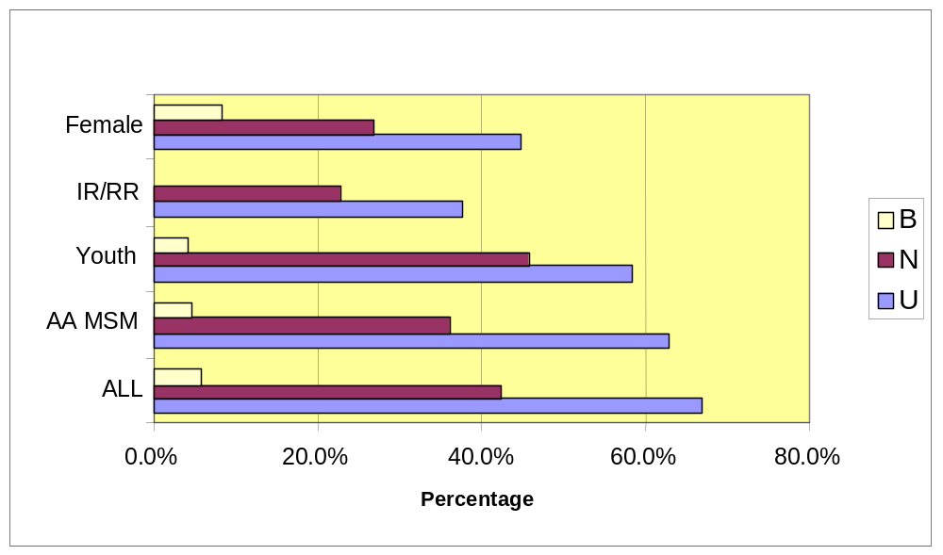

All Respondents:
Status Percent Rank
Use: 66.9 1
Need: 42.5 6
Barrier: 5.9 72
Gap: 2.5 38

Special Study Populations:

AA MSM:
Status Percent
Use 62.8
Need 36.1
Barrier 6.6

Incarcerated/Recently Released:
Status Percent
Use 59.3
Need 38.6
Barrier 7.0

Women of Childbearing Age:
Status Percent
Use 68.4
Need 41.4
Barrier 7.9

Youth (age 13 - 24):
Status Percent
Use 58.3
Need 45.8
Barrier 4.2

Central Themes
- The primary care provider was consistently referenced as the main source of information for HIV services and clinical information.
- Respondents complimented the quality of services provided by their HIV/AIDS clinic providers, with some concerns voiced about attitude or bureaucratic attitudes.
- Private providers, however, received comments from client respondents related to both the quality of clinical services, their knowledge base about HIV/AIDS and related services.

Discussion
Nearly 70% of respondents indicated a need for one or more Outpatient Clinical Services. Outpatient primary care ranked first in use among all Individual Services. In the focus groups, when participants were asked about services that most contributed to their health, each mentioned Outpatient Primary Medical Care. Consistent with national trends, as reported by the CDC, the need and utilization of outpatient primary care will continue to grow as inpatient care recedes due to the success of anti-retroviral therapies.

The sample of respondents included patients from several sites who assigned to their primary care providers a range of significant roles. Among these, the provider was seen as the essential source of information about HIV and HIV-related services, the motivator for adherence to medical regimens and a source of interpersonal acceptance. As one young woman noted:
“This [provider] is family. These people know what I live, if everyone told us about our disease and treated us in this positive way, we would still be HIV positive but not think about dying or death.” (Woman - not currently pregnant)

With that assignment of significance comes a demand on the providers, especially for the most current information, and the willingness to approach clients in a manner that is perceived as caring, as the following focus group quotes indicate:
“The ignorance that people can have, even my doctors, about my comorbidities and the interactions of my HIV drugs is amazing. I have hypertension and have researched myself the wrong interactions with my heart and HIV drugs. I have to tell my doctors and nurses about it.”
(Older Adult)
“If you are in healthcare you shouldn’t be ignorant. You have a responsibility in the medical profession to realize how your attitude can affect my mind and treatment.” (Rural client)
“They tried to talk with me, but everyone they looked at me with pity. Their behavior makes me depressed and isolated in a world of my own.” (Female client)

“The doctor I have now, I have CMV in both eyes—the doctor I have right now, he didn’t mention it, didn’t care. So I just say screw it and don’t go to the doctor. My last viral load was half a million.” (Older Adult)

Viral Load Profiles
Analysis of the self-reported viral loads of the survey respondent sample further adds to the understanding of use and need for primary care services. According to the CDC, a benchmark for outpatient primary care is the achievement of undetectable viral loads for 86% of clients within 6 months of initiation of anti-retroviral therapies. Figure 4-2 below shows the viral load profiles of respondents.

Figure 4-2: Viral Load Knowledge
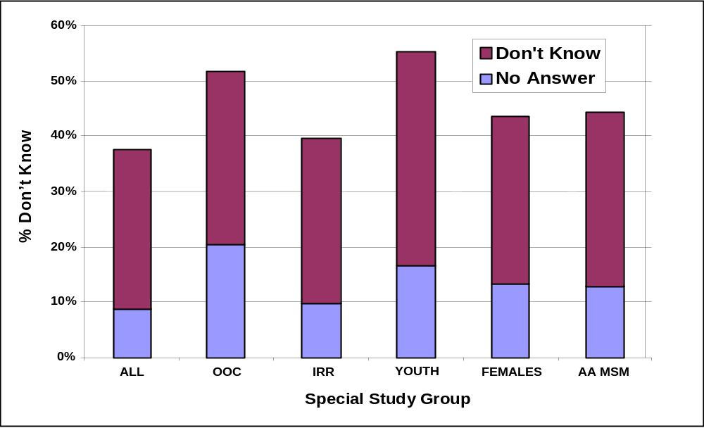
Noteworthy is that 35% of respondents could not report their current viral load information. Focus group participants offered a range of reasons for this from personal denial (“I don’t care anything about that stuff”), to reported physician choice (“My doctor doesn’t tell me that”) to simply forgetting (“I don’t remember that”) or reported inability to understand the concept (“What’s that? I heard about it but I don’t know about that”).

Comorbidities/Side Effects
An additional concern for the primary care providers is the extent and type of comorbidities among PLWH/As. Several of the medical conditions in the following list occur as side effects to HIV treatment, as comorbidities typical in HIV infection or as conditions related to neither of those factors. Limitations in the survey instrument did not permit an analysis that would distinguish the causes of the conditions reported by respondents. Figure 4-3 illustrates the rates of the conditions reported by survey respondents.

Figure 4-3: COMORBIDITY RATES
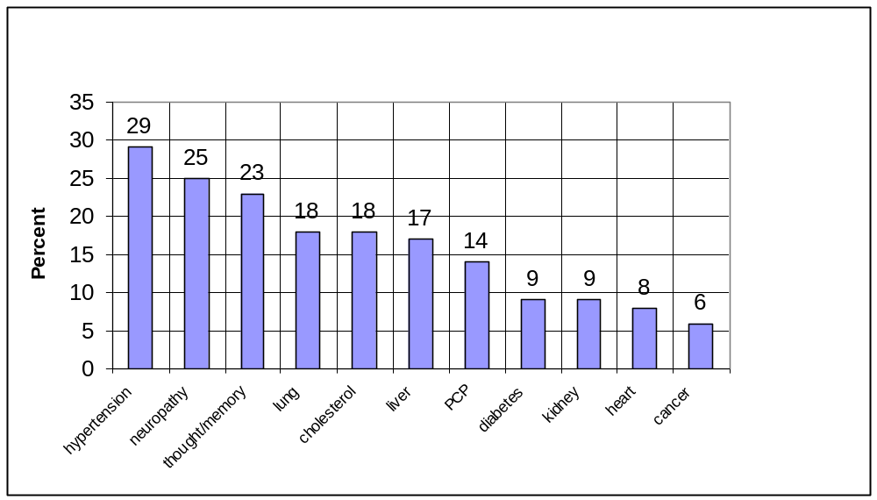
A compelling consideration in this illustration is the prevalence of several of these conditions—hypertension, diabetes, high cholesterol and heart disease—among the general population of African American and Hispanic individuals, populations who are disproportionately affected by HIV.

Among the special study groups, the Incarcerated/Recently Released respondents manifested higher rates in all conditions except diabetes and kidney disease; women reported higher rates of pneumocystis pneumonia (PCP), diabetes and kidney disease; for youth higher rates of cancer were noted and among African American MSM, higher rates of hypertension were reported.

Table 4-2: PREVALENCE OF HEALTH CONDITIONS IN THE GENERAL POPULATIONS
Health Condition | Houston Area  2002 Client Survey* | Prevalence  in US | % of U.S. Population
Hypertension | 29% | 72.3 million in U.S. | 25%  (28.1 African American,  23.2 White)
Neuropathy | 25% | 2 million | .7%
Thought/Memory loss
Lung Disease | 18% | 24.75 million | 8.8%
- Pneumocystis pneumonia | 14% | Opportunistic infection for people with HIV | (Without treatment, 80-85% of PLWH/A would acquire PCP)
Cholesterol | 18% | 42.3 million | 15%
Liver | 17% | 25.1 million | 8.9%
- Hepatitis C | 34% | 4 million | 1.4%
Diabetes | 9% | 16 million  -1/3 don’t know  800,000 diagnosed/yr | 5.6%
Kidney | 9% | 3.4 million | 1.2%
Cardiac | 8% | 58 million | 21%
Cancer | 6% | 8.4 million | 3%
Tuberculosis*: (much higher in ethnic groups)  Risk:  > 6 x Hispanic  > 6 x Native Americans  > 8 x African Americans  > 17 x Asian Pacific Islanders | 2% | 19-28 million have latent TB, 10% of those (2-3 million) go active.  HIV & TB: 11 million  have both | 7-10% latent = 0.7-1% active  [While 10% of the entire population in the U.S. convert to active TB IN A LIFETIME, for those with HIV and TB, 7 - 10% convert to active status IN A YEAR]

VISION CARE

Figure 4-4: VISION CARE – REPORTED BARRIER (B), NEED (N), USE (U)
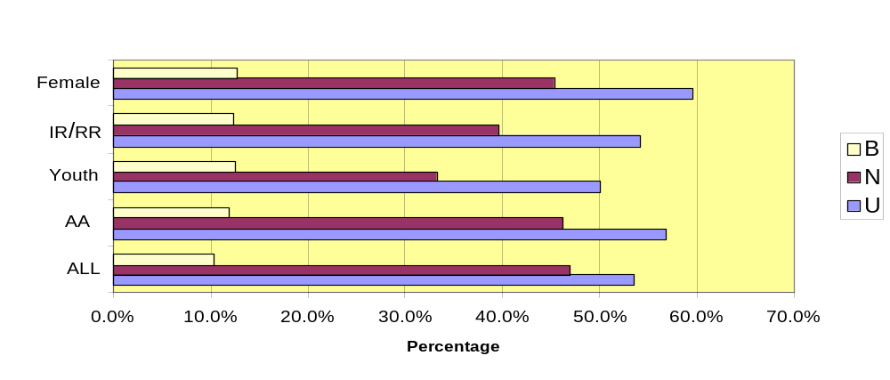

All Respondents:
Status Percent Rank
Use 53.6 4
Need 46.9 4
Barrier 10.3 5
Gaps 3.9 12

Special Study Populations:

AA MSM:

Status Percent
Use 56.7
Need 46.1
Barrier 11.8

Incarcerated/Recently Released:

Status Percent
Use 54.1
Need 39.5
Barrier 12.3

Women of Childbearing Age:

Status Percent
Use 59.5
Need 45.4
Barrier 12.8

Youth (age 13 - 24):

Status Percent
Use 50.0
Need 33.3
Barrier 12.5

Central Themes
- Most concerns about vision care focused on three interrelated issues: 1) access to general optometric care 2) need for CMV screenings and 3) limited choice of providers, associated with health insurance plans.

Discussion
As the service ranked 4th in use, vision care is a concern for respondents. Of note is similarity among the special study populations in perceptions barrier between these populations and the sample as a whole.

Focus group participants cited concerns that providers whom they were able to access lacked sufficient knowledge to address their need for frequent, accurate screening for CMV. Rural respondents especially reported frustration at the lack of local services and the inconvenience of procedures associated with securing care in the Houston, as noted in the quotes that follow.
“There is no eye care. I just got these glasses a few months ago. I went all the way over to the Third Ward. I saw a nice little man who’s probably been there 50 years, and that’s where I got my glasses from.” (Rural client)
“You need to know that all clinics who say they offer CMV checks—they only do that at a certain time, on Wednesdays. If I had a job and worked full-time I don’t have the time to be seen there. And you know what’s worse? They make us go there the first time without being seen to fill out the paperwork.” (Northern Rural client)

A noteworthy point discussed by both providers and focus group participants is that vision care is important to HIV+ clients, particularly because many have had little to no access to the service, prior to their involvement in the HIV continuum of care. In addition, because HIV is increasingly a chronic illness, more clients will now face vision changes associated with aging. Increasingly, data should become available to determine if PLWH/A are differentially susceptible to such conditions as glaucoma and/or cataracts. Another factor that can potentially have an impact on the need for vision care is the rate of diabetes that occurs among PLWH/A and with that the increased risk of retinopathy.
OBSTETRICS AND GYNECOLOGY

Figure 4-5: OB/GYN SERVICES – REPORTED BARRIER (B), NEED (N), USE (U)
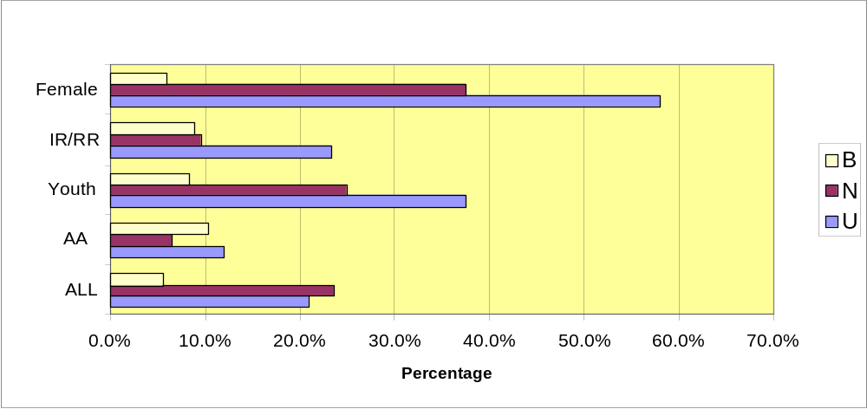

All Respondents:

Status Percent Rank
Use 20.9 35
Need 13.6 70
Barrier 5.5 67
Gap 1.2 69

Special Study Populations:

AA MSM*:

Status Percent
Use 12.0
Need 6.4
Barrier 10.3

* Transgendered individuals

Incarcerated/Recently Released:

Status Percent
Use 23.4
Need 9.6
Barrier 8.8

Women of childbearing age:
Status Percent
Use 58.0
Need 37.6
Barrier 5.9

Youth (age 13 - 24):
Status Percent
Use 37.5
Need 25.0
Barrier 8.3

Central Themes
- Women respondents cited neither gynecology nor obstetrical care as a significant need unless they were pregnant or recently pregnant.
- Young women who were currently or recently pregnant were enthusiastic in their praise of obstetrical providers, and linked their emotional attachment to their clinicians with expectations that prenatal care would assure that their children would be HIV negative
- Women expected that providers understand HIV and impact on pregnancy.
- Women who were currently or recently pregnant consistently indicated their primary motivator for adherence to HIV treatment regimens was concern for their children.

Discussion
As would be expected, the highest reported use rate of Ob/Gyn services is among women of childbearing age. The 10.3% barrier cited by the AA MSM likely reflects the concerns of a small number of male-female transgendered individuals, who indicated a preference for treatment by a gynecologist. Of concern is the barrier rate cited by both the Incarcerated/Recently Released and Youth, both of which are higher than the rate for all respondents in this category.

According to findings from the qualitative data, for many women, the provider of choice for their HIV-related care is the Ob/Gyn practitioner. Among survey respondents, 13.9% were diagnosed with HIV when they sought pregnancy testing, and according to numerous focus group participants, the same providers were sought for ongoing HIV treatment. Several women reported the perception that these providers are more relational, and that the care they receive is more targeted to their needs and concerns, as the following quote exemplifies.
“For me, it’s that I can connect with them. I don’t like going where I’m not wanted. Whenever I go to the Ob/Gyn they give me hugs, ask me how I am. From the cabdriver to the doctors, they love my little girl.” (Female client)

In targeting care for women, education in the prevention and treatment of sexually transmitted infections might be stressed. Despite the persistence of sexually transmitted infections among HIV+ women, treatment for these conditions was not cited as a need among female focus group participants or RARE respondents. Figure 4-6 shows the percentage of female respondents who reported a history of sexually transmitted infections. Table 4-3 shows sexually transmitted infection rates as reported by all respondents and their prevalence in the U.S. population.

Figure 4-6: SEXUALLY TRANSMITTED INFECTIONS
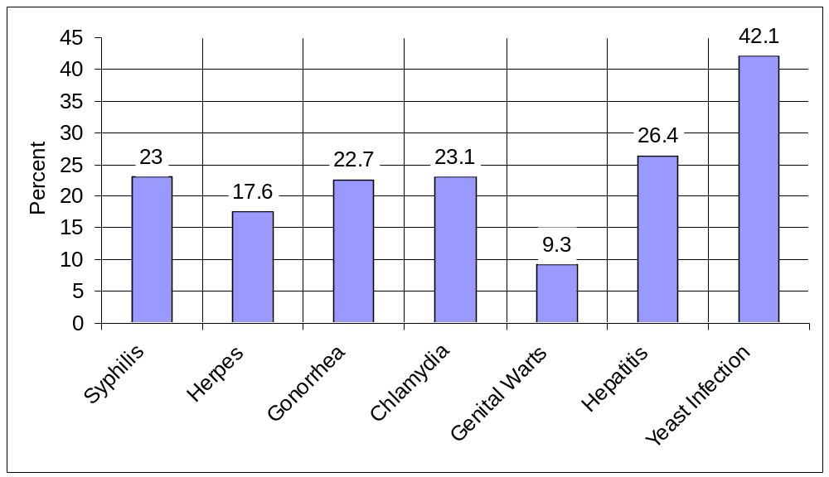

Table 4-3: RATE OF SEXUALLY TRANSMITTED INFECTIONS
Sexually Transmitted Infections (STI) | Houston EMA  2002 Client Survey* | Prevalence  in U.S. | % of U.S. Population
Syphilis | 23% | 13 per 100,000 | .013%
Genital Herpes | 17.6% | 9,433 per 100,000 | 9%
Gonorrhea | 22.7% | 133 per 100,000 | .133%
Chlamydia | 23.1% | 254 per 100,000 | .254%
Genital Warts | 9.3% | 1.7 per 100,000 | .0017%
Yeast Infections | 17%
(Source: National Center for Health Statistics, Centers for Disease Control and Prevention)
*The rate of sexually transmitted infections was self-reported.
PEDIATRIC CARE

Figure 4-7: PEDIATRIC CARE – REPORTED BARRIER (B), NEED (N), USE (U)
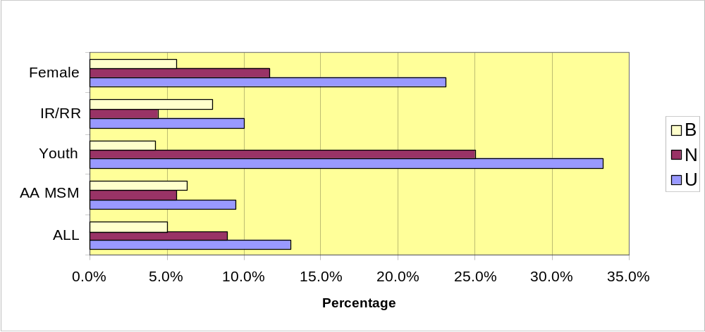

All Respondents:

Status Percent Rank
Use 13.0 51
Need 8.9 73
Barrier 5.0 69
Gap 1.6 72

Special Study Populations:

AA MSM:

Status Percent
Use 9.5
Need 5.6
Barrier 6.3

Incarcerated/Recently Released:

Status Percent
Use 10.0
Need 4.4
Barrier 7.9

Women of Childbearing Age:

Status Percent
Use 23.1
Need 11.7
Barrier 5.6

Youth (age 13 - 24):

Status Percent
Use 33.3
Need 25.0
Barrier 4.2

Central Themes
- Caregivers of HIV+ children indicated that care for PLWH/A is provided by the healthcare clinicians with a Pediatric/Infectious Disease background.
- Respondents with children who are sero-negative did not specify needs for pediatric care.
- Many client respondents indicated that they did not need childcare. Upon further probing in focus groups, these women often stated that they have come to depend on family members or friends to supply this resource. That does not mean that they would not welcome reliable, trustworthy childcare resources.

Discussion
As is expected, the highest rates of reported use and need for pediatric services is found in omen of Childbearing Age and Youth. Both of these populations include individuals who are current or recent pediatric clients and/or young parents. This assertion is verified both in the survey data and in the focus groups. Of note is the elevated barrier percent among the Incarcerated/Recently Released. While no definitive data was generated to adequately explain this finding, incarcerated women expressed grave concerns about their ability to provide care for even the most basic needs of their children due to a range of barriers, related to access to housing, transportation, financial resources as well as lack of information about available services for themselves or their children.

Consistent with the findings in Primary Care and Ob/Gyn, respondents who indicate that the pediatrician is their primary provider tend to emphasize the importance of a supportive relationship with the provider, as illustrated by the following:
“They (pediatric clinic staff and physician) are great. The problem is when we turn 18 and move to another clinic and physician. I want to continue with the same physician.” (Youth, age 20-24)

SPECIALTY CARE

(i.e. medical practice specialties such as cardiology or psychiatry)

Figure 4-8: SPECIALTY SERVICES – REPORTED BARRIER (B), NEED (N), USE (U)
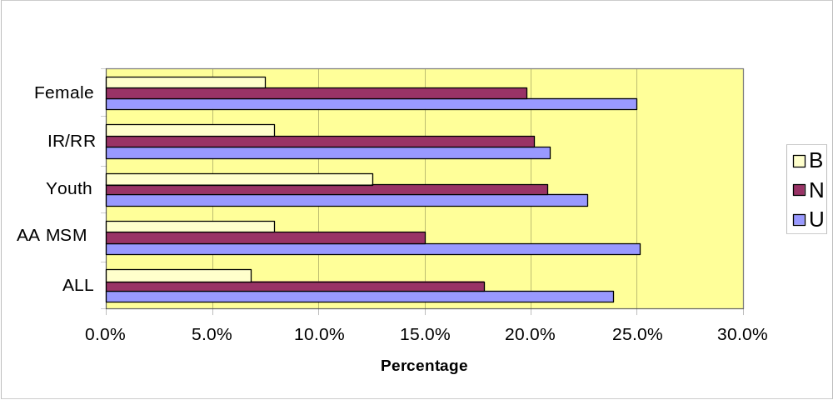

All Respondents:

Status Percent Rank
Use 23.9 29
Need 17.8 39
Barrier 6.8 24
Gap 2.9 26

Special Study Populations:

AA MSM:
Status Percent
Use 25.1
Need 15.0
Barrier 7.9

Incarcerated/Recently Released:
Status Percent
Use 20.9
Need 20.2
Barrier 7.9

Women of Childbearing Age:
Status Percent
Use 25.0
Need 19.8
Barrier 7.5

Youth (age 13 - 24):
Status Percent
Use 22.7
Need 20.8
Barrier 12.5

Central Themes
- Clients expected that their primary care provider would provide treatment for comorbidities. They talked about the frequency of primary care provider visitation and the fact that they are overwhelmed with the time and energy required if they are referred to another provider.

Discussion
Very little variation is noted in reported use and need rates among the special study populations and in comparison to the entire sample. Reported barriers, however, are notably higher in Youth and although the number of respondents in this group is small, the finding is repeated in the qualitative data. There is a caveat, however, several young respondents defined “specialty” as services that targeted youth, as opposed to one of the more traditional connotations of specialty care (ex. cardiology, neurology, etc.).

No focus group respondents specifically addressed the need for specialty care despite the fact that many raised the issue of comorbidities. The incidence of reported comorbidities may highlight a need for specialty care and raises questions about the extent of referrals, respondent perception of access and possibly about health insurance reimbursements. (See page 66 for a discussion of comorbidities)

Comments from focus group participants detailed their experience with other health concerns:
“The ignorance that people can have, even my doctors, about my comorbidities and the interactions of my HIV drugs is amazing. I have hypertension and have researched myself the wrong interactions with my heart and HIV drugs. I have to tell my doctors and nurses about it.”
(Older Adult)
“I have diabetes and this complicates my life more than AIDS.”
(Long-Term Survivor)
“ I don’t worry about (my cervical cancer) it, I have to see what will happen with the cancer. I’m not worried about it. I’m not gonna tell anyone about this.” (Incarcerated Female)
“I have a heart problem because of the AIDS cocktails that I was taking over the years. I have difficulty even cleaning my house—I’m good for about an hour and then I have to go rest. I don’t know where to go for help in this direction.” (Anglo MSM)
INFECTIOUS DISEASES

Figure 4-9: INFECTIOUS DISEASES – REPORTED BARRIER (B), NEED (N), USE (U)
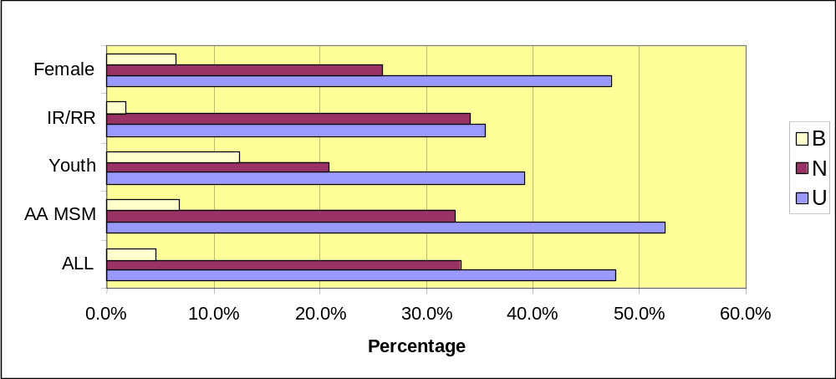

All Respondents:

Status Percent Rank
Use 47.8 7
Need 33.2 14
Barrier 4.6 51
Gap 2.2 44

Special Study Populations:
AA MSM:  Status Percent  Use 52.3  Need 32.7  Barrier 6.9 | Women of Childbearing Age:  Status Percent  Use 47.3  Need 25.8  Barrier 6.4
Incarcerated/Recently Released:  Status Percent  Use 35.5  Need 34.2  Barrier 1.8 | Youth (age 13 - 24):  Status Percent  Use 39.1  Need 20.8  Barrier 12.5

Central Themes
- Seventy-seven percent of survey respondents who indicated use of primary care also reported use of infectious disease care.
- Although focus group and RARE respondents consistently reported the importance of medical care to their well-being, they did not discriminate between infectious disease and primary care.

Discussion
With the exception of the incarcerated/recently released the reported rates of use of infectious disease care are notably higher than the report of need.

Information from other EMAs suggests patterns of use similar to the Houston area. In Dallas, women and MSM were most likely to express a need for infectious disease care. A special study held in Miami-Dade, Florida found that among the homeless, infectious disease care was ranked the highest need after housing and food. Given that 19% of survey respondents in the Houston area indicated that they had been homeless within the last 2 years, similar findings might be expected.
CASE MANAGEMENT

HRSA DEFINITION:

A range of client-centered services that link clients with health care, psychosocial and other services to ensure timely, coordinated access to medically appropriate levels of health and support services, continuity of care, ongoing assessment of the client’s and other family members’ needs and personal support systems, and inpatient case management services that prevent unnecessary hospitalization or that expedite discharge, as medically appropriate from inpatient facilities. Key activities include initial comprehensive assessment of the client’s needs and personal support systems; development of a comprehensive individualized service plan; coordination of the services required to implement the plan; client monitoring to assess the efficacy of the plan and periodic re-evaluation and revision of the plan as necessary over the life of the client. May include client-specific advocacy and/or review of utilization of services.

Individual Services
Social Case Management
Medical Case Management

CPCDMS/COMPIS Registration Data
CPCDMS and COMPIS data show that 2,564 unduplicated clients used Titles I and II and TDH State Services social case management services. COMPIS data shows an additional 118 unduplicated clients used Title IV case management services. This represents 4.0% - 8.3% and 11.8% - 24.3% of the estimated 11,051 - 22,706 PLWH/A in the EMA/HSDA. However, many PLWH/A use case management services not funded by either Title I or Title II.

These data represents only those services billed to Titles I, II, IV and State Services. Many services have supplemental funding sources.
SOCIAL CASE MANAGEMENT

Figure 4-10: SOCIAL CASE MANAGEMENT – REPORTED BARRIER (B), NEED (N), USE (U)
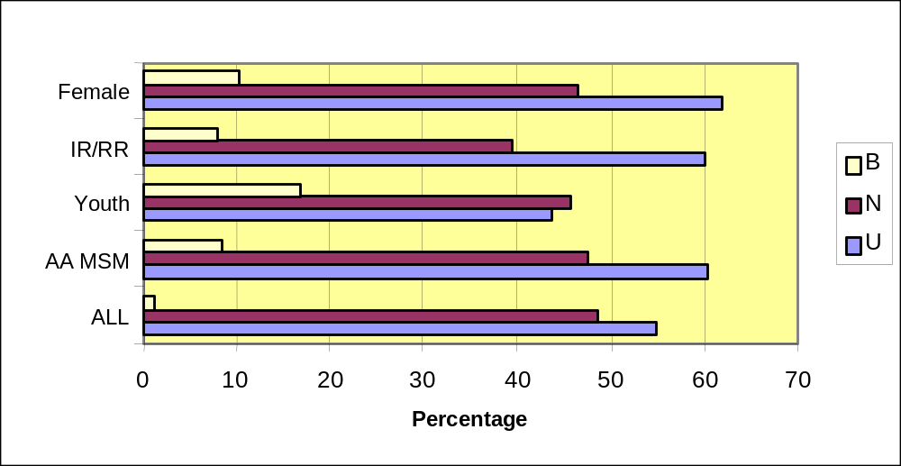

All Respondents:
Status Percent Rank
Use 62.8 5
Need 46.8 6
Barrier 9.0 7
Gap 3.3 15

Special Study Populations:
AA MSM:  Status Percent Rank  Use 63 9  Need 64 3  Barrier 9 9  Gap 3 17 | Women of Childbearing Age:  Status Percent Rank  Use 66 5  Need 54 2  Barrier 11 4  Gap 3 11
Incarcerated/Recently Released:  Status Percent Rank  Use 63 6  Need 63 2  Barrier 7 12  Gap 2 16 | Youth (age 13 - 24):  Status Percent Rank  Use 14 5  Need 26 2  Barrier 9 4  Gap 3 11

MEDICAL CASE MANAGEMENT

Figure 4-11: MEDICAL CASE MANAGEMENT – REPORTED BARRIER (B), NEED (N), USE (U)
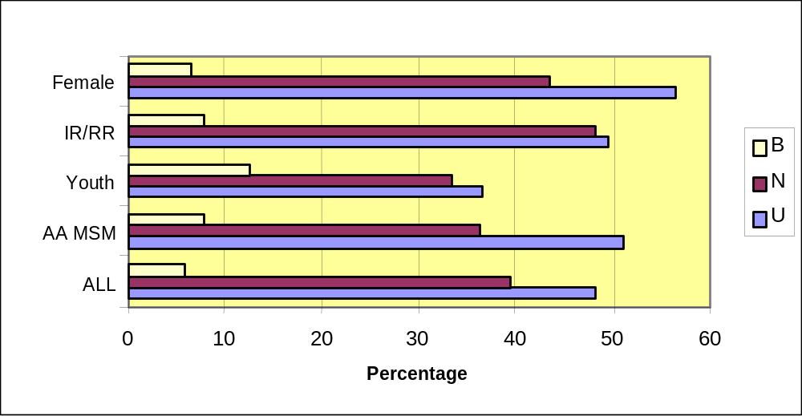

All Respondents:

Status Percent Rank
Use 48.1 6
Need 39.5 9
Barrier 6.0 62
Gap 2.6 32

Special Study Populations:
AA MSM:  Status Percent  Use 51.0  Need 36.2  Barrier 7.8 | Women of Childbearing Age:  Status Percent  Use 56.3  Need 43.4  Barrier 6.6
Incarcerated/Recently Released:  Status Percent  Use 49.5  Need 48.2  Barrier 7.9 | Youth (age 13 - 24):  Status Percent  Use 36.4  Need 33.3  Barrier 12.5
Central Themes
- Case management is one of the most widely used services, and relationships with case managers can be among the most interpersonally involving for the client.
- According to providers, the goal of social case management is client independence, but the goal of medical case management is an ongoing relationship with clients to assist them in implementing their medical care plan and to overcome barriers both to receiving care and adhering to treatment regimens.
- In discussing case managers, respondents were more likely to offer comments about level of satisfaction than with any other service. Of note is that every possible level of satisfaction was reported. Many praised their case managers, especially those new to the system or younger clients. Long-term survivors or those experienced in the system stated that they had experienced a significant decline in the quality of case managers with less awareness by many of available services or services for which clients were eligible. Many respondents reported no case manager, with some stating because they did not have need for their services and others because they had trouble being assigned a case manager.

Discussion
A common issue with case management was the ambivalence that respondents experienced with achieving independence. This ambivalence may partly explain the disparity between the large use statistic and the much smaller need statistic. Respondents do not generally differentiate between the Social and Medical Case Manager, which may partly explain some of the ambivalence, since they are not clear about the differing roles each plays in the client’s care plan.
“I was diagnosed in 1994 and they had me go to (hospital) cause I was pregnant. My case manager was magnificent, but once my baby was older and I turned 18, I was turned over to a clinic case manager, and it wasn’t the same.” (Adolescent Woman, age 19 - 24)
“My case manager is like family to me. I didn’t care after I found out I was HIV positive, I didn’t care, I wanted to die. Within three months, my case manager had me smiling again. I thought of not taking my medications—when I go to the clinic, they make me feel so tranquil, even peaceful.” (Pregnant Woman)
“The two nasty words have already been said—case workers. Basically I don’t exist unless I call. It takes 2 weeks to get in to see him, which is ludicrous.” (Anglo MSM)

Compared to other EMAs, the Houston area appears to assign case management a much lower gap score in needs assessments. Miami-Dade respondents rated case management the highest gap, with the highest barriers after transportation. In Dallas, women of childbearing age, also ranked the service as the #1 gap and highest need. Participants in focus groups in several cities, including Philadelphia and Newark, NJ consistently expressed very low satisfaction with case managers, indicating that as clients, they feel abandoned by case managers whom they view as inadequately knowledgeable, culturally insensitive and abandoning.

NUTRITIONAL SERVICES

HRSA DEFINITION:

Provision of nutrition education and/or counseling provided by a licensed/registered dietitian outside of a primary care visit. Nutritional counseling provided by other than a licensed/registered dietician should be provided under psychosocial support services. Provision of food, meals or nutritional supplements should be reported a part of the sub-category, Food and Home-Delivered Meals/Nutritional Supplements.

Individual Services
Nutrition education, counseling and/or direct therapeutic nutritional/supplemental food products and/or services.

CPCDMS/COMPIS Registration Data
Because nutritional counseling is not a billable activity within primary care it is not tracked as a subcategory in the CPCDMS. Examples of billable subcategories within primary care include ultrasound, biopsy, psychiatry, mammography, CD4 testing, etc. Nutritional counseling is an activity that primary care providers are expected to do as part of a regular office visit, as it is included in the public health service guidelines.

All Respondents:

Status Percent Rank
Use 52.3 9
Need 42.5 8
Barrier 6.0 11
Gap 6.2 11

Special Study Populations:

AA MSM:

Status Percent Rank
Use 63 8
Need 47 4
Barrier 6 17
Gap 11 10

Incarcerated/Recently Released:

Status Percent Rank
Use 57 8
Need 41 5
Barrier 6 16
Gap 4 14

Women of Childbearing Age:

Status Percent Rank
Use 43 9
Need 42 4
Barrier 6 16
Gap 6 10

Youth (age 13 - 24):

Status Percent Rank
Use 13 11
Need 10 10
Barrier 5 17
Gap 0 0

NUTRITIONAL SERVICES (continued)

Figure 4-12: NUTRITIONAL SUPPLEMENTS – REPORTED BARRIER (B), NEED (N), USE (U)
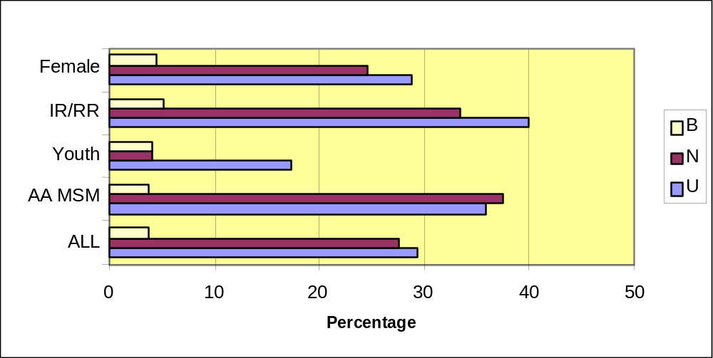

All Respondents:

Status Percent Rank
Use 29.4 19
Need 27.6 22
Barrier 3.8 66
Gap 2.1 46

Special Study Populations:
AA MSM:  Status Percent  Use 35.9  Need 37.5  Barrier 3.9 | Women of Childbearing Age:  Status Percent  Use 28.8  Need 24.5  Barrier 4.6
Incarcerated/Recently Released:  Status Percent  Use 39.9  Need 33.3  Barrier 5.3 | Youth (age 13 - 24):  Status Percent  Use 17.4  Need 4.2  Barrier 4.2
Central Themes
- Respondents associate nutritional supplements with enhanced physical energy and a lessening of medication side effects among PLWH/A.
- Because of the perceived value of supplements, respondents indicated a preference for a purchasing assistance program similar to those used for purchase of medication.

Discussion
Participants in focus groups conducted for AA MSM, Older Adults, Youth and Rural (North and South) residents all mentioned the importance of access to nutritional supplements. Clients were very dissatisfied with the cost barrier they perceived in accessing supplements, especially because, as they reported, costs were formerly covered for them, as the following passage shows:
“We get our AIDS meds, but anything like vitamins or Sustecal you have to pay for. I don’t think that’s right because we used to get it all for free.” (Long-Term Survivor)
“The nutritional supplements should be paid for just like prescription drugs cause you know, they are medicine.” (Older Adult)
SUPPORT SERVICES

HRSA DEFINITION (relevant categories only)
Buddy/Companion Services: Activities provided by peers or volunteers to assist a client in performing household or personal tasks. Buddies also provide mental and social support to combat loneliness and isolation.
Client Advocacy: Assessment of individual need, provision of advice and assistance obtaining medical, social, community, legal, financial and other needed services. Advocacy does not involve coordination and follow-up on medical treatments.
Adult Day Care or Childcare : Home- or community-based non-medical assistance designed to relieve the primary caregiver responsible for providing day-to-day care of client or client’s child.
Emergency Financial Assistance: Provision of short-term payments for transportation, food, essential utilities or medication assistance, which planning councils, Title II grantees and consortia may allocate. These short-term payments must be carefully monitored to assure limited amounts, limited use and or limited periods of time. Expenditures must be reported under relevant service category.
Food Bank/Home Delivered Meals/Nutritional Supplements: Provision of food, meals or nutritional supplements.
Health Education/Risk Reduction: Provision of information, including information dissemination about medical and psychosocial support services and counseling or preparation/distribution of materials in the context of medical and psychosocial support service to educate clients with HIV about methods to reduce the spread of HIV.
Health Insurance Payments: Provision of information, including information dissemination about medical and psychosocial support services and counseling or preparation/distribution of materials in the context of medical and psychosocial support service to educate clients with HIV about methods to reduce the spread of HIV.
Housing Assistance/Housing-Related Services: This assistance is limited to short-term or emergency financial assistance to support temporary and/or transitional housing to enable the individual or family to gain and/or maintain medical care. Use of Titles I, II and IV funds for short-term or emergency housing must be linked to medical and/or health-care services or be certified as essential to a client’s ability to gain or maintain access to HIV-related medical care or treatment.
Interpreter Services: (TDH definition) Provision of interpreter services for medical and social service appointments for persons living with HIV/AIDS who are deaf/hard-of-hearing or monolingual.

Outreach Services: Programs that have as their principal purpose identifying people with HIV disease so that they may become aware of and may be enrolled in care and treatment services. Outreach services do not include HIV counseling and testing nor HIV prevention education. Outreach service programs must be planned and delivered in coordination with local HIV prevention outreach programs to avoid duplication of effort, be targeted to populations known through local epidemiological data to be at disproportionate risk for HIV infection, be conducted at times and in places where there is a high probability that individuals living with HIV/AIDS will be reached, and be designed with quantified program reporting that will accommodate local effectiveness evaluation. Broad marketing of the availability of healthcare services for PLWH/A should be prioritized and funded as Planning Council or Consortium supported activities.
Referral: The act of directing a person to a service in person or through telephone, written or other type of communication. Referral may be made formally from one clinical provider to another, within a case management system by professional case managers or informally through support staff or as part of an outreach services program.
Transportation: Conveyance services provided to a client in order to access health care or psychosocial support services. May be provided routinely or on an emergency basis.
Other Support Services: Direct support services not listed above, such as translation or interpretation services.

These data represents only those services billed to Titles I, II, IV and State Services. Many services have supplemental funding sources.

SUPPORT SERVICES

All Respondents:

Status Percent Rank
Use 81 1
Need 74 1
Barrier 34 1
Gap 42.7 1

Special Study Populations:
AA MSM:  Status Percent Rank  Use 84 1  Need 57 3  Barrier 37 1  Gap 55 1 | Women of Childbearing Age:  Status Percent Rank  Use 82 1  Need 50 3  Barrier 38 1  Gap 40 1
Incarcerated/Recently Released:  Status Percent Rank  Use 81 1  Need 67 2  Barrier 41 1  Gap 41 1 | Youth (age 13 - 24):  Status Percent Rank  Use 48 4  Need 17 6  Barrier 19 3  Gap 24 1
ADULT DAY CARE

CPCDMS/COMPIS Registration Data

This service came online with the CPCDMS on 03/01/02. An estimated 171 clients used Ryan White Title I funded day or respite care from 03/01/01 through 2/28/02. COMPIS data show that 255 unduplicated clients used TDH State Services legal services during the same time period. This represents 1.8% - 3.8% of the estimated 11,051 - 22,706 PLWH/A living in the EMA/HSDA.

These data represents only those services billed to Titles I, II, IV and State Services. Many services have supplemental funding sources.

All Respondents:

Status Percent Rank
Use 8.1 53
Need 7.1 52
Barrier 6.1 38
Gap 1.7 52

Special Study Populations:

AA MSM:

Status Percent
Use 10.2
Need 6.3
Barrier 7.1

Incarcerated/Recently Released:

Status Percent
Use 11.8
Need 9.6
Barrier 7.9

Women of Childbearing Age:

Status Percent
Use 11.3
Need 7.7
Barrier 7.0

Youth (age 13 - 24):

Status Percent
Use 4.3
Need 4.2
Barrier 8.3

Central Themes
- With the increases in the client population of individuals with severe mental illness as reported by providers and increased longevity of clients, it is likely that the need for adult day care may also increase.
- This service was ranked in the lower half of services in use, need and gap, but in the upper half for barriers.
- Because survey respondents were primarily young or middle aged ambulatory clients, there may be under-reporting of the need for services such as adult day care.

Discussion

Some insight on the barriers may be found in the needs assessment conducted in Newark, NJ. Of all the EMAs reviewed for the local study, only Newark identified this service as a need. Specifically, the needs of the elderly were highlighted. Adult respite care was deemed necessary to fill a need for accessing support services, opportunities to socialize and a way to lessen the sense of isolation often felt by PLWH/As. Respondents to the Newark study asserted that services are needed specifically for the HIV positive elders. The respondents noted that in “mainstream” adult care, they are often subjected to discrimination, stigmatized and placed in the care of individuals who have only limited knowledge of the complex medication protocol that clients face.

BUDDY/COMPANION SERVICES

HRSA DEFINITION:
Activities provided by peers or volunteers to assist a client in performing household or personal tasks. Buddies also provide mental and social support to combat loneliness and isolation.

CPCDMS/COMPIS Registration Data
This service has not yet come online with CPCDMS. During the period between 3/1/01 through 2/28/02, an estimated 6,670 units of services were recorded for buddy/companion services. This represents 29.4% - 60.4% of the estimated 11,051 -22,706 PLWH/A living in the EMA/HSDA.

These data represents only those services billed to Titles I, II, IV and State Services. Many services have supplemental funding sources.

Figure 4-13: BUDDY/COMPANION SERVICES – REPORTED BARRIER (B), NEED (N), USE (U)
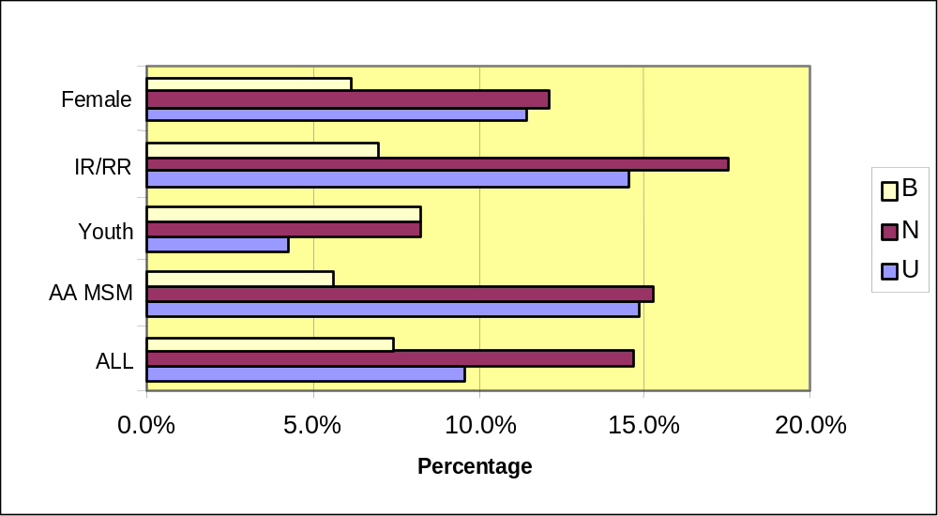

BUDDY/COMPANION SERVICES (continued)

All Respondents:

Status Percent Rank
Use 9.6 55
Need 14.7 47
Barrier 7.4 15
Gap 3.6 14

Special Study Populations:

AA MSM:

Status Percent
Use 14.8
Need 15.3
Barrier 5.6

Incarcerated/Recently Released:

Status Percent
Use 14.5
Need 17.5
Barrier 7.0

Women of Childbearing Age:

Status Percent
Use 11.4
Need 12.1
Barrier 6.1

Youth (age 13 - 24):

Status Percent
Use 4.3
Need 8.3
Barrier 8.3

Central Themes
Across special study populations reported need and gap for Buddy/Companion Services is higher than for the entire survey sample, with the greatest need cited by those who are incarcerated or recently released from jail or prison.

Discussion

Like Houston, the Dallas EMA found that the incarcerated/recently released were most likely to express a need for this service. However, while African American MSM expressed the next highest need, in Dallas this group ranked the need very low. In Newark, companion services were identified as essential for the elderly PLWH/A. In a pilot study, Newark researchers found that those elderly clients with buddy/companions were more likely to adhere to treatment regimens. Also in Newark, a program called “Women Helping Women” guides newly diagnosed Hispanic or Latina women through the service system, and provides them with assistance in overcoming cultural stigma and language barriers.

CHILDCARE

HRSA DEFINITION:
Home- or community-based, non-medical assistance designed to relieve the primary caregiver responsible for providing day-to-day care of the client or the client’s child.

CPCDMS/COMPIS Registration Data

This service did not come online with the CPCDMS until 03/01/02. An estimated 197 clients used Ryan White Title I funded childcare from 03/01/01 through 2/28/02. This represents 0.9 - 1.7% of the estimated 11,051 - 22,706 PLWH/A living in the EMA/HSDA.

All Respondents:

Status Percent Rank
Use 9.7 56
Need 8.1 53
Barrier 5.9 39
Gap 2.7 30

Special Study Populations:

AA MSM:

Status Percent
Use 8.6
Need 5.2
Barrier 4.7

Incarcerated/Recently Released:

Status Percent
Use 11.8
Need 7.0
Barrier 7.9

Women of Childbearing Age:

Status Percent
Use 19.7
Need 11.1
Barrier 6.5

Youth (age 13 - 24):

Status Percent
Use 13.6
Need 20.8
Barrier 8.3

Central Themes
As would be expected, women reported the highest use of childcare services. That Youth indicated the highest need and the highest gap is likely reflective of the fact that the preponderance of that group is young mothers, who may have limited awareness of or resources to secure childcare. Although women in all focus groups discussed childcare as essential for them to access medical and support services as well as employment, many reported that children were being cared for by family members, most often grandmothers and sisters.

Discussion
As was found locally, the needs assessment in Dallas found that women of childbearing age and youth were most likely to report needing childcare. In that study, Hispanic/Latina women were most likely to identify a gap in the service.
CLIENT ADVOCACY/LEGAL SERVICES

HRSA DEFINITION:
Assessment of individual need, provision of advice and assistance obtaining medical, social, community, legal, financial and other needed services. Advocacy does not involve coordination and follow-up on medical treatments.

CPCDMS/COMPIS Registration Data
Although this service was not online in the CPCDMS until 03/01/02, an estimated 799 clients used Ryan White Title I legal services during the one-year period between 3/1/01 through 2/28/02. COMPIS data show that 288 unduplicated clients used TDH State Services legal services during the same time period. These numbers represent 4.8% - 9.8% of the estimated 11,051 - 22,706 PLWH/A living in the EMA/HSDA.

These data represents only those services billed to Titles I, II, IV and State Services. Many services have supplemental funding sources.

Figure 4-14: LEGAL SERVICES/CLIENT ADVOCACY – REPORTED BARRIER (B), NEED (N), USE (U)
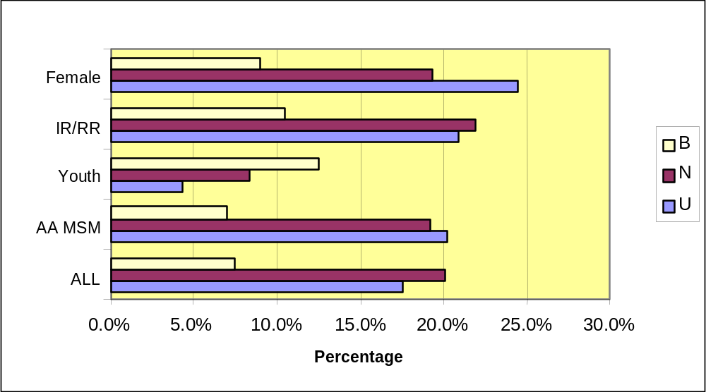
CLIENT ADVOCACY/LEGAL SERVICES (continued)

All Respondents:

Status Percent Rank
Use 17.5 40
Need 20.1 33
Barrier 7.4 14
Gap 2.8 27

Special Study Populations:

AA MSM:

Status Percent
Use 20.2
Need 19.2
Barrier 7.0

Incarcerated/Recently Released:

Status Percent
Use 20.9
Need 21.9
Barrier 10.5

Women of Childbearing Age:

Status Percent
Use 24.5
Need 19.3
Barrier 9.0

Youth (age 13 - 24):

Status Percent
Use 4.3
Need 8.3
Barrier 12.5

Central Themes
Approximately twenty to twenty-five percent of adult respondents indicated use of Client Advocacy services. Although there were no specific discussions in focus groups or explanations in the survey, experience from the community-at-large and comparable EMAs would suggest that clients would require the service for several possible reasons. Among these: immigration concerns, issues related to incarceration (the survey sample included 17% who reported current or recent incarceration), family law situations, probate issues and permanency planning for children.
EMERGENCY FINANCIAL ASSISTANCE

HRSA DEFINITION:
Provision of short-term payments for transportation, food, essential utilities or medication assistance, which planning councils, Title II grantees and consortia may allocate. These short-term payments must be carefully monitored to assure limited amounts, limited use and or limited periods of time. Expenditures must be reported under relevant service category.

CPCDMS/COMPIS Registration Data
CPCDMS and COMPIS data show that 831 unduplicated clients used Ryan White Title I emergency financial assistance and Title II emergency assistance with household items during the one-year period 3/1/01 through 2/28/02. This represents 3.7% - 7.5% of the estimated 11,051 - 22,706 PLWH/A in the EMA/HSDA.

These data represents only those services billed to Titles I, II, IV and State Services. Many services have supplemental funding sources.

Figure 4-15: EMERGENCY FINANCIAL ASSISTANCE – REPORTED BARRIER (B), NEED (N), USE (U)
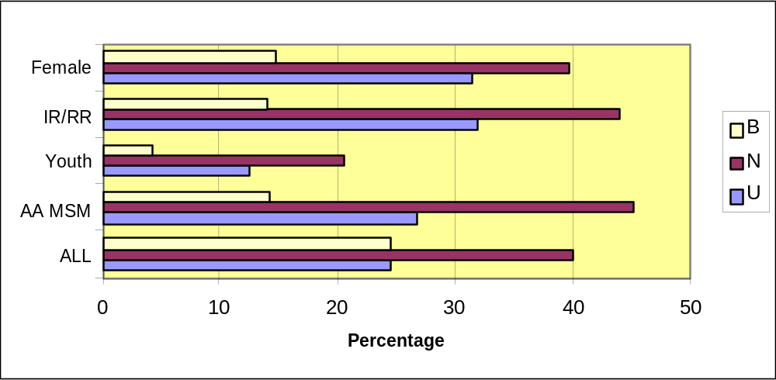
EMERGENCY FINANCIAL ASSISTANCE (continued)

All Respondents:

Status Percent Rank
Use 24.4 27
Need 39.9 8
Barrier 14.4 3
Gap 7.5 1

Special Study Populations:
AA MSM:  Status Percent  Use 26.8  Need 45.1  Barrier 14.1 | Women of Childbearing Age:  Status Percent  Use 31.5  Need 39.6  Barrier 14.6
Incarcerated/Recently Released:  Status Percent  Use 31.8  Need 43.9  Barrier 14.0 | Youth (age 13 - 24):  Status Percent  Use 12.5  Need 20.5  Barrier 4.2

Central Themes
- With the exception of Youth, 26.8 - 31.8 percent of respondents noted use of Direct Emergency Financial Assistance in the entire sample and in the special study groups and as many as 45% designated a need for the service. Further, this service was ranked as the primary gap.
- Throughout each phase of the data collection, respondents raised financial issues directly or in relation to obtaining needed medical or support services, as well as the more basic services such as food, housing and transportation. Respondents were consistent in their linkage of poverty with the potential for compromised health status.
- Data from survey respondents support the assumption that financial issues are central to those served by Ryan White CARE Act providers. When questioned about household income in the last year, respondents indicated that:
- 73% earned less than $10,000 per year
- 90% earned less than $20,000 per year

Discussion
Not surprisingly, this topic emerged in each of the focus groups. At least a third of participants in the older adults focus group mentioned Direct Emergency Financial Assistance as one of their top three needs. Specifically referenced were items such as rent support and assistance with bills.

In the long-term survivors group, all participants mentioned the importance of direct emergency financial assistance and referenced difficulty in obtaining financial assistance, specifically for food or housing. The rural focus group experienced limited access to services. This forced them to use private services, many of which require co-payments. This compromised their access to service.

Among young women with children, the need for financial assistance was mentioned directly in association with medication acquisition, for childcare and to obtain the services that would allow them to achieve self-sufficiency. Disabled respondents each mentioned financial assistance as a significant barrier toward achieving desired health status. They specifically required financial assistance in obtaining medication and housing support.

FOOD BANK/HOME-DELIVERED MEALS

HRSA DEFINITION:
Provision of food, meals or nutritional supplements.

CPCDMS/COMPIS Registration Data
CPCDMS Data show that 2,138 unduplicated clients used Ryan White Title I food services during the one-year period between 3/1/01 - 2/28/02. The services included food bank, meals at a public clinic and nutritional supplement services. Only 1 of the 4 food bank providers was online with CPCDMS during this time. COMPIS data show that 494 unduplicated clients used Ryan White Title II and TDH State Services food pantries during the same time period. These numbers represent 11.6% - 23.8% of the estimated 11,051 - 22,706 PLWH/A in the EMA/HSDA.

These data represents only those services billed to Titles I, II, IV and State Services. Many services have supplemental funding sources.

Figure 4-16: FOOD BANK/HOME DELIVERED MEALS – REPORTED BARRIER (B), NEED (N), USE (U)
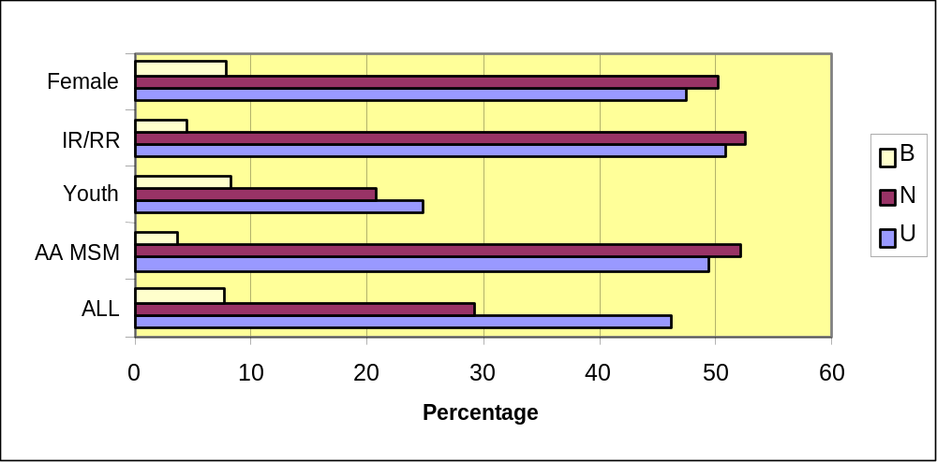
FOOD BANK/HOME-DELIVERED MEALS (continued)

All Respondents:

Status Percent Rank
Use 46.2 8
Need 49.2 2
Barrier 7.7 10
Gap 4.8 6

Special Study Populations:
AA MSM:  Status Percent  Use 49.4  Need 52.2  Barrier 3.8 | Women of Childbearing Age:  Status Percent  Use 47.5  Need 50.2  Barrier 7.9
Incarcerated/Recently Released:  Status Percent  Use 50.9  Need 52.6  Barrier 4.4 | Youth (age 13 - 24):  Status Percent  Use 25.0  Need 20.8  Barrier 8.3

Central Themes
Access to food/meals was ranked second by survey respondents when asked to indicate from a list of services which ones they required. However, respondents ranked food first when asked to list their 10 most pressing needs. Approximately half of the entire sample (all respondents) and half of the adults in the special study populations cite food as a need.

- Among PLWH/As who take antiretroviral drugs, concerns were raised about the relationship between nutrition and treatment side effects, especially those related to digestion.

Discussion
Focus group participants consistently discussed the need for food and/or prepared meals. Those who frequented food pantries voiced distress about:
- Long lines and waits, experienced by many respondents in obtaining food;
- Limited access to fresh produce and meat;
- Little or no access to cultural food;
- Inconsistencies in volume of food available; and
- Inconsistencies in the quality of food available

Respondents stated that they needed to access more than one pantry to obtain sufficient food, especially if they had young children or were pregnant; had been treated for an extended time with antiretroviral medicine or were experiencing comorbidities, especially diabetes, heart disease and kidney disease. PLWH/A noted with appreciation that service providers often overlooked the restriction of limiting access to one agency and allowed respondents to use multiple food pantries.

Numerous discussions in focus groups stressed that residents of the outlying regions of the EMA/HSDA were particularly vulnerable to food shortages, as the following passages illustrate.
“Those pantries are all around Southwest Houston. They don’t hardly have any service on the North side or East. The Fifth Ward could use one.” (Young female client)
“If you are outside the Beltway, you can buy whatever you want for $70 every week and you go to a supermarket.” (Rural client-North)
HEALTH EDUCATION/RISK REDUCTION (HE/RR)

HRSA DEFINITION:
Provision of information, including information dissemination about medical and psychosocial support services and counseling or preparation/distribution of materials in the context of medical and psychosocial support service to educate clients with HIV about methods to reduce the spread of HIV.

CPCDMS/COMPIS Registration Data
CPCDMS data show that 129 unduplicated clients use Ryan White Title I health education/risk reduction services during the one-year period of 3/1/01 through 2/28/02. However, only 2 of 4 health education/risk reduction providers and 1 of 2 peer counseling providers were online with CPCDMS during the time.

These data represents only those services billed to Titles I, II, IV and State Services. Many services have supplemental funding sources.

Figure 4-17: HEALTH EDUCATION – REPORTED BARRIER (B), NEED (N), USE (U)
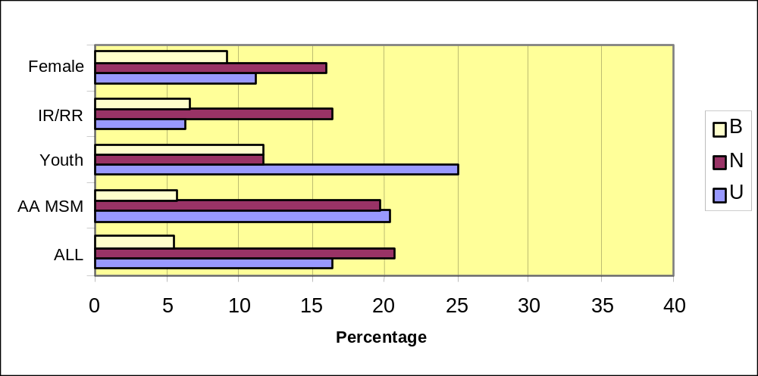

HEALTH EDUCATION/RISK REDUCTION (HE/RR) (continued)

All Respondents:

Status Percent Rank
Use 17.2 41
Need 21.4 31
Barrier 6.5 28
Rank 2.5 35

Special Study Populations:

AA MSM:

Status Percent
Use 20.9
Need 19.4
Barrier 6.3

Incarcerated/Recently Released:

Status Percent
Use 15.5
Need 16.7
Barrier 7.0

Women of Childbearing Age:

Status Percent
Use 12.9
Need 17.0
Barrier 8.2

Youth (age 13 - 24):

Status Percent
Use 25.0
Need 12.5
Barrier 12.5

Central Themes
- Respondents’ indicated the importance of educating the general community about HIV/AIDS. Specifically mentioned were prevention, risk factors, treatment and resources. Key channels are churches, media, and community leaders.
- For 80% of survey respondents, health care providers were cited as the primary source of information about HIV and services. No other consistent source of information was reported though the Internet is mentioned as a fast-growing source of knowledge.
- The study indicates that participants want more information from and for physicians about comorbidities related to antiretroviral therapy and HIV/AIDS, and to potential conditions that are unrelated to either medication or HIV.
- 34.5% of respondents indicated that they were unable to access the service because they did not know it was available.

Discussion
- Focus group participants, particularly women, were firm in their opinion that health education, specifically HIV prevention and risk reduction were essential not only to them, but their families and their communities.
- Respondents stated that prevention education is necessary to both prevent HIV/AIDS and also to educate their community to achieve acceptance of the disease.
- Sociocultural-specific education is required to dispel myths about the causes and transmission of HIV/AIDS.
- Young women specifically requested more patient education about their disease and its impact upon their children. They believed that their physicians did not offer sufficient information.
- Older adults stated that they used the Internet regularly to access patient education and were often more aware of comorbidity and medication interaction than their physicians.
“I sell sex, I do drugs… I am having sex without condoms. I don’t like them. I like the [descriptor for unprotected anal sex] action.” (RARE Interview)
“I’ve been out of jail for a month and a half now. I’ve turned tricks since then. I haven’t [descriptor for using IV drugs] or anything like that. My tricks are low risk, it depends, I do it for money, for food… I always categorize my behaviors as low risk.” (RARE Interview)
“We did studies to educate our area and one of our main concerns was the lack of knowledge and ignorance. The more information you get out to the community, the better people deal with stuff. There are family members that are not able to deal well with us because they don’t know better—that is very uncomfortable.” (Rural client)
“I have lived in other cities, and Houston (and Texas) are terrible in not publicizing where to go to get care or be diagnosed for HIV. It is as if they believed that by not talking about it, it will go away—this kind of mass neglect is shameful. (Disabled client)
“In other cities and even in Puerto Rico and Mexico you see big billboards on major streets and on buses telling you really specific things about how to get HIV-related care, how to get condoms and where to go to get help. This can’t do anything but take the stigma away from a disease that nobody seems to want to talk about. Without talking about it, there can be no real education.” (Long-Term Survivor)
“If you are a male and you are positive, the chances of getting it from a female are so statistically low, unless you’re really kinky like I am, there’s no way. I got it from a female, from my first wife, ‘cause we played heavy… you’re pretty much dooming yourself, but I was also bisexual and sleeping with men.”

HEALTH INSURANCE PAYMENTS

CPCDMS/COMPIS Registration Data
CPCDMS and COMPIS data show that 248 unduplicated clients used Ryan White Titles I & II health insurance deductible/co-pay payments services during the one-year period of 3/1/01 through 2/28/02. This represents 1.1% - 2.2% of the estimated 11,051 - 22,705 PLWH/A in the EMA/HSDA.

These data represents only those services billed to Titles I, II, IV and State Services. Many services have supplemental funding sources.

All Respondents:

Status Percent Rank
Use 15.7 45
Need 24.2 26
Barrier 12.4 4
Gap 5.3 4

Special Study Populations:

AA MSM:

Status Percent
Use 19.2
Need 27.0
Barrier 12.6

Incarcerated/Recently Released:

Status Percent
Use 22.7
Need 27.2
Barrier 12.3

Women of Childbearing Age:

Status Percent
Use 17.2
Need 24.2
Barrier 16.2

Youth (age 13 - 24):

Status Percent
Use 4.2
Need 16.7
Barrier 8.3

Central Themes
Respondents voiced that a strong gap (#4) existed between need and need being met for health insurance payment despite low use and need rankings.

Discussion
Respondents asserted that the most significant barrier was the progressive increase in required co-payments and a more rigorous enforcement of collection. Escalating medical costs and termination of commercial and COBRA insurance have caused some populations to experience a more pressing barrier (AA MSM, for example) while others are confronted with eligibility changes in payors or services (Young Women, age 15 - 24). According to focus group respondents:
“When I first went to (provider), they said that whatever Medicare did not pay for, Ryan White would pick up. But then they’re constantly sending you bills and enormous bills. $5.00 each time you go to the doctor, $3.00 for each prescription.” (Long-Term Survivor)
“I actually wanted to see (a different) physician—but I have to go to (provider) because of the limitations on medications. With all the medications I take, I have to have both—it makes no sense to me. It’s a real headache and hassle and it’s also caused me medical problems.” (Rural client - North)

HOUSING ASSISTANCE

(See Chapter 5 for a thorough discussion of Housing Assistance)

HRSA DEFINITION:
This assistance is limited to short-term or emergency financial assistance to support temporary and/or transitional housing to enable the individual or family to gain and/or maintain medical care. Use of Titles I, II and IV funds for short-term or emergency housing must be linked to medical and/or health-care services or be certified as essential to a client’s ability to gain or maintain access to HIV-related medical care or treatment.

CPCDMS/COMPIS Registration Data
CPCDMS data show that 717 unduplicated clients used Ryan White Title I housing assistance services and 377 unduplicated clients used Title I housing coordination services during the one-year period between 3/1/01 and 2/28/02. COMPIS data show that 34 unduplicated clients used TDH State Services short- and long-term housing assistance. These numbers represent 5.0% - 10.2% of the estimated 11,051 - 22,706 PLWH/A in the EMA/HSDA. However, many PLWH/A use housing service such as the facilities and programs funded by Housing Opportunities For Persons with AIDS (HOPWA) that are not funded by either Title I or Title II.

These data represents only those services billed to Titles I, II, IV and State Services. Many services have supplemental funding sources.

Figure 4-18: HOUSING ASSISTANCE – REPORTED BARRIER (B), NEED (N), USE (U)
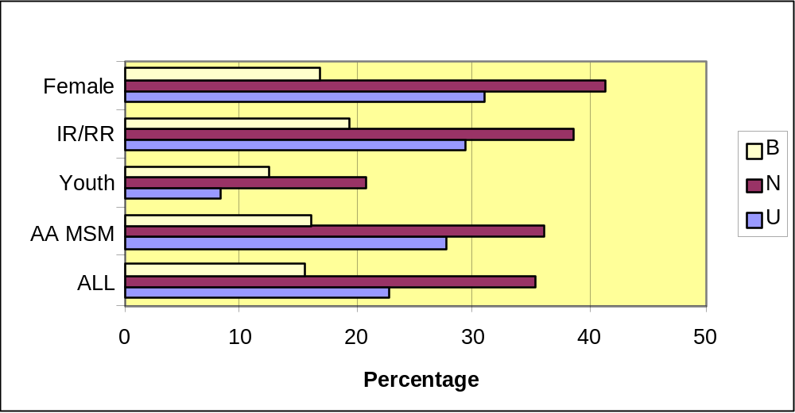

HOUSING ASSISTANCE (continued)

All Respondents:

Status Percent Rank
Use 22.9 31
Need 35.4 12
Barrier 15.6 2
Gap 6.9 2

Special Study Populations:

AA MSM:

Status Percent
Use 27.7
Need 36.1
Barrier 16.1

Incarcerated/Recently Released:

Status Percent
Use 29.4
Need 38.6
Barrier 19.3

Women of Childbearing Age:

Status Percent
Use 30.9
Need 41.4
Barrier 16.9

Youth (age 13 - 24):

Status Percent
Use 8.3
Need 20.8
Barrier 12.5

Discussion

Respondents indicated that they were unclear about the meaning of the terms “Housing versus Housing Assistance”. The definitions supplied by the facilitators did not help clarify the distinction between these terms
HOUSING
(See Chapter 5 for a thorough discussion of Housing)

Figure 4-19: HOUSING RELATED SERVICES – REPORTED BARRIER (B), NEED (N), USE (U)
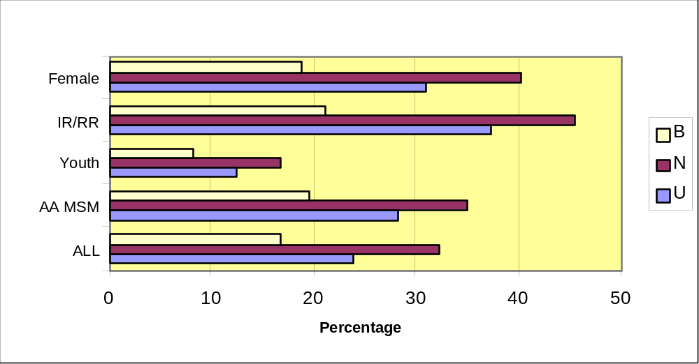

All Respondents:

Status Percent Rank
Use 23.9 28
Need 32.3 15
Barrier 16.8 1
Gap 4.4 7

Special Study Populations:

AA MSM:

Status Percent
Use 28.3
Need 35.0
Barrier 19.5

Incarcerated/Recently Released:

Status Percent
Use 37.3
Need 45.6
Barrier 21.1

Women of Childbearing Age:

Status Percent
Use 30.9
Need 40.3
Barrier 18.9

Youth (age 13 - 24):

Status Percent
Use 12.5
Need 16.7
Barrier 8.3

Discussion

Respondents indicated that they were unclear about the meaning of the terms “Housing versus Housing Assistance”. The definitions supplied by the facilitators did not help clarify the distinction between these terms
INTERPRETER SERVICES

TDH DEFINITION:
Provision of interpreter services for medical and social service appointments for persons living with HIV/AIDS who are deaf/hard-of-hearing or monolingual.

CPCDMS/COMPIS Registration Data
COMPIS data show that 37 unduplicated clients used TDH State Services interpretation services. These numbers represent 1.6% - 3.3% of the estimated 11,051 - 22,706 PLWH/A in the EMA/HSDA.

These data represents only those services billed to Titles I, II, IV and State Services. Many services have supplemental funding sources.

Figure 4-20: INTERPRETER SERVICES – REPORTED BARRIER (B), NEED (N), USE (U)
0.0%
2.0%
4.0%
6.0%
8.0%
10.0%
12.0%
14.0%
ALL
AA MSM
Youth
IR/RR
Female
B
N
U

INTERPRETER SERVICES (continued)

All Respondents:

Status Percent Rank
Use 8.7 80
Needs 9.7 80
Barriers 6.8 26
Gaps 1.9 80

Special Study Respondents:
AA MSM:  Status Percent  Use 9.0  Need 5.1  Barrier 6.3 | Women of Childbearing Age:  Status Percent  Use 12.8  Need 12.6  Barrier 9.5
Incarcerated/Recently Released:  Status Percent  Use 11.8  Need 7.0  Barrier 7.9 | Youth (age 13 - 24):  Status Percent  Use 8.3  Need 4.2  Barrier 12.4

Central Themes
- As immigration patterns in the region have continued to shift from primarily Latin nations, so have the range of translation services. While the need for Spanish translators continues, there is increasing need for translation services from Asian and African nations.
- Youth reported the highest barriers to translation though use was much more pronounced among females and the incarcerated/recently released.

Discussion
In a focus group conducted for providers of services to immigrants and/or refugees, participants expressed concerns about the severe consequences that language barriers pose for their clients in gaining access to services, understanding the facts related to the course of HIV and comprehending and following treatment regimens. While many immigrants recruit bilingual family members friends to assist them, this is no longer the norm. The providers added that especially among African immigrants and refugees, a cultural code of privacy with respect to personal issues and misunderstanding and shame about HIV status, causes many not only to refrain from enlisting their own contacts, but also to decline a translator appointed by the provider because of fear of exposure to someone from the client’s community. The challenge is magnified when clients seek services from providers who do not regularly assist non-English speaking clients.

Even when a client is willing to permit a translator, the community is often faced with the situation of not finding anyone capable of performing the service. This is especially true of African and Asian immigrants.

Clients validated the perceptions of providers. Language and cultural barriers were mentioned in several focus groups, most often by female participants. In one discussion, participants emphasized that even when interpreters are available and the client permits their involvement, the challenges of presenting complex medical information in a manner that is comprehensible can be insurmountable.

Providers of services to immigrants and refugees described the challenges they face. Immigrants from Africa are especially burdened by codes of secrecy about their HIV status. These immigrants often refuse to allow access to translators from their community for fear of disclosure and the consequences of such exposure.

OUTREACH SERVICES

HRSA DEFINITION:
Programs that have as their principal purpose identifying people with HIV disease so that they may become aware of and may be enrolled in care and treatment services. Outreach services do not include HIV counseling and testing or HIV-prevention education. Outreach service programs must be planned and delivered in coordination with local HIV-prevention outreach programs to avoid duplication of effort, be targeted to populations known through local epidemiological data to be at disproportionate risk for HIV infection, be conducted at times and in places where there is a high probability that individuals living with HIV/AIDS will be reached, and be designed with quantified program reporting that will accommodate local effectiveness evaluation. Broad marketing of the availability of healthcare services for PLWH/A should be prioritized and funded as Planning Council or Consortium supported activities.

CPCDMS/COMPIS Registration Data
CPCDMS and COMPIS data show that 390 unduplicated out-of-care clients were reached through Ryan White Titles I & II outreach services during the one-year period of 3/1/01 through 2/28/02. This represents 1.7% - 3.5% of the estimated 11,051 - 22,706 PLWH/A in the EMA/HSDA.

These data represents only those services billed to Titles I, II, IV and State Services. Many services have supplemental funding sources.

Figure 4-21: OUTREACH SERVICES – REPORTED BARRIER (B), NEED (N), USE (U)
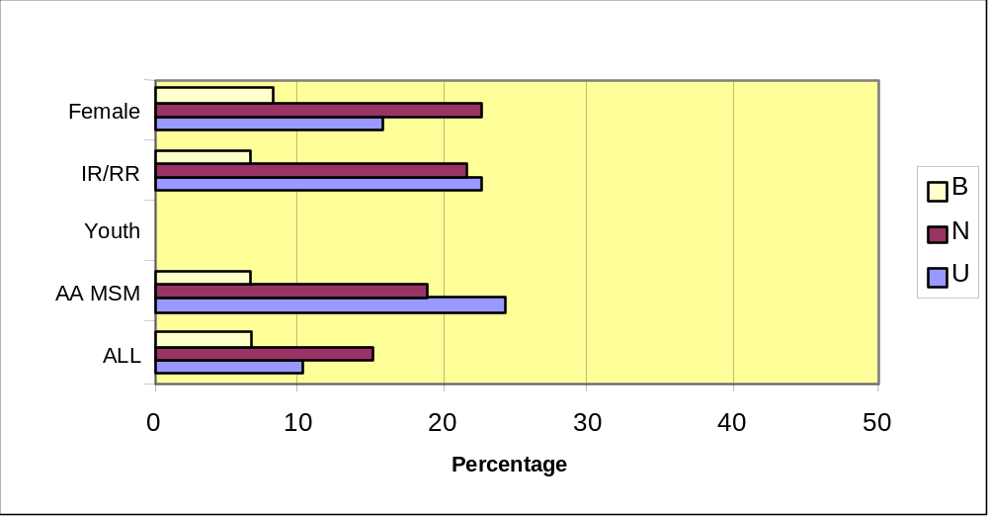
OUTREACH SERVICES (continued)

All Respondents:

Status Percent Rank
Use 10.6 79
Need 15.2 46
Barrier 6.2 34
Gap 3.6 16

Special Study Populations:
AA MSM:  Status Percent  Use 24.2  Need 18.2  Barrier 6.1 | Women of Childbearing Age:  Status Percent  Use 15.8  Need 22.2  Barrier 8.7
Incarcerated/Recently Released:  Status Percent  Use 22.7  Need 21.9  Barrier 6.1 | Youth (age 13 - 24):  Status Percent  Use NA  Need NA  Barrier NA

Central Themes
- Providers indicated that while several agencies offer street outreach, they suggested that improvements might include clearer information about which services were available at each agency and what follow-up services could be provided.
- Despite low use and gap statistics, the survey respondents ranked need at the mid-range and barriers in the top half.
- Clients report a lack of coordination among providers of Outreach services. Outreach is funded by several sources; in some areas there are many outreach workers but in others there are none.

Discussion
Although outreach was not a topic that emerged from the focus groups, street interview respondents were quite familiar with the service and many acknowledged multiple contacts with workers. They identified a range of services provided by outreach workers including: condom distribution, Orasure testing and brochure distribution. They reported that the workers are accessible and generally informed. Respondents recommended that there be more consistent dates, places and services offered, especially in bars.
“They (provider) have people in here a lot. Only problem is they change days, times. They tend to go to the same bar, but they need to be here from Thursday through Saturday nights, when it is hopping. They also need to establish a pattern of us knowing when they’ll be here.” (RARE interview)
REFERRAL

HRSA DEFINITION:
The act of directing a person to a service in person or through telephone, written or other type of communication. Referral may be made formally from one clinical provider to another, within a case management system by professional case managers or informally through support staff or as part of an outreach services program.

The survey instruments did not list this service as one where respondents were asked about use, need, barrier or gaps. Referral information is inferred from respondents answer to the question, “When you found out you were HIV positive, were you referred for any of the following services?” (Question 30b of the survey instrument.)

Central Themes
Respondents indicated that at the time of diagnosis the following referrals were made:
- 46.7% - Medical care for HIV
- 31.7% - Case Management
- 14.7% - Mental Health services
- 13% - for other medical condition
- 13% - for Substance Abuse treatment/counseling

These percents add to more than 100% due to multiple referrals.
TRANSPORTATION
(See Chapter 5 for a detailed analysis of Transportation)

HRSA DEFINITION:
Conveyance services provided to a client in order to access health care or psychosocial support services. May be provided routinely or on an emergency basis.

CPCDMS/COMPIS Registration Data
CPCDMS and COMPIS data show that 1,462 unduplicated clients used Ryan White Titles I & II transportation services during the one-year period between 3/1/01 and 2/28/02. COMPIS data show an additional 66 unduplicated clients used Title IV transportation services. These numbers represent 6.7% - 13.8% of the estimated 11,051 - 22,706 PLWH/A in the EMA/HSDA.

These data represents only those services billed to Titles I, II, IV and State Services. Many services have supplemental funding sources.

Figure 4-22: TRANSPORTATION – REPORTED BARRIER (B), NEED (N), USE (U)
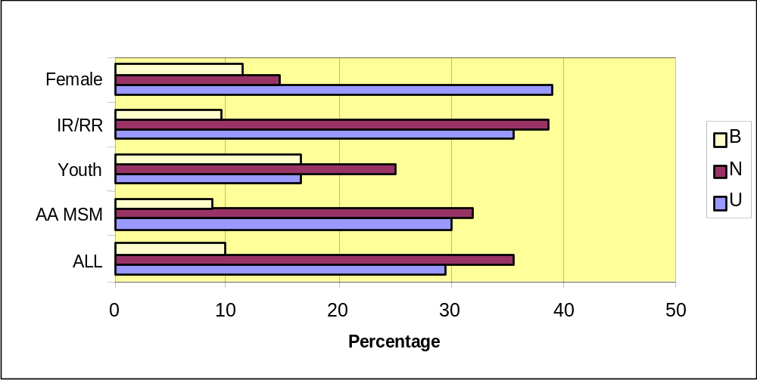
TRANSPORTATION (continued)

All Respondents:

Status Percent Rank
Use 29.5 18
Need 35.5 11
Barrier 9.9 6
Gap 4.4 8

Special Study Populations:
AA MSM:  Status Percent  Use 30.0  Need 31.9  Barrier 8.6 | Women of Childbearing Age:  Status Percent  Use 39.0  Need 14.6  Barrier 11.4
Incarcerated/Recently Released:  Status Percent  Use 35.5  Need 38.6  Barrier 9.6 | Youth (age 13 - 24):  Status Percent  Use 16.7  Need 25.0  Barrier 16.7

Central Themes
Transportation was cited in all focus groups as a significant barrier to access to medical and support services. It was specifically strong in the focus groups with Disabled, Rural, Older Adults and Young Women with Children.

Discussion
According to participants, difficulties with Title I funded transportation services continue to impact client ability to access a range of services. The specifics of those limitations are illustrated in the following analysis of the client survey.

The percent of clients who responded that it is difficult to get to:
- Childcare from their house - 25.8%
- Transportation from their house - 23.9%
- Basic services - 23%
- Social services - 21%
- Medical services - 20.8%
The extent of the impact of transportation challenges on care access is manifested in the following analysis of client survey responses:
- 31.7% of survey participants responded that they missed between 1 and 5 medical appointments.
- 9% missed more than 5 medical appointments within a year due to transportation concerns.
- 28% missed 1 - 5 non-medical service appointments.
- 9% more than 5 non-medical service appointments due to transportation issues.
DENTAL CARE

HRSA DEFINITION:
Diagnostic, prophylactic and therapeutic services rendered by dentists, dental hygienists and similar professional practitioners.

Individual Services
Dental Care is a service category with no individual services.

CPCDMS/COMPIS Registration Data
CPCDMS data show 1,115 unduplicated clients used Ryan White Titles I & II oral health care services during the seven-month period between 8/1/01 through 2/28/02. (The service came online with CPCDMS in 8/01). COMPIS data show that an additional 40 unduplicated clients used Title II oral health care services during the one-year period between 3/1/01 and 2/28/02. These numbers represent 4.9% - 10.1% of the estimated 11,051 - 22,706 PLWH/A in the EMA/HSDA.

These data represents only those services billed to Titles I, II, IV and State Services. Many services have supplemental funding sources.

Figure 4-23: DENTAL CARE – REPORTED BARRIER (B), NEED (N), USE (U)
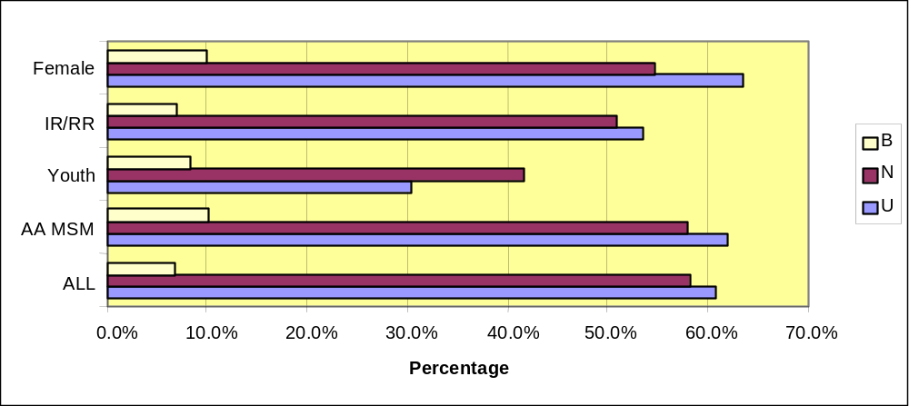
DENTAL CARE (continued)

All Respondents:
Status Percent Rank
Use 67.1 4
Need 58.1 3
Barrier 7.0 9
Gap 3.4 14

Special Study Populations:
AA MSM:  Status Percent Rank  Use 73 4  Need 82 1  Barrier 10 5  Gap 4 15 | Women of Childbearing Age:  Status Percent Rank  Use 64 6  Need 71 1  Barrier 9 11  Gap 4 13
Incarcerated/Recently Released:  Status Percent Rank  Use 59 7  Need 67 1  Barrier 6 15  Gap 3 13 | Youth (age 13 - 24):  Status Percent Rank  Use 38 7  Need 38 1  Barrier 9 6  Gap 10 5

Central Themes
- As is evident by the use and need statistics among all survey respondents, special study populations and focus group findings, dental care access is a significant concern. Respondents frequently articulated their understanding of their increased vulnerability to conditions such as thrush (oral candidiasis), cavities (dental caries) and the secondary and systemic effect these conditions have on their general health.
- Populations eligible for Ryan White funding have often been Medicaid clients prior to HIV infection. Many individuals from this group have poor oral health due to continued lack of dental services by Medicaid and thus, have more urgent need for dental care when they enter the HIV continuum of care system.
- The interplay of access to transportation, perception of limited choices of provider and client understanding of scheduling policies were reported by respondents to present a significant barrier to care.

Discussion
Of the discussions that emerged in focus groups, those about Dental Care resulted in the clearest expressions of barriers to access. Many respondents commented on the complexity that providers face in their attempts to provide such a high-demand service and several even articulated the necessity for policies such as block scheduling (assigning several clients to arrive at the clinic the same time, rather than to a more specific appointment), as a means of addressing individuals who arrive late for or miss appointments. Despite this, they reported that they experienced these policies as punitive, since they attributed the reasons for late arrival or missed appointment to transportation difficulties, that they report are beyond their control. This was most true for mothers, especially young mothers and for rural clients, as the following quotes indicated:
“When you’re on block time—the only advantage to block time is that you can defer which block time you want. For us rural folks it’s always the 9 a.m.—of course you’re penalized because you’re rural.” (Rural client - North)
“There’s no dental, you have to go downtown to get that. I haven’t accessed dental care in over 3 years because I don’t want to go down there and deal with it.” (Rural client - North)

Providers of dental services noted that use of prostodontic (ex. partial dental plate, denture) services has been increasing since funding of these services began in 1993. Increases in funding are expected to result in further client demand for these services but will also tend to further stress the system of care.

Although it is illegal in Texas to discriminate against people with HIV/AIDS, participants described another barrier as the perception by clients and some dentists that Texas law supports dentists who refuse care to PLWH/As. Although it is illegal to discriminate against PLWH/A, several respondents reported concerns that they would not have access to care because of their HIV status, as the following illustrates:
“In Texas, a dentist does not have to work with you if you have HIV. They’re allowed to refuse that—our doctors out here don’t want to see us. It’s hell when dental and eye services locally are denied us.” (Rural client - North)
SUBSTANCE ABUSE TREATMENT/COUNSELING

HRSA DEFINITION:
Provision of treatment and/or counseling to address substance abuse (including alcohol) problems, provided in an outpatient or residential health service setting.

Individual Services
Substance Abuse Treatment
Substance Abuse Counseling

CPCDMS/COMPIS Registration Data
CPCDMS and COMPIS data show that 45 unduplicated clients used Ryan White Title I and TDH State Services substance abuse treatment services during the one-year period 3/1/01 through 2/28/02. This represents .20% - .41% of the estimated 11,051 - 22,706 PLWH/A in the EMA/HSDA. However, most PLWH/A use substance abuse services such as the facilities and programs funded by the Texas Commission on Alcohol and Drug Abuse (TCADA) that are not funded by Ryan White or TDH State Services.

These data represents only those services billed to Titles I, II, IV and State Services. Many services have supplemental funding sources.

Figure 4-24: SUBSTANCE ABUSE TREATMENT & COUNSELING – REPORTED BARRIER (B), NEED (N), USE (U)
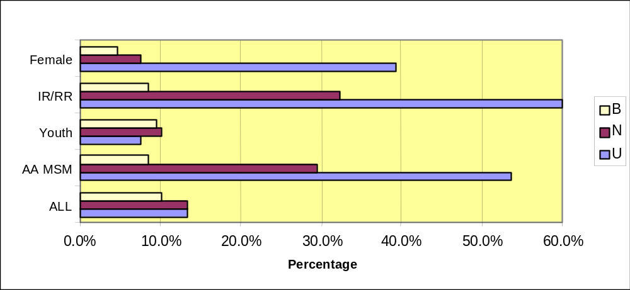
SUBSTANCE ABUSE TREATMENT/COUNSELING (continued)

All Respondents:

Status Percent Rank
Use 36.7 13
Need 22.2 13
Barrier 6.0 10
Gap 0.7 79

Special Study Populations:
AA MSM:  Status Percent Rank  Use 54 11  Need 29 11  Barrier 8 15  Gap 5 14 | Women of Childbearing Age:  Status Percent Rank  Use 39 11  Need 7 13  Barrier 4 17  Gap 1 16
Incarcerated/Recently Released:  Status Percent Rank  Use 66 4  Need 32 7  Barrier 8 8  Gap 2 17 | Youth (age 13 - 24):  Status Percent Rank  Use 7 13  Need 10 9  Barrier 9 7  Gap 0 0

Central Themes
- Alcohol and drug use were extensive among survey respondents.
- 37% of survey respondents reported using drugs and/or alcohol within the past 6 months, 26% injected substances in the past and 33% had been in substance abuse treatment.
- While 36.7% of the survey respondents indicated that they have participated in substance abuse counseling or treatment and 22% attest to the need for the services, gap ranking is 79th of 80, despite the perceptions of barriers to the service.
- Substance use was reported in each of the focus groups and in all street outreach interviews. Respondents were very clear that substance use was a significant contributor to HIV risk behavior and a deterrent to medication adherence.
- Incarcerated individuals in surveys and in focus groups reported higher levels of substance use than any other subset of respondents. (See Chapter 12, Special Study: Incarcerated/Recently Released)
- Individuals with self-identified substance abuse difficulties also reported current high-risk behaviors.
- Access to safe and affordable housing was cited frequently in focus groups as an essential condition to recovery from substance abuse.

Discussion
In addition to alcohol, survey respondents reported use of the following substances:
- Cocaine - powder form of the drug
- Crack - a crystalline form of cocaine
- Heroin - a very addictive depressant
- Crystal (methamphetamine) - a stimulant
- Speedball - a mixture of cocaine and heroin or amphetamines and heroin

Figure 4-25 below shows the percentage of respondents using these substances.

Figure 4-25: PERCENT OF SURVEY RESPONDENTS USING SUBSTANCES
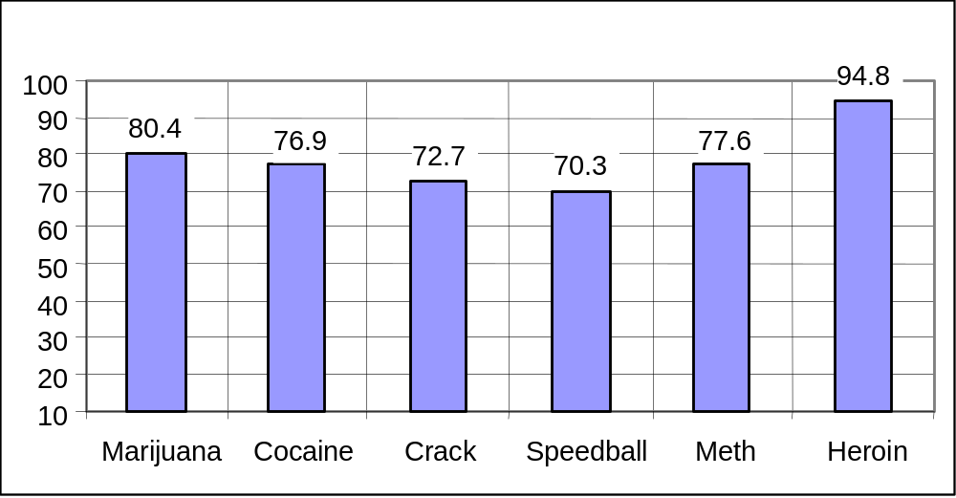
From 70% to almost 95% of survey respondents, who report using these substances, also use alcohol, as shown in Figure 4-26.

Figure 4-26: PERCENT OF SURVEY RESPONDENTS USING SUBSTANCES & ALCOHOL
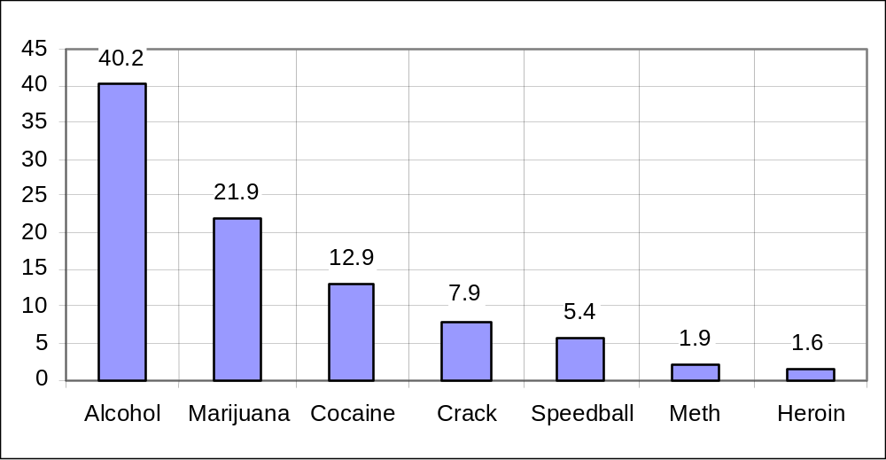
Throughout the RARE interviews and focus groups, participants were very clear about the relationship between substance use and the range of HIV risk behaviors. The passage that follows reflects the stated opinion and experience of several participants.

“Any type of drug use will make it so your decision process is tampered with, so it causes you to do things that make you privy to catching HIV—a lot of them don’t even know they’re taking risks, to be honest. If they’re on drugs, they don’t have inhibitions and they really don’t care when they’re under the influence of drugs, that’s the last thing on their mind—they’re not thinking about catching HIV.” (RARE interview)

Two consistent themes emerged from the qualitative data about barriers to substance abuse recovery: housing and support. Participants stressed the importance of living in areas that are safe and sheltered from overt drug-related behaviors. Current self-identified substance users indicated that finding and retaining housing are among the most pressing of their challenges. Several examples follow:
“If there is one thing I’d want it is a decent place to live. It is very hard to stay clean when you’re in a neighborhood full of junkies.” (Disabled client)
“The location of halfway houses is not helpful. They are in drug-infested neighborhoods. This makes it very hard to recover. The success rates of the houses need to be checked.” (Substance user)
“As part of my rehabilitation for drugs, I was given a nice efficiency and wish that could happen again, though I don’t want to ever get addicted again.” (Substance user)
“I wish I could live in a better place—the area I live in makes it very easy to slide back into bad habits. It is not just a matter of having better housing—it is the environment that shapes your whole existence.” (Substance user)

The rates of substance abuse counseling and treatment were very striking among the incarcerated/recently-released population. Their reported use of and need for the services was higher than the rate of the entire sample and also for any of the special study populations. It is noteworthy that all of the women who participated in the focus group for incarcerated individuals indicated that they were in prison for substance abuse offenses.
“There’s a big need for substance abuse counseling for people getting out of prison. 85% of the people in the penitentiary have drug or alcohol problems.” (Long-Term Survivor)

“Support is important too. I was a drug user and that’s how I got HIV. I got really sick from injecting drugs and was diagnosed with HIV.” (Incarcerated woman)

Several participants, because they receive a disability check, identified themselves as “financially disabled”.
1 NOTE: Interpretation of data for Hospice, Home Health Care and Adult Day Care is limited by 2 factors: 1- the population surveyed was primarily ambulatory and relatively healthy; 2- the questions on the survey were inadequate to accurately assess the need for these services.
NOTE: Interpretation of data for Hospice, Home Health Care and Adult Day Care is limited by 2 factors: 1- the population surveyed was primarily ambulatory and relatively healthy; 2- the questions on the survey were inadequate to accurately assess the need for these services.
NOTE: Interpretation of data for Hospice, Home Health Care and Adult Day Care is limited by 2 factors: 1- the population surveyed was primarily ambulatory and relatively healthy; 2- the questions on the survey were inadequate to accurately assess the need for these services.

