DRUG REIMBURSEMENT PROGRAM

HRSA DEFINITION:
Ongoing service/program to pay for approved pharmaceuticals/medications for persons with no other payment source. Subcategories include:
State-Administered Drug Reimbursement Program: Title II CARE Act-funded and administered program or other state-funded Drug Reimbursement Program;
Local/Consortium Drug Reimbursement Program: A program established, operated and funded locally by a Title I EMA or a consortium to expand the number of covered medications available to low income patients and/or to broaden eligibility beyond that established by a State-operated Title II or other State-funded Drug Reimbursement Program.

CPCDMS/COMPIS Registration Data
CPCDMS and COMPIS data show that 1,941 unduplicated clients used Ryan White Titles I/State drug reimbursement services during the one-year period of 3/1/01 through 2/28/02. This represents 8.5% - 17.6% of the estimated 11,051 - 22,706 PLWH/A in the EMA/HSDA. However, many clients participate in medication reimbursement programs such as the State of Texas AIDS Drug Assistance Program (ADAP).

These data represents only those services billed to Titles I, II, IV and State Services. Many services have supplemental funding sources.

Drug Reimbursement Program (continued)

All Respondents:

Status Percent Rank
Use 62.6 6
Need 50.1 5
Barrier 8.0 8
Gap 5.9 12

Special Study Population

AA MSM:

Status Percent Rank
Use 57 10
Need 47 5
Barrier 7 16
Gap 8 13

Incarcerated/Recently Released:
Status Percent Rank
Use 54 10
Need 50 3
Barrier 5 17
Gap 8 10

Women of Childbearing Age:
Status Percent Rank
Use 62 7
Need 40 5
Barrier 7 14
Gap 5 12

Youth (age 13 – 24):
Status Percent Rank
Use 49 3
Need 0 0
Barrier 5 16
Gap 10 6

MEDICATIONS/PHARMACY

Figure 4-27: MEDICATIONS/PHARMACY – REPORTED BARRIER (B), NEED (N), USE (U)
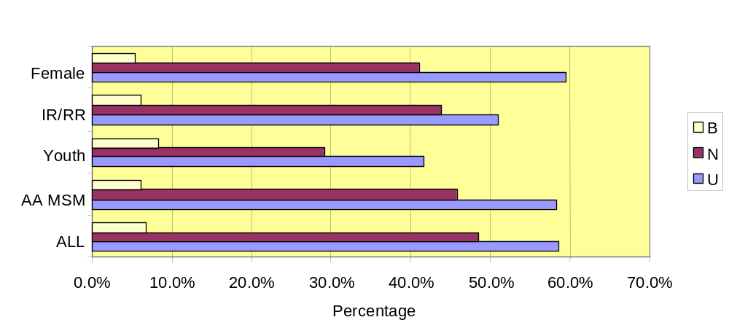

All Respondents:

Status Percent Rank
Use 58.4 3
Needs 48.4 3
Barrier 6.8 25
Gaps 2.5 39

Special Study Populations:
AA MSM:  Status Percent  Use 58.3  Need 45.9  Barrier 6.1 | Women of Childbearing Age:  Status Percent  Use 59.5  Need 41.1  Barrier 5.4
Incarcerated/Recently Released:  Status Percent  Use 50.9  Need 43.9  Barrier 6.1 | Youth (age 13 - 24):  Status Percent  Use 41.7  Need 29.2  Barrier 8.3

Central Themes
- Drug Reimbursement was ranked by survey respondents as a high-use, high-need service. This was validated by focus group participants who stressed the importance of access to medication, which they specified to be access to drug reimbursement, in each of the groups.
- Nearly one-half of survey respondents reported using the TDH HIV Medication Program or AIDS Drug Assistance Program (ADAP) (47.5%).
- An anticipated shortfall in funding for programs such as ADAP is expected to adversely impact local communities.

Discussion
As illustrated in Figure 6, the pattern of use of Drug Reimbursement is similar among the special study populations. TDH or ADAP are the most commonly used and with the exception of African American MSM, private insurance is the least likely source. The highest rate of private insurance across all populations and the entire sample is by African American MSM.

Figure 4-28: DRUG REIMBURSEMENT USE
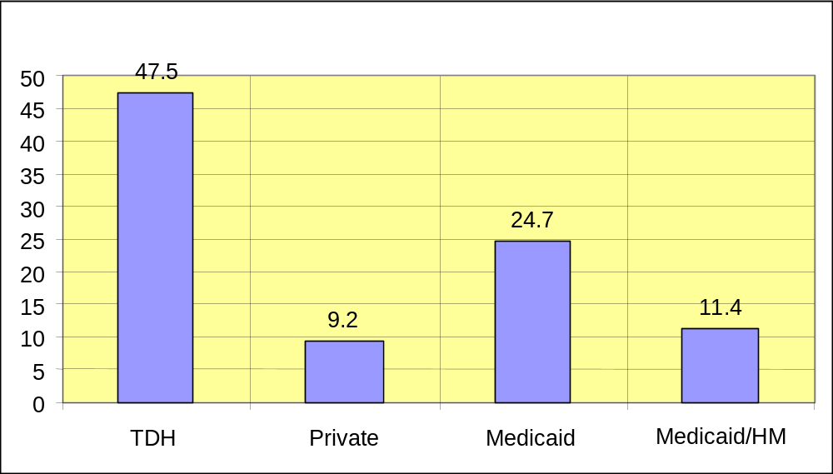
Of the survey sample, 62% indicated that they are treated with antiretroviral medications. Respondents also reported use of a range of other prescriptions medications, frequently associated with treatment of HIV-related conditions. These include:

- 33.5% antibiotics
- 29.6% antidepressants
- 19.2% antifungals
- 12.5% steroid
- 21.6% other, not specified

Survey respondents assigned a low barrier ranking of 12 (out of 17 categories) to this service and several focus group participants detailed those barriers. The most commonly cited barrier was eligibility. Other barriers discussed were:
- Co-payments that are considered to be excessive
- Lack of adequate coverage for drugs not directly related to HIV

Particular challenges were faced by those currently incarcerated or recently released. Both those interviewed in prison focus groups and RARE participants with a history of incarceration detailed the difficulties they experienced gaining access to medication on a consistent schedule while in prison and the sense of worry they faced immediately upon release. Several quotes from the incarcerated group expand on these points.
“When I got out of jail, I didn’t have medical insurance and I was on Social Security but I couldn’t get Medicare. When I walked into [provider], they told me I [needed to be] in the computer before getting medication. It took three months to get into their system so I was denied medications.”
“When I was released, I got a 3 day supply of meds. They tell you if you are getting HIV medicine in jail, then go to this [provider]. But then you’re not eligible because you don’t have a permanent address.”
“The thing that is really important is medicine. When I was in (jail), I could not get any medicine and my viral load went from “nondetectable” to really high and my CD4 count dropped to under 200. That was bad.”

Significance
The Texas HIV Medication Program (ADAP) anticipates a substantial budgetary need starting September 2004, which will translate into potential decreases in funding for AIDS Drug Assistance Programs in 2004 and 2005. Possible measures include:
- Enacting operational efficiencies within TDH;
- Seeking financial assistance from outside resources;
- If still needed, making changes in ADAP including:
  - Modifying the current formulary
  - Limiting the cost per client of medications provided
  - Closing the program to new clients

Other EMAs throughout the nation have experienced similar shortfalls in AIDS drug funding due to the escalating cost of antiretroviral therapy and increased longevity of clients. Florida is a state with multiple EMAs that has been hard hit by this price increase and compassionate care programs have been in existence for years to help relieve those awaiting ADAP approval, the uninsured or those not eligible for Medicaid.

Compassionate care programs, also known as patient assistance or medication relief programs, are the pharmaceutical companies response to dealing with patients who are temporarily unable to afford the medications they need by offering medications at a significant discount or for free. The Miami-Dade EMA conducted a specific study on the compassionate care programs of 25 pharmaceutical companies and determined that:
Eligibility:
- 94% require verification of insurance coverage status (uninsured or insured in a program that did not offer medication assistance)
- 81% have income level requirements
- 59% mandate U.S. residency and 41% U.S. citizenship
Enrollment:
- 63% of the enrollees were processed by their Case Manager
- 34% of the patients self-applied
- 31% were enrolled through their physician
- 22% were processed by an ‘other provider’
Cost:
- 78% received the medications for free
- 12% received medications at a significant discount
- 10% received some combination (some at a discount, some for free)
Distribution Channel:
- 81% received their medications through their provider’s office
- 41% secured their medications directly from the pharmacy
- 3% were provided their medications by their case manager
- 3% had their medications directly sent to them

Summary
The significance of compassionate care programs for the Houston EMA/HSDA will grow with the anticipated shortfall by TDH of AIDS drug assistance funds, but also will be exacerbated as the epidemic continues to shift towards minorities. As the Needs Assessment indicates, the increase of HIV in both Black and Hispanic populations is an emerging trend in the Houston area. This will be felt strongly in regards to AIDS drug assistance programs, since recently published articles in the Wall Street Journal and New England Journal of Medicine state that racial disparities exist in AIDS drug trials.

This specific investigation stated that although a third of all HIV patients are Black, they represent only 23% of those enrolled in clinical trials and 17% receiving experimental drugs.

Findings of this study represent a growing body of evidence that racial disparities in health care continue despite efforts to erase such imbalance. These disparities persist even when differences in health insurance, education level and proximity to clinical trial sites are taken into account.
MENTAL HEALTH SERVICES

HRSA DEFINITION:

Psychological and psychiatric treatment and counseling services, including individual and group counseling, provided by a mental health professional licensed or authorized within the State, including psychiatrists, psychologists, clinical nurse specialists, social workers and counselors.

Individual Services
Psychological & Psychiatric Treatment & Counseling
Support Groups

CPCDMS/COMPIS Registration Data
CPCDMS and COMPIS data show that 458 unduplicated clients used Ryan White Titles I and IV and TDH State Services mental health care services, 207 used Title I support group services and 223 used Title I peer counseling services during the one-year period between 3/1/01 through 2/28/02. This represents 2.0% - 4.1% of the estimated 11,051 - 22,706 PLWH/A in the EMA/HSDA.

These data represents only those services billed to Titles I, II, IV and State Services. Many services have supplemental funding sources.

All respondents:

Status Percent Rank
Use 61.9 8
Need 45.4 7
Barrier 8.0 7
Gap 10.2 6

Special Study Populations:

AA MSM:

Status Percent Rank
Use 70 6
Need 29 10
Barrier 9 12
Gap 12 9

Incarcerated/Recently Released:

Status Percent Rank
Use 64 5
Need 35 6
Barrier 9 7
Gap 8 11
Women of Childbearing Age:

Status Percent Rank
Use 57 8
Need 27 9
Barrier 9 10
Gap 7 9

Youth (age 13 - 24):

Status Percent Rank
Use 40 6
Need 14 9
Barrier 9 8
Gap 0 0

PSYCHOLOGICAL & PSYCHIATRIC TREATMENT & COUNSELING

Figure 4-29: PSYCHOLOGICAL & PSYCHIATRIC TREATMENT & COUNSELING – REPORTED BARRIER (B), NEED (N), USE (U)
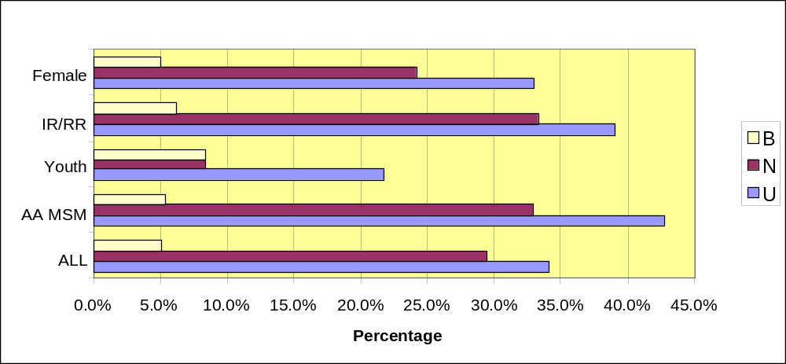

All Respondents:

Status Percent Rank
Use 34.1 15
Need 29.4 18
Barrier 5.1 74
Gap 2.6 34

Special Study Populations:
AA MSM:  Status Percent  Use 42.7  Need 32.9  Barrier 5.4 | Women of Childbearing Age:  Status Percent  Use 33.0  Need 24.2  Barrier 5.0
Incarcerated/Recently Released:  Status Percent  Use 39.1  Need 33.3  Barrier 6.1 | Youth (age 13 - 24):  Status Percent  Use 21.7  Need 8.3  Barrier 8.3

SUPPORT GROUPS

Figure 4-30: SUPPORT GROUPS – REPORTED BARRIER (B), NEED (N), USE (U)
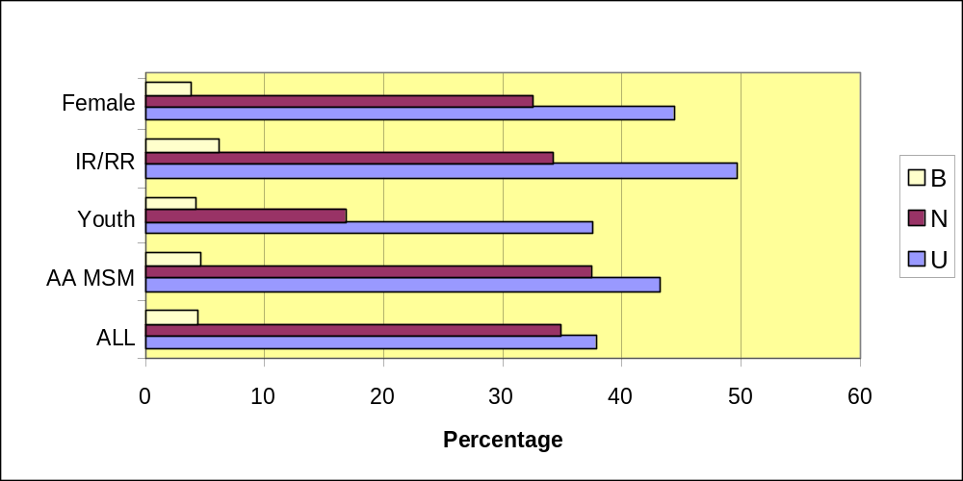

All Respondents:

Status Percent Rank
Use 37.7 12
Need 34.8 13
Barrier 4.4 80
Gap 2.6 33

Special Study Populations:
AA MSM:  Status Percent  Use 43.3  Need 37.4  Barrier 4.7 | Women of Childbearing Age:  Status Percent  Use 44.3  Need 32.5  Barrier 3.9
Incarcerated/Recently Released:  Status Percent  Use 49.5  Need 34.2  Barrier 6.1 | Youth (age 13 - 24):  Status Percent  Use 37.5  Need 16.7  Barrier 4.2
MENTAL HEALTH SERVICES, LICENSED CLINICAL

Figure 4-31: MENTAL HEALTH SERVICES – REPORTED BARRIER (B), NEED (N), USE (U)
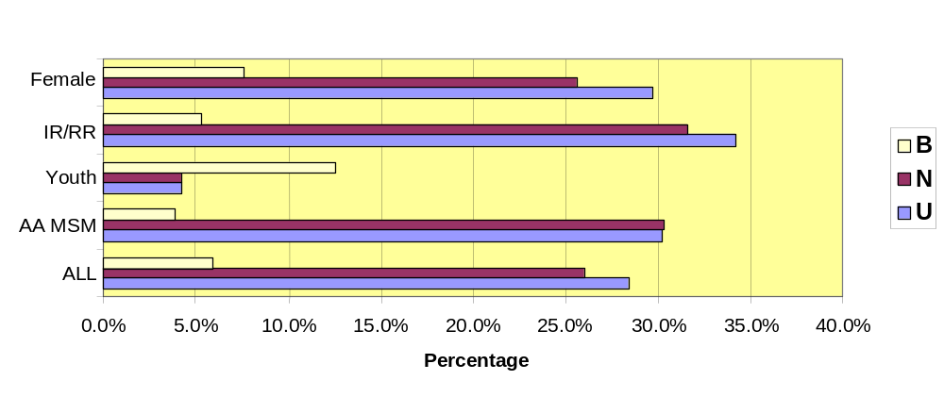

All Respondents:

Status Percent Rank
Use 28.4 26
Need 26.0 23
Barrier 5.9 63
Gap 3.1 22

Special Study Populations:
AA MSM:  Status Percent  Use 30.2  Need 30.3  Barrier 3.9 | Women of Childbearing Age:  Status Percent  Use 29.7  Need 25.6  Barrier 7.6
Incarcerated/Recently Released:  Status Percent  Use 34.2  Need 31.6  Barrier 5.3 | Youth (age 13 - 24):  Status Percent  Use 4.2  Need 4.2  Barrier 12.5

Central Themes
- PLWH/As in this study consistently recounted experiences where they felt isolated as a result of their diagnosis. Many had not confided their HIV status to even their closest family or friends. As a result, participants frequently cited the need for counseling services and support groups.
- Those who identified the need for support group expressed a strong preference for groups that were organized by demographics or interest, i.e. groups for Hispanic women, African American MSM, Anglo MSM, etc.
- Providers cited an increase in the number of clients who present with severe mental health disorders. Commonly reported were bipolar disorder, schizophrenia and major depression.
- Substance abuse remains a persistent problem as reported in the client survey (74% prevalence) as well as in focus groups and street interviews. Providers further confirmed this.
- Of individuals who were homeless within the last two (2) years, 71% indicated receiving psychosocial services.

Discussion
Approximately two-thirds of all survey respondents indicate having used mental health services. Analysis of each of the individual services shows a use rate of approximately one-third of all respondents. Among special study populations, these rates can approach 50%. Of these, 74% were treated as outpatients, 14% as inpatients and 12% reported both inpatient and outpatient treatment.

In focus groups and RARE interviews, though participants reported use rates of individual counseling similar to survey respondents, they most requested that providers offer more support groups. Participants assert that such groups provide not only emotional support, but also can be instrumental in helping individuals avoid risky behaviors and adhere to treatment protocols.

“You have to realize that being gay in the South, you’re going to have situations where you just need counseling, reassurance that you’re not the only out there battling—how many times do people have to tell you that we need support groups?” (African American MSM)

“I think the biggest help is just talking to other people like me who have AIDS from being in risky sexual behaviors. Addictions got me there and keep me here, so only people in my position know what that’s like and the lengths I will go to get drugs. I need them to help me, not licensed folks who haven’t lived it.” (RARE interview)

While substance abuse is known to be significant among PLWH/A, continuing research is also finding rates of major depression to be alarming. In this study, 29% of respondents report currently taking antidepressants, for example. As the following chart shows, the rate of major depression in the general population is estimated to be about 9.5%.

Table 4-4: RATES OF MENTAL ILLNESS IN US POPULATION
Mental Illness | Prevalence* | % of U.S. Population
Bipolar Disorder | 2 million | 1%
Schizophrenia | 2.2 million | 1.1%
Major Depression | 18.8 million | 9.5%
Generalized Anxiety Disorder | 19 million | 10%
Panic Disorder | 2.4 million | 1.3%
HIV Associated Dementia | 10-50% HIV+
Suicidal Ideation | 15-25% HIV+**
Sleep Disorders | 40 million | 14%
Source: National Institute of Mental Health
*Self-reported **Caveat - stated by NIMH as under-reported, under-estimated

The importance of treating major depression in an individual living with HIV/AIDS is underscored by several studies. While independent of physical symptoms, recent research has concluded that major depression is associated with higher mortality rates in gay men living with HIV/AIDS (Mayne et al., 1996). Major depression associated with HIV infection has been associated with decreased survival, increased hospital stays, impaired quality of life, decreased treatment adherence and increased risk behavior. (Lesserman et al., 1997)

Focus group participants mentioned major depression as a serious concern in many of the sessions and providers confirmed the prevalence among their clients. According to participants:
“I need two types of help for my head. I have a person with this same disease that I go to for counseling who is also a MSM, and another provider that I go to for drugs.” (Anglo MSM)
“I went over my diagnosis—depression all over again—and even worse, guilt, when I found out my daughter and grand-baby were HIV positive.” (Pregnant woman)
“I turn tricks instead of getting a job, because I’m not stable enough, I’m not mentally stable enough.” (RARE interview)

HOSPICE

HRSA DEFINITION:
Home-Based Hospice Care: Nursing care, counseling, physician services, palliative therapeutics provided by a hospice program in the terminal stages of illness in their home setting.

Residential Hospice Care: Room, board, nursing care, counseling, physician services and palliative therapeutics provided to patients in the terminal stages of illness in a residential setting, including a non-acute section of a hospital that has been designated and staffed to provide hospice services for terminal patients.

Individual Services
Home-Based Hospice Care
Residential Hospice Care

CPCDMS/COMPIS Registration Data
This service came online with the CPCDMS 2/02. An estimated 10 clients used Ryan White Title I funded hospice care services during the six-month period between 8/1/01 through 2/28/02. COMPIS data show that 39 unduplicated clients used TDH State Services funded hospice care during the one-year period between 3/1/01 through 2/28/02. These 49 clients represent 0.2% - 0.44% of the estimated 11,051 - 22,706 PLWH/A in the EMA/HSDA.”

These data represents only those services billed to Titles I, II, IV and State Services. Many services have supplemental funding sources.

HOSPICE (continued)

All Respondents:

Status Percent Rank
Use 9.7 17
Need 5.9 17
Barrier 7.0 14
Gap 2.0 17

Special Study Populations:

AA MSM:

Status Percent Rank
Use 13 17
Need 6 16
Barrier 10 7
Gap 3 16

Incarcerated/Recently Released:

Status Percent Rank
Use 7 17
Need 2 2
Barrier 8 11
Gap 6 12
Women of Childbearing Age:

Status Percent Rank
Use 10 17
Need 2 17
Barrier 8 17
Gap 1 17

Youth (age 13 - 24):

Status Percent Rank
Use 0 17
Need 0 0
Barrier 9 15
Gap 0 0

HOME-BASED HOSPICE

Figure 4-32: HOME-BASED HOSPICE – REPORTED BARRIER (B), NEED (N), USE (U)
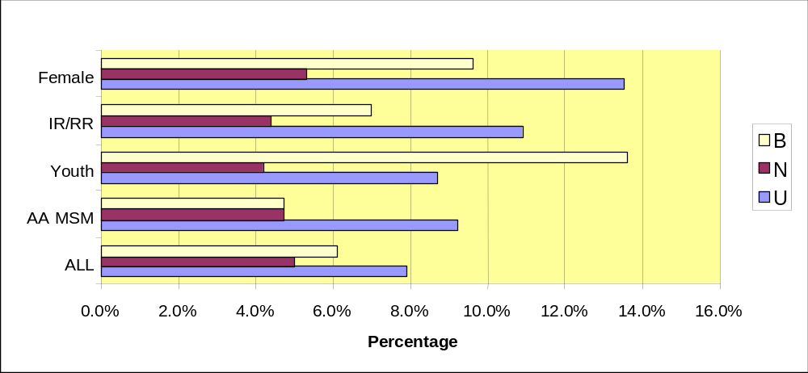

All Respondents:
Status Percent Rank
Use 7.9 61
Need 5.0 59
Barrier 6.1 35
Gap 1.7 56

Special Study Populations:

AA MSM:

Status Percent
Use 9.2
Need 4.7
Barrier 4.7

Incarcerated/Recently Released:

Status Percent
Use 10.9
Need 4.4
Barrier 7.0

Women of Childbearing Age:

Status Percent
Use 13.5
Need 5.3
Barrier 9.6

Youth (age 13 - 24):

Status Percent
Use 8.7
Need 4.2
Barrier 13.6

RESIDENTIAL HOSPICE

Figure 4-33: RESIDENTIAL HOSPICE – REPORTED BARRIER (B), NEED (N), USE (U)
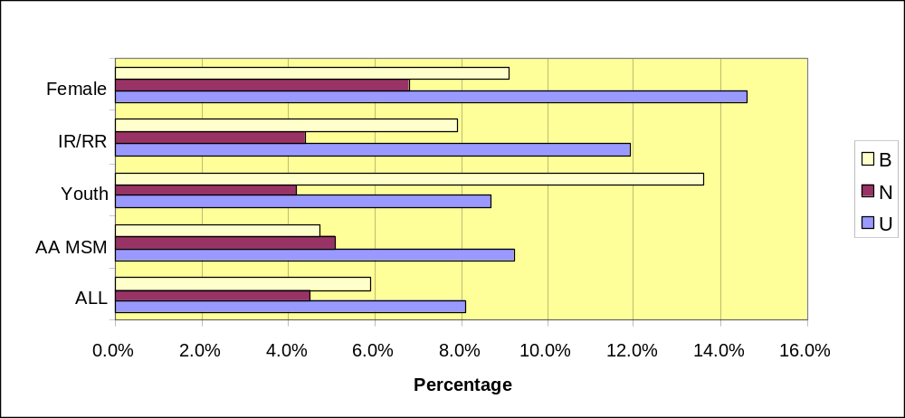

All Respondents:

Status Percent Rank
Use 8.1 76
Need 4.5 77
Barrier 5.9 75
Gap 1.6 75

Special Study Populations:

AA MSM:

Status Percent
Use 9.2
Need 5.1
Barrier 4.7

Incarcerated/Recently Released:

Status Percent
Use 11.9
Need 4.4
Barrier 7.9

Women of Childbearing Age:

Status Percent
Use 14.6
Need 6.8
Barrier 9.1

Youth (age 13 - 24):

Status Percent
Use 8.7
Need 4.2
Barrier 13.6

Central Themes
- The need for hospice has dramatically decreased even since the last Needs Assessment. This is likely due in part, to conversion of HIV/AIDS from an acute, catastrophic illness to a chronic condition with the advent of antiretroviral medication.
- Survey respondents indicated a clear preference for home-based hospice care, rather than residential care. However, women and African American MSM, reported a slightly higher need for residential care.

Discussion
It is important to remember that the survey was conducted with individuals who were ambulatory and well enough to participate. Further, experience in the community has shown that when queried about such services as hospice or others related to end-of-life or palliative (i.e. pain management) care, relatively healthy respondents are more likely to provide useful data to such questions as, “Which type of hospice care would you prefer, were you to need it?” rather than “Do you currently need this service?”

Because of the phrasing of the question and the relative health of the respondents, it can be assumed that need may be underreported.

Home Health Care

HRSA DEFINITION:
Therapeutic, nursing, supportive and/or compensatory health services provided by a licensed/certified home health agency in a home/residential setting in accordance with a written, individualized plan of care established by a case management team that includes appropriate health care professionals. Component services include:
- Durable medical equipment
- Homemaker or home health aide services and personal care services
- Day treatment or other partial hospitalization services
- Home intravenous and aerosolized drug therapy, including related prescription drugs administered as part of such therapy
- Routine diagnostic testing administered in the home of the individual
- Appropriate mental health, developmental and rehabilitation services

Individual Service:
Paraprofessional care
Professional care
Specialized care
Durable Medical Equipment

CPCDMS/COMPIS Registration Data
CPCDMS data show that 35 unduplicated clients used Ryan White Title I home health care services during the four-month period between 11/1/01 and 2/28/02 (this service came online with CPCDMS in 11/01). COMPIS data show that an additional 28 unduplicated clients used TDH State Services home health care services during the one-year period between 3/1/01 through 2/28/02. While these numbers represent only 0.3% - 0.6% of the estimated 11,051 - 22,706 of the PLWH/A in the EMA/HSDA, it represents 0.8% of the estimated 7,636 PLWA in the EMA/HSDA. Clients with an AIDS diagnosis are more likely to require home healthcare services than are individuals diagnosed with HIV.

These data represents only those services billed to Titles I, II, IV and State Services. Many services have supplemental funding sources.

HOME HEALTH CARE (continued)

All Respondents:

Status Percent Rank
Use 27.0 16
Need 19.9 14
Barrier 9.0 7
Gap 9.7 7

Special Study Populations:

AA MSM:

Status Percent Rank
Use 71 5
Need 13 16
Barrier 13 3
Gap 11 11

Incarcerated/Recently Released:

Status Percent Rank
Use 19 16
Need 15 15
Barrier 8 10
Gap 10 9

Women of Childbearing Age:

Status Percent Rank
Use 31 14
Need 16 14
Barrier 7 13
Gap 8 7

Youth (age 13 - 24):

Status Percent Rank
Use 18 9
Need 3 14
Barrier 9 11
Gap 7 9

PARAPROFESSIONAL CARE

Figure 4-34: PARAPROFESSIONAL CARE – REPORTED BARRIER (B), NEED (N), USE (U)
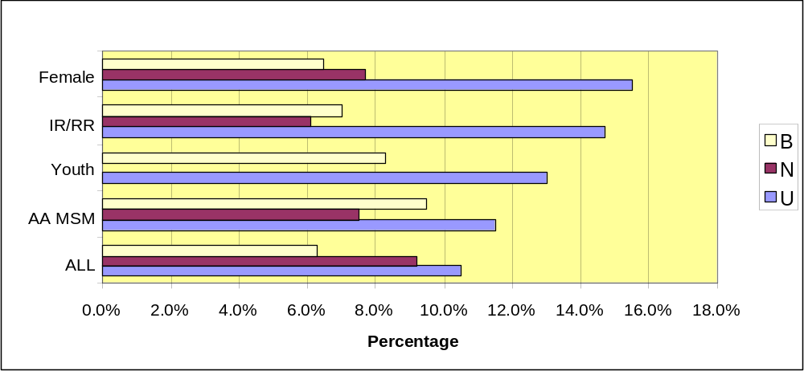

All Respondents:

Status Percent Rank
Use 10.5 70
Need 9.2 71
Barrier 6.3 33
Gap 1.9 70

Special Study Populations:

AA MSM:

Status Percent
Use 11.5
Need 7.5
Barrier 9.5

Incarcerated/Recently Released:

Status Percent
Use 14.7
Need 6.1
Barrier 7.0

Women of Childbearing Age:

Status Percent
Use 15.5
Need 7.7
Barrier 6.5

Youth (age 13 - 24):

Status Percent
Use 13.0
Need 0.0
Barrier 8.3

PROFESSIONAL CARE

Figure 4-35: PROFESSIONAL CARE – REPORTED BARRIER (B), NEED (N), USE (U)
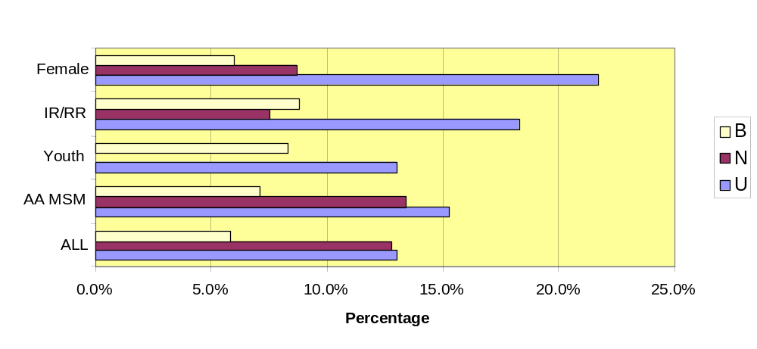

All Respondents:

Status Percent Rank
Use 13.0 50
Need 12.8 76
Barrier 5.8 73
Gap 2.1 49

Special Study Populations:

AA MSM:

Status Percent
Use 15.3
Need 13.4
Barrier 7.1

Incarcerated/Recently Released:

Status Percent
Use 18.3
Need 7.5
Barrier 8.8

Women of Childbearing Age:

Status Percent
Use 21.7
Need 8.7
Barrier 6.0

Youth (age 13 - 24):

Status Percent
Use 13.0
Need 0.0
Barrier 8.3

SPECIALIZED CARE

Figure 4-36: SPECIALIZED CARE – REPORTED BARRIER (B), NEED (N), USE (U)
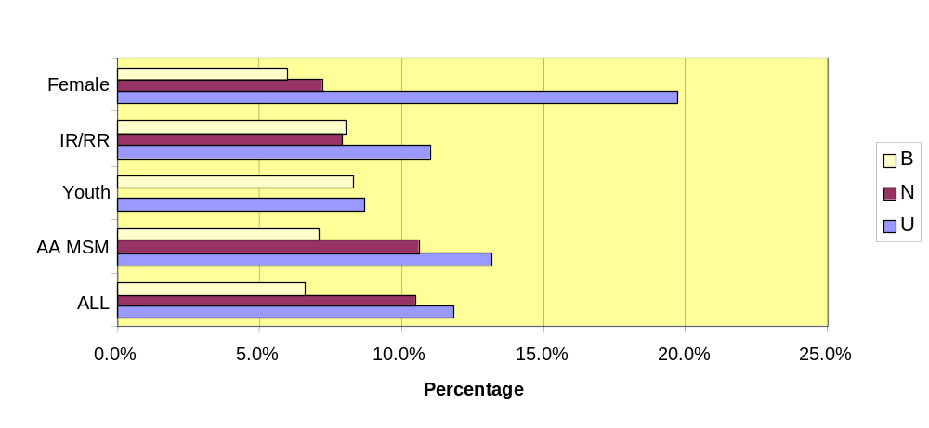

All Respondents:

Status Percent Rank
Use 11.8 77
Need 10.5 78
Barrier 6.6 27
Gap 2.6 31

Special Study Populations:

AA MSM:

Status Percent
Use 13.2
Need 10.6
Barrier 7.1

Incarcerated/Recently Released:

Status Percent
Use 11.0
Need 7.9
Barrier 8.0

Women of Childbearing Age:

Status Percent
Use 19.7
Need 7.2
Barrier 6.0

Youth (age 13 - 24):

Status Percent
Use 8.7
Need 0.0
Barrier 8.3

DURABLE MEDICAL EQUIPMENT

Figure 4-37: DURABLE MEDICAL EQUIPMENT – REPORTED BARRIER (B), NEED (N), USE (U)
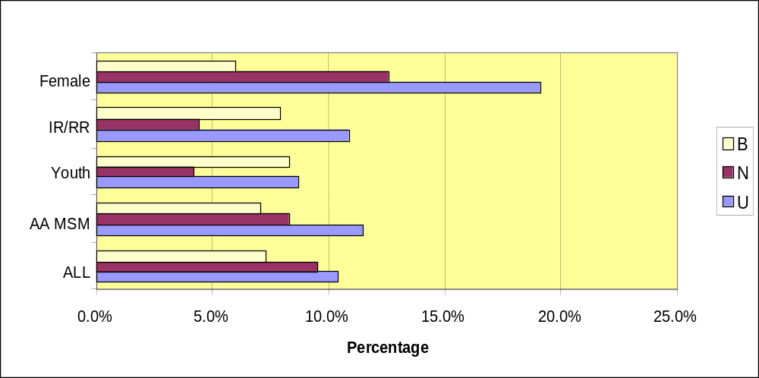

All Respondents:

Status Percent Rank
Use 10.4 57
Need 9.5 54
Barrier 7.3 17
Gap 2.0 53

Special Study Populations:

AA MSM:

Status Percent
Use 11.5
Need 8.3
Barrier 7.1

Incarcerated/Recently Released:

Status Percent
Use 10.9
Need 4.4
Barrier 7.9

Women of Childbearing Age:

Status Percent
Use 16.1
Need 12.6
Barrier 6.9

Youth (age 13 - 24):

Status Percent
Use 8.7
Need 4.2
Barrier 8.3

Central Themes
- Although use of these services reported by survey respondents was quite low, 20% indicated a need for the service category, 10% reported a gap and barriers were ranked in the upper third expect for Professional Care.

Discussion
Home healthcare was rarely mentioned in focus groups, even among those who participated in the group for persons with disabilities. Participants who did mention the service envisioned it only as a service that might be needed well into the future. It is worth noting that the vast majority of survey respondents and focus group participants were ambulatory and did not identify themselves as disabled.

Rehabilitation

HRSA DEFINITION:
Services provided by a licensed or authorized professional in accordance with an individualized plan of care that is intended to improve or maintain a client’s quality of life and optimal capacity for self-care. This definition includes physical therapy, speech pathology and low-vision training services.

Individual Services
Physical Therapy, Speech Therapy, Low Vision Services

CPCDMS/COMPIS Registration Data
CPCDMS data show 68 unduplicated clients used Ryan White Title I rehabilitation services during the five-month period between 10/1/01 through 2/28/02. (This service came online with CPCDMS in 01/01.) This represents 0.29% - 0.61% of the estimated 11,051 - 22,706 PLWH/A in the EMA/HSDA.

These data represents only those services billed to Titles I, II, IV and State Services. Many services have supplemental funding sources.

All Respondents:

Status Percent Rank
Use 38.3 10
Need 27.2 10
Barrier 11.0 4
Gap 11.6 5

Special Study Population:
AA MSM:  Status Percent Rank  Use 50 12  Need 20  Barrier 11 4  Gap 19 | Women of Childbearing Age:  Status Percent Rank  Use 35 12  Need 12  Barrier 11 6  Gap 8
Incarcerated/Recently Released:  Status Percent Rank  Use 40 12  Need 19  Barrier 13 3  Gap 12 | Youth (age 13 - 24):  Status Percent Rank  Use 0 16  Need 0 0  Barrier 9 14  Gap 0 0

PHYSICAL THERAPY

Figure 4-38: PHYSICAL THERAPY – REPORTED BARRIER (B), NEED (N), USE (U)
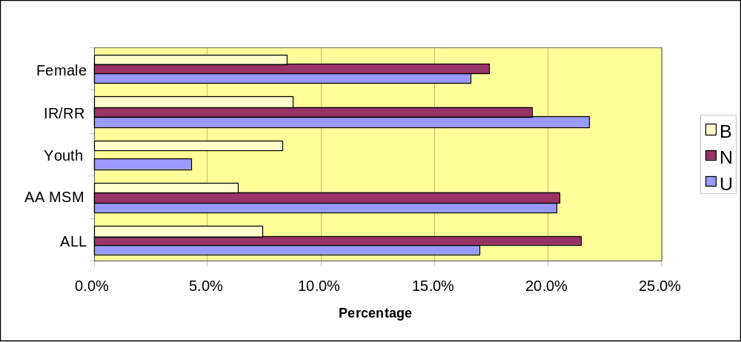

All Respondents:

Status Percent Rank
Use 17.0 42
Need 21.5 30
Barrier 7.4 15
Gap 3.1 23

Special Study Populations:

AA MSM:

Status Percent
Use 20.4
Need 20.5
Barrier 6.3

Incarcerated/Recently Released:

Status Percent
Use 21.8
Need 19.3
Barrier 8.8

Women of Childbearing Age:

Status Percent
Use 16.6
Need 17.4
Barrier 8.5

Youth (age 13 - 24):

Status Percent
Use 4.3
Need 0.0
Barrier 8.3

SPEECH PATHOLOGY

Figure 4-39: SPEECH PATHOLOGY – REPORTED BARRIER (B), NEED (N), USE (U)
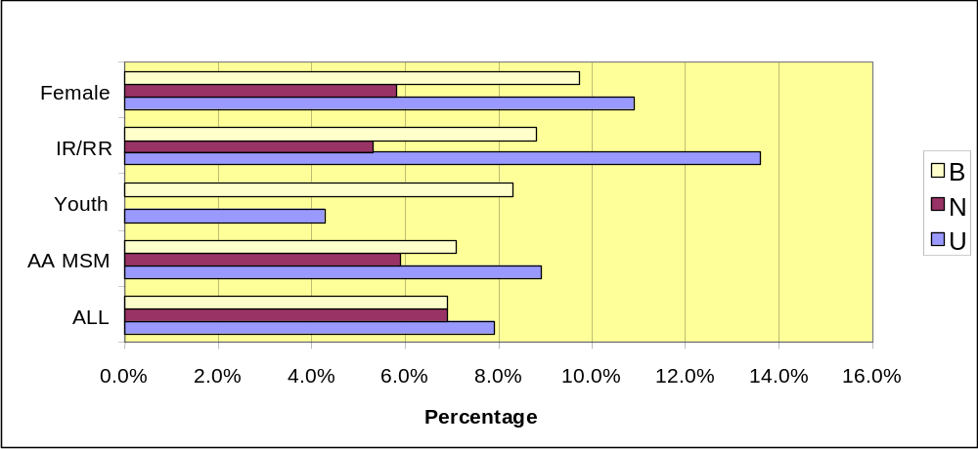

All Respondents:

Status Percent Rank
Use 7.9 28
Need 6.9 79
Barrier 6.9 19
Gap 2.0 76

Special Study Populations:

AA MSM:

Status Percent
Use 8.9
Need 5.9
Barrier 7.1

Incarcerated/Recently Released:

Status Percent
Use 13.6
Need 5.3
Barrier 8.8

Women of Childbearing Age:

Status Percent
Use 10.9
Need 5.8
Barrier 9.7

Youth (age 13 - 24):

Status Percent
Use 4.3
Need 0.0
Barrier 8.3

LOW-VISION TRAINING SERVICES

Figure 4-40: LOW-VISION TRAINING SERVICES – REPORTED BARRIER (B), NEED (N), USE (U)
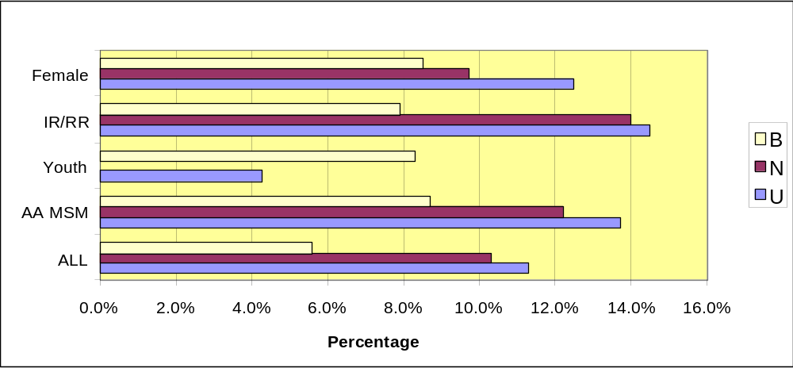

All Respondents:

Status Percent Rank
Use 11.3 66
Need 10.3 65
Barrier 5.6 6
Gap 3.6 15

Special Study Populations:

AA MSM:

Status Percent
Use 13.7
Need 12.2
Barrier 8.7

Incarcerated/Recently Released:

Status Percent
Use 14.5
Need 14.0
Barrier 7.9

Women of Childbearing Age:

Status Percent
Use 12.5
Need 9.7
Barrier 8.5

Youth (age 13 - 24):

Status Percent
Use 4.3
Need 0.0
Barrier 8.3

Central Themes

Thirty-eight percent (38%) of the survey population reported a disability other than HIV.

Thirty-eight percent (38.3%) reported use of rehabilitation services, though use of the three individual services ranged from 17% (physical therapy) to 7.9% (speech therapy). Some of the discrepancy may be explained by the possible misunderstanding of the services included in the HRSA definition of the service category. The definitions of the service categories were not included in the survey for participants to reference.
Increased risk of hypertension, diabetes and cardiac conditions, associated with anti-retroviral therapies may cause an increase in the need for rehabilitation services.

Discussion

As illustrated in the following chart, survey respondents cited a range of physical challenges in addition to HIV. Of respondents who reported disabilities other than HIV, 30.9% indicated developmental delays, 11.5%, hearing impairment, 10.9% visual impairment, and 7.1% were wheelchair bound as illustrated in Figure 4-41.

Figure 4-41: REPORTED SEVERE DISABILITIES
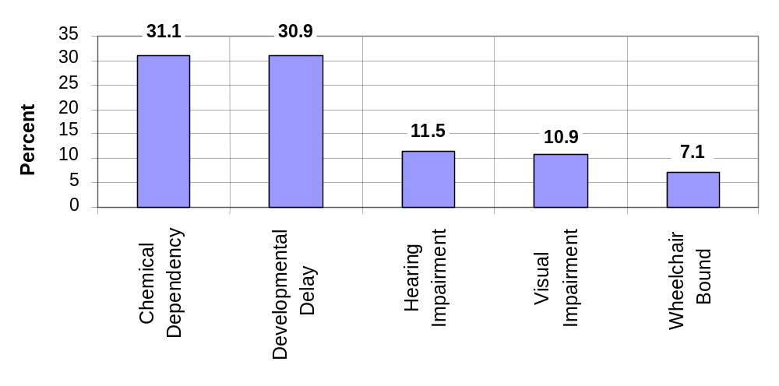

Chemical dependency is the most prominent of the condition, followed closely by developmental delays. Data from the focus group for individuals with disabilities suggested three predominant concerns for the participants:
  - Housing
  - Social isolation
  - Diminished opportunity for self-sufficiency.

Several participants from the focus group for people with disabilities noted that their access to housing was limited by their combined challenge of HIV and other disabilities. This was especially true for those with substance abuse issues.
“ I live with my mom right now and she is on a fixed income. Even without me, she couldn’t afford independent housing since it takes 3.5 times your monthly rent to qualify for substandard housing.” (sic) (Disabled Client)
“There is more subsidized housing for drug addicts and alcoholics than for people with HIV. It’s as if they (landlords) still believe we’re contagious.” (Disabled Client)

Several participants, who lived with older relatives, discussed additional difficulties associated with misinformation about HIV. Participants characterized this situation as the “plastic treatment.”

“She [mother with whom he lives] gives me the ‘plastic treatment.’ She will only serve me on plastic plates, using plastic utensils and glasses.” (Disabled Client)
“Here is a cruel time - everyone was served at a party with real glasses but me. I got a plastic cup.” (Disabled Client)
“The ‘plastic treatment’ makes me isolated and I just close up.” (Disabled Client)

That sense of isolation was summarized by another participant:

”I feel really isolated having AIDS and a handicap. I am pitied or shunned and can’t get people to treat me as ‘just folks’. This causes me to work hard to be accepted, though I know I am prickly when I think I am being rejected by using sharp words, actions or avoiding people.” (Disabled Client)

Additional concerns were the limitations imposed on the participants’ attempts toward achieving greater self-sufficiency, specifically their efforts to find and maintain employment.

“I wish there were more services, maybe grant-funded for people with HIV to help them return to work. So many folks can’t explain the time gap when they were being treated, and need interim help to retrain, learn a new skill, get back on their feet. If employers were encouraged to help those with HIV and the disabled, this would really show our dedication to return to a full life with gainful employment.” (Disabled Client)

EARLY INTERVENTION SERVICES

HRSA DEFINITION:
Counseling, testing, and referral services to PLWH who know their status but are not in primary medical care or who are recently diagnosed and are not in primary medical care for the purpose of facilitating access to HIV-related health services.
The survey instruments did not list this service as one where respondents were asked about use, need, barrier or gaps. Referral information is inferred from respondents answer to the question,. “When you found out you were HIV positive, were you referred for any of the following services?” (Question 23 of the survey instrument.)
“How soon after finding out you were HIV positive did you get medical care for your HIV? (Question 30c—respondents could indicate more than one answer.)
If you did not seek medical care within 1 year of finding out you were HIV positive, please indicate why. (Question 30d-respondents could indicate more than one answer.)

Central Themes
- While the 61% of respondents reported receiving treatment within three months, 16.9% did not enter treatment for more than one year, as the following illustrates:
- 61% received medical care within 3 months of diagnosis
- 8.6% within six months
- 6.6% within a year
- 16.9% over a year

Discussion
Of those respondents who did not receive care within 1 year:
- 17% chose not to seek treatment
- 9.2% decided they didn’t need care
- 4.5% didn’t want care
- 3.3% decided care would do no good

Another 9.3% reported that they were told either that they did not need treatment or were not told that treatment would be appropriate for them
- 5.9% were told they did not need care
- 3.4% were not told they needed care

Significant barriers were faced by 8.6% of respondents.
- 4.2% didn’t know where to go
- 3.6% couldn’t afford care
- 0.8% couldn’t find a provider to treat them
- For 1.9% of the respondents, alternative care seemed a better option.

Chapter 5

Targeted Findings:

Housing & Transportation

HOUSING & TRANSPORTATION

Housing and Transportation are perennially listed among the top five needs and gaps nationally and in the Houston Area EMA/HSDA by People Living with HIV/AIDS (PLWH/A). Clients responding to the survey with self-ranked write-in responses listed these among their top three slots in both need and gaps. See Figure 5-1.

HRSA DEFINITIONS:
Housing Assistance/Housing-Related Services: This includes assistance in locating and obtaining suitable, ongoing or transitional shelter, costs associated with finding a residence and/or subsidized rent and residential housing services which are the provision of housing assistance in a group home setting.

Transportation: Conveyance services provided to a client in order to access health care or psychosocial support services. May be provided routinely or on an emergency basis.

Figure 5-1: SELF-DEFINED (WRITE-IN) NEEDS
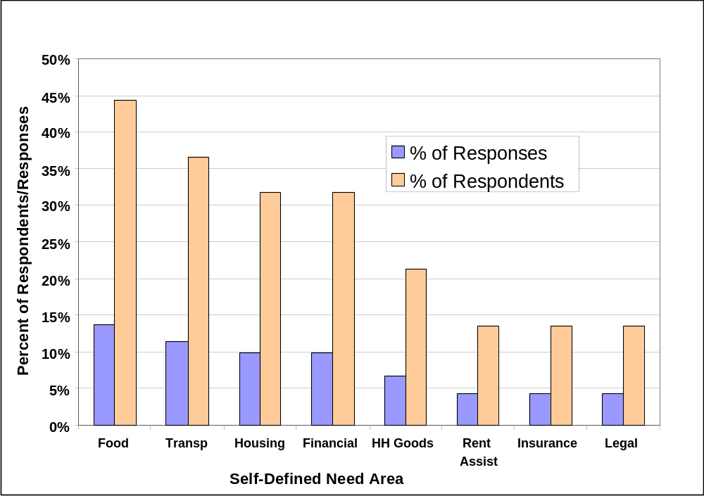Transportation ranked 2nd in the client survey as a self-defined need, with housing 3rd.
These two service categories reversed positions for gaps and moved up to 1st and 2nd rank, respectively, in this same self-defined, write-in section of the client survey as shown in Figure 5-2.

Figure 5-2: SELF-DEFINED (WRITE-IN) SERVICES NOT AVAILABLE
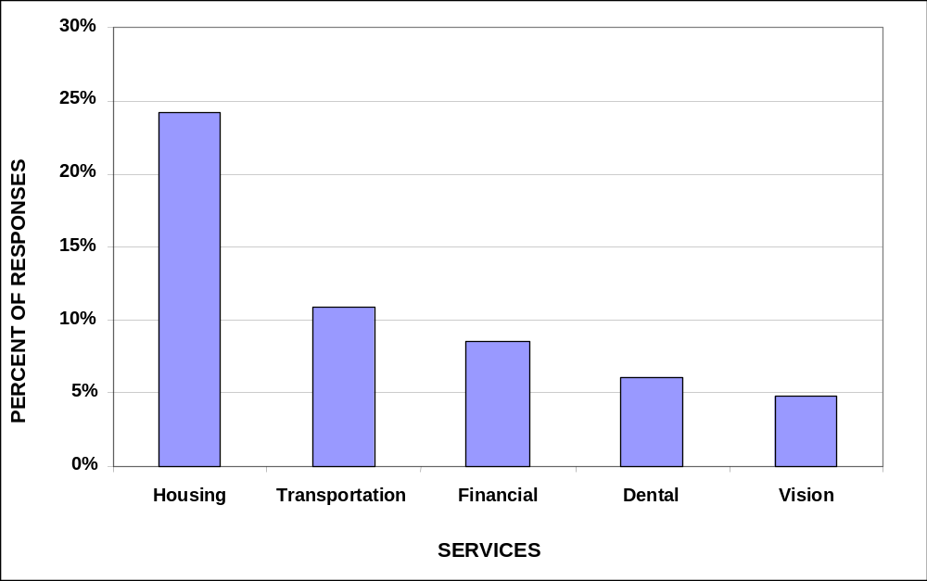
Housing
Housing was an overriding need and barrier across all population segments in the quantitative survey and qualitative research. See Figure 5-1 and 5-2.

It should be stated that the issue of affordable and desired housing is a generic one most related to the high cost of housing for any citizen living on a fixed income. While this definition includes many PLWH/A, it is not restricted to them or a corollary of their disease. The typical SSI benefit of $530 per month, with a typical 3.5 times down-payment to secure rental housing, makes most housing situations less than acceptable for those on a fixed income.

Houston contains 1.78 million people within the city proper, with 4.2 million residing within the Houston area EMA/HSDA. A large proportion of residents within the city are foreign-born (18%), an international immigration rate that continues to rise.

Minority groups constitute the majority percentage of citizens in the city (59%), which is comprised of Hispanics, Blacks, Asians and other minorities. The proportions living in the city were well matched with the distribution of racial, ethnic, gender and age groups of clients that responded to the survey.

Over three-quarters of respondents (77%) live by themselves or with family or friends with 16% living in supervised or group settings, homeless or incarcerated. See Table 5-1.

717 unduplicated clients utilized Ryan White Title I and II housing assistance services and 377 unduplicated clients utilized Title I housing coordination services during the one-year period of 3/01/01 and 2/28/02. This represents 3.2% - 6.5% (housing assistance) and 1.7% - 3.4% (housing coordination) of the estimated 11,051 - 22,706 PLWH/A in the Houston area.

Table 5-1: INDIVIDUAL SERVICE GAPS
Gap Rank | Individual Service Gaps  All Respondents | % Gaps
1 | Direct Emergency Financial Assistance | 7.5%
2 | Housing Payment | 6.9%
3 | Exercise/Fitness Training | 6.7%
4 | Health Insurance Payments | 5.3%
5 | Alternative Treatment | 5.2%
6 | Food Bank/Home Delivered Meals | 4.8%
7 | Housing | 4.4%
8 | Transportation | 4.4%
9 | Nutritional Education | 4.2%
10 | Support Groups | 4.0%

Many PLWH/A utilize housing services not funded by Title I and Title II, including:
- Facilities and programs funded by HOPWA
- Programs funded for youth, the elderly, disabled, substance users and/or mentally disabled under local and/or other federal grant programs.

The Housing Opportunities for Persons With AIDS (HOPWA) program provides emergency housing assistance and rental assistance to eligible persons with HIV/AIDS and their families. The primary objective of HOPWA is to provide housing assistance to help PLWH/A continue to live independently.

Most PLWH/A’s cannot afford housing due to their disabilities. People on a fixed income experience trouble paying for anything other than seriously substandard housing; a finding corroborated by the client survey and focus group responses.

Living Arrangements:
- 47% of PLWH/A’s did not live alone, with 53% living alone.
- Females and Youth (many of whom were young females with children) were the most likely to live with children while AA MSM were least likely.

All respondents report the following housing arrangements:
- 53% live by themselves
- 24% lived with family
- 16% lived in a supervised living arrangement
- 6% were homeless
- 1% were in jail

The rate of recidivism is reported by respondents as highly correlated to adequate housing. Many yearn for independent housing in a ‘safe’ neighborhood in which drug dealing, sex work or other risk factors that weaken their resolve to recover are not present.

Homelessness:
In the client survey, 19% of respondents reported that they had been homeless or lived in a homeless shelter in the past year, with 20% of those indicating that they had been homeless for 12 months or more.

This rate is at the upper end of the national report, with most large EMAs reporting ranges between 10% - 20% homelessness. Of these, 14% to 20% are HIV infected, many of which are unaware of their condition. The highest rates of HIV infection are found in African Americans, both male and female.

Complicating diagnosis and treatment is the lack of a stable living situation, which makes adherence to strict medical regimens, transportation to providers and risk of comorbidities, either related to HIV or opportunistic to HIV, at an even higher probability for this group.

Discrimination:
- 10.0% believed they were discriminated against for housing because of HIV
- 21.1% because of income
- 7.7% race/ethnicity
- 6.9% disability
- 1.4% because they have kids
- 3.0% reported discrimination because they had been incarcerated (under-reported since these were all write-in responses)

Affordability:
14% of all respondents noted a need for housing modifications to address their non-HIV/AIDS disability. Disabilities were commonly reported (38%), especially by the recently released and females. Twenty-five percent of survey respondents stated that disabilities have been a problem at some time in their disease, with 14% needing a housing modification to address their non-HIV/AIDS disability.

People with disabilities continue to be the poorest people in the nation. As a national average, federal disability or Supplemental Security Income (SSI) benefits in 2000 were equal to only 18.5% of the one-person median household income, and fell below 20% of median income for the first time in over a decade.

In 2000, people with disabilities receiving SSI benefits needed to pay, on a national average, 98% of their SSI check in order to be able to rent a modest one-bedroom unit at the published HUD Fair Market Rent. (See Figure 5-3) Cost of living adjustments to SSI benefit levels have not kept pace with the increasing cost of rental housing. Between 1998 and 2000, housing rental costs rose almost twice as much as the income of people with disabilities.

In 2000, there was not a single housing market in the country where a person with a disability receiving SSI benefits could afford to rent a modest efficiency or one-bedroom unit. Housing wage data from the National Low Income Housing Coalition shows that people with disabilities receiving SSI benefits needed to triple their income to be able to afford a decent one-bedroom unit.

Figure 5-3: PERCENT OF SSI BENEFITS NEEDED TO RENT A ONE-BEDROOM APARTMENT
Source: National Low Income Housing Coalition

Medications include prescription drugs provided through an ADAP to prolong life or prevent the deterioration of health. The definition does not include medications that are dispensed or administered during the course of a regular medical visit, that are considered part of the services provided during that visit.
Refers to registration into the CPCDMS system, see page 39.
Source: April 22, 2002 letter from Texas Department of Health
Wall Street Journal: May 2, 2002
New England Journal of Medicine: May 1, 2002
NOTE: Interpretation of data for Hospice, Home Health Care and Adult Day Care is limited by 2 factors: 1- the population surveyed was primarily ambulatory and relatively healthy; 2- the questions on the survey were inadequate to accurately assess the need for these services.
NOTE: Interpretation of data for Hospice, Home Health Care and Adult Day Care is limited by 2 factors: 1- the population surveyed was primarily ambulatory and relatively healthy; 2- the questions on the survey were inadequate to accurately assess the need for these services.
Rehabilitation was a term that survey respondents may have found confusing, which may have influenced their response. During the validation process, several told facilitators that they interpreted rehabilitation to refer to such services as substance abuse treatment or post-incarceration services, such as employment training.

