

HOUSTON AREA

EPIDEMIOLOGICAL REPORT

Prepared for

HOUSTON AREA HIV SERVICES RYAN WHITE PLANNING COUNCIL

FINAL COPY
Edited August 03, 1999 - Approved by Council August 12, 1999

Submitted by: Partnership for Community Health, Inc.
245 West 29th Street
Suite 1202
New York, NY 10001

Prepared By: Mitchell Cohen, Ph.D.
Partnership for Community Health, Inc. and
Patrick Leung, Ph.D.
Office of Community Projects
University of Houston Graduate School of Social Work

Primary Contact: Mitchell Cohen, Ph.D.
Telephone: 212.564.9790 X 26
Fax: 212.564-9781
E-mail: PCH@pchealth.org

TABLE OF CONTENTS

ACKNOWLEDGMENTS i
INTRODUCTION 1
TRENDS 2
People Diagnosed with AIDS Each Year 2
Fatality and Death Rates 8
People Living with AIDS 10
Projecting the Number of AIDS Cases Diagnosed Each Year 13
Projecting the Number of People Living with AIDS 16
PEOPLE LIVING WITH AIDS IN 1998 18
Ethnicity, Sex, and Risk Group 18
Subpopulations with Small Numbers of People Living with AIDS 23
HIV ESTIMATES 25
At-Risk Population Estimates 25
HIV Estimates re: Holmberg / CDC with the Interim IDU Estimates 25
HIV Estimates Based on Logistic Regression re: Cohort at Testing Centers 28
Projection of HIV Rate 30
CO-MORBIDITIES 32
STDs 32
Tuberculosis (TB) 34
Substance Use and Abuse 34
Homeless 35
CONCLUSION 37

Tables
Table 1 AIDS Statistics for Houston 1
Table 2 At-Risk Population Estimates by Holmberg 26
Table 3 Interim At-Risk Population Estimates 27
Table 4 At-Risk Population Estimates Recommended by PHR6 27
Table 5 HIV Rates Based on the Interim IDU Estimate Using Holmberg’s “Low” and “High” Estimates for New Infection 28
Table 6 HIV Rates for Houston Based on the Adjusted Estimate of Holmberg Updated with 1999 TSDC Pop Estimate 28
Table 7 Probability Estimates Based on City Cohort 29
Table 8 Estimates of HIV for Subpopulations for 1999 Based on Clinic Data from the City of Houston HHSD 30
Table 9 Estimated HIV Positive Prevalence Based on 1999 Estimated Population 31
Table 10 Estimated HIV Positive Prevalence Based on 2003 Estimated Population 31
Table 11 Range of Estimates of HIV Positive for 1999-2003 32

Figures
Figure 1 AIDS Cases by Year of Diagnosis: Houston EMA 2
Figure 2 AIDS Cases by Year of Diagnosis: Rural Counties 4
Figure 3 Percentage Change in Number of AIDS Cases 4
Figure 4 AIDS Cases by Year of Diagnosis by Race 5
Figure 5 AIDS Cases by Year of Diagnosis by Gender 6
Figure 6 AIDS Cases by Year of Diagnosis by Risk Group 7
Figure 7 HIV/AIDS Deaths by Ethnicity per 100,000 of Houston Area Population 8
Figure 8 % Deceased by Year of People with AIDS in a Cohort Tracked by TDH 9
Figure 9 Living with AIDS: Houston EMA and Harris County 10
Figure 10 Living with AIDS by Ethnicity 10
Figure 11 Living with AIDS by Risk Group 11
Figure 12 Living with AIDS by Counties 11
Figure 13 % Increase in Living with AIDS from 1992-1998 by Race 12
Figure 14 % Increase in Living with AIDS from 1992 - 1998 Risk Group 12
Figure 15 Linear Trend for New AIDS Cases by Year of Diagnosis for Houston EMA 14
Figure 16 Loglinear Projection of Newly Diagnosed AIDS Cases (Reported 1998 data) 14
Figure 17 Loglinear Projection of Newly Diagnosed AIDS Cases (Trend of 1998 cases based on 1996-1997 data) 15
Figure 18 “Best Guess” Trend of Cases by Year of Diagnosis for Houston EMA 16
Figure 19 Trend for PLWA in Houston EMA: Loglinear Model 17
Figure 20 Trend for PLWA in Houston EMA: Revised Model 17
Figure 21 PLWA through 1998 by Risk Group and Sex 18
Figure 22 PLWA through 1998 by Ethnicity and Sex 20
Figure 23 PLWA through 1998 by Age Group and Sex 20
Figure 24 PLWA in 1998 by Risk Group and Race 21
Figure 25 PLWA by County in 1998 22
Figure 26 PLWA by Urban Rural in 1998 22
Figure 27 PLWA in 1998 by County and Risk Group 23
Figure 28 Young Adults and Adolescents (Between 13 and 19 Years Old) Living with AIDS in 1998: Risk Factors 23
Figure 29 People less than 13 Years Old Living With AIDS by Race 24
Figure 30 STDs and AIDS 33

Attachment:

Attachment 1 TREND DATA 1992-1998 AIDS Cases and PLWA 40
Attachment 2 Cumulative AIDS Cases Reported 40
Attachment 3 PLWA Through 1998 40
Attachment 4 STD Rates 40

Abbreviations
API | Asian Pacific Islander
CDC | Centers for Disease Control and Prevention
EMA | Eligible Metropolitan Area
HHSD | City of Houston Health and Human Services Department
IDU | Intravenous drug user
MSA | Metropolitan Statistical Area
MSM | Men-who-have-sex-with-men
OI | Opportunistic infection
PCH | Partnership for Community Health
PHR6 | Public Health Region Six
PPG | Prevention Planning Group (Public Health Region Six.)
STD | Sexually transmitted diseases
TCADA | Texas Commission on Alcohol and Drug Abuse
TDH | Texas Department of Health
TSDC | Texas State Data Center

ACKNOWLEDGMENTS

Several individuals and organizations assisted in providing the data for this report. Foremost, PCH would like to thank the Texas Department of Health (TDH), particularly Sharon King, head of the HIV/STD Epidemiological Monitoring Branch, and Ed Weckerly, an analyst in that office, for preparing uniform data for this presentation. Kaye Reynolds, Marcia Wolverton, Johnny Westerholm and Brian Boyett at the Houston Department of Health and Human Services provided assistance and access to the cohort data used in providing the HIV estimates. The PHR6 Prevention Planning Group’s epidemiological work was used in the section of HIV estimates.

The Council and Consortium have been supportive throughout the process. The Project Advisory Group has provided supervision and comments. Dr. David Whittier and Ms. Jays Janney from the Council Office of Support and Mr. Michael Springer from the Resource Group provided insightful comments on the draft.

HOUSTON AREA EPIDEMIOLOGICAL REPORT

Prepared by the Partnership for Community Health

For Houston Area HIV Services Ryan White Planning Council
February 28, 1999

 | INTRODUCTION
The epidemiology of AIDS is changing. | The epidemiology of HIV and AIDS in the Houston Eligible Metropolitan Area (EMA), like other EMAs, is changing dramatically due to the success of medical treatment efforts. The basic statistics through 1998 for the six county Houston EMA and larger ten county area covered by the Consortium (Health Service Delivery Area (HSDA)) are shown in Table 1.

Table 1 AIDS Statistics for Houston
 | Cumulative Houston 10 county Health Services Delivery Area (HSDA) through 1997 | 16,955¹
 | Cumulative Houston 6 county EMA AIDS Cases through 1997 | 16,855¹
 | Living with AIDS in HSDA Area through 1998 | 7,580¹
 | Living with AIDS in the Houston EMA area in 1998 | 7,538¹
 | Projected number living with AIDS in 2003 in Houston area | 10,845
 | Projected number of HIV infected in 1999 in Houston area | 12,982 - 20,235²
 | Projected number of HIV infected in 2003 in Houston area | 13,811 - 21,584
- Texas Department of Health
- See Table 11
People living with AIDS - those in need of services - are the focus of this report. | This document will be used as input into the Comprehensive Plan for AIDS Care. Rather than focus on cumulative AIDS cases, the trends of people diagnosed with AIDS and people living with AIDS (PLWA) – those who are in need of services – are presented below.
 | In the following section the trends for the yearly AIDS diagnosis and PLWA are reviewed from 1992 to 1997. In the third section additional demographic and risk group information is presented for those living with AIDS in 1998.
 | The next to last section of this report includes a projection of HIV incidence and the last section presents co-morbidities of STD, drug use, and TB with HIV infection.

 | TRENDS
 | People Diagnosed with AIDS Each Year
From 1992 to 1997, there was an 11% drop in the number of persons diagnosed with AIDS yearly. | As an outcome of successful anti-retroviral and prophylactic treatments, many HIV infected persons are not progressing to AIDS as rapidly as in the past. In 1992, 1,806 persons were diagnosed with AIDS in the Houston EMA, while in 1997, 1,606 persons were diagnosed, indicating a decline of about 11%. Between 1993 and 1994, there was a decline in AIDS cases. However, it should be noted that one reason for the steep decline between 1993 and 1994 was due to the change in the AIDS surveillance case definition in 1993. As a result of these changes, the number of AIDS cases increased significantly as compared to 1994. Notably between 1994 and 1996 there was a reversal in the decline, but between 1996 and 1997 there was about a 13% decline. Harris County accounted for the vast majority of all AIDS cases in the Houston EMA. In Harris County, 1,749 AIDS cases were diagnosed in 1992 and 1,525 in 1997. Figure 1 displays the decline in AIDS cases reported yearly in the six county Houston EMA and Harris County.
Figure 1 AIDS Cases by Year of Diagnosis: Houston EMA
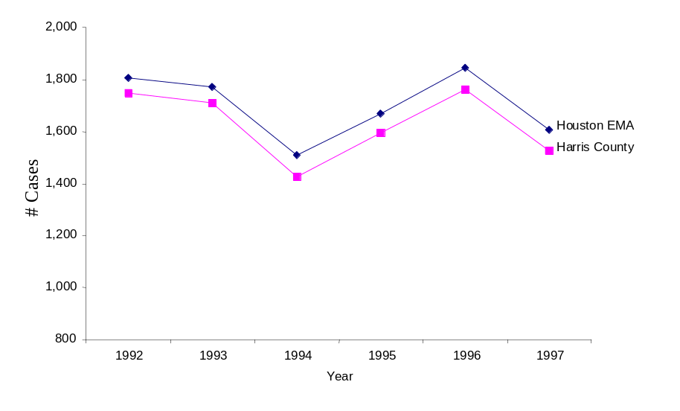
Outlying counties had a slightly smaller level of decline than Harris County. | Harris County’s decrease in newly diagnosed AIDS cases is about the same level as the decrease in Fort Bend. There were smaller decreases in yearly-diagnosed AIDS cases in Liberty, Montgomery, and Waller Counties ( ) while Chambers County had only a few newly diagnosed AIDS cases from 1992 to 1997.

Figure 2 AIDS Cases by Year of Diagnosis: Rural Counties
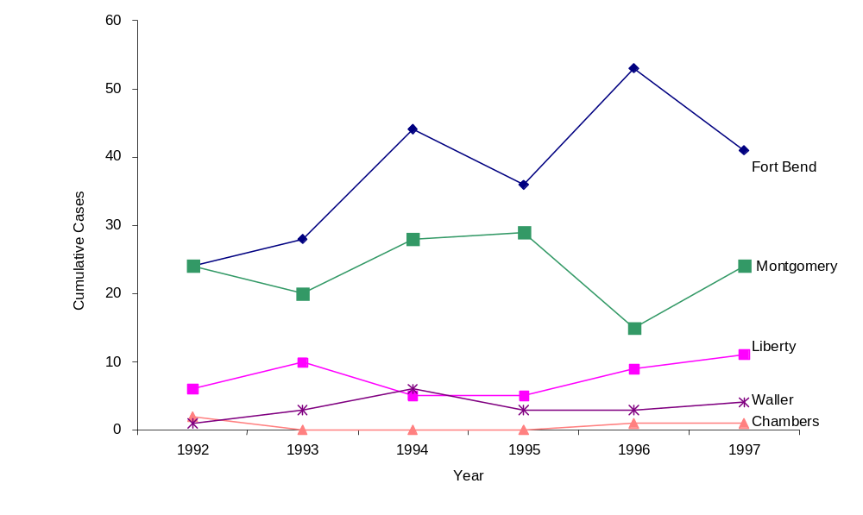
As seen in Figure 3, there was a 13% drop in the number of AIDS cases annually diagnosed for Harris County between 1992 and 1997. During this same period, there was a 38% increase in the number of AIDS cases in the rural counties of the Houston EMA, Fort Bend, Liberty, Chambers, Montgomery and Waller. Overall, the number of rural cases remains quite small. Out of 1,606 cases diagnosed with AIDS in 1997, 81(5%) were rural. Of those 81 cases, 76 lived in Fort Bend, Montgomery and Liberty Counties.

Figure 3 Percentage Change in Number of AIDS Cases
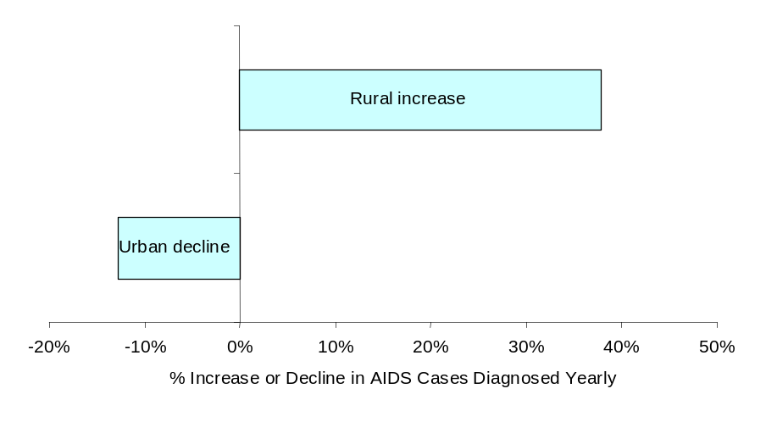

Anglos experienced a decline in newly diagnosed AIDS cases between 1992 and 1997, while African Americans and Hispanics experienced an increase during the same period. | As seen in Figure 4, an unequal decline was observed in the diagnosed cases by race. From 1992 to 1997, the number of newly diagnosed Anglo cases dropped 45% from 959 per year to 528 per year. This compares to the increase in newly diagnosed African American cases from 574 to 760 per year (32%) and the increase in newly diagnosed Hispanic cases from 268 per year to 307 per year (15%). The 1998 figures reported in Attachment 1 suggest a modest decline in the number of African American and Hispanic cases, but the 1998 trend will not be reliable until the number of newly diagnosed cases is complete. In terms of absolute numbers, African Americans surpassed the number of newly diagnosed Anglos in 1996 and 1997.
 | Although the number of newly diagnosed AIDS cases is higher among African Americans as shown in the framed pie chart in Figure 4, continuing into 1998 the highest percentage of people living with AIDS were Anglo (45% or 3,350 cases) followed by African Americans (38% or 2,883 cases), and Hispanics (17% or 1,267 cases). There were also 33 Asian Pacific Islanders.
Figure 4 AIDS Cases by Year of Diagnosis by Race
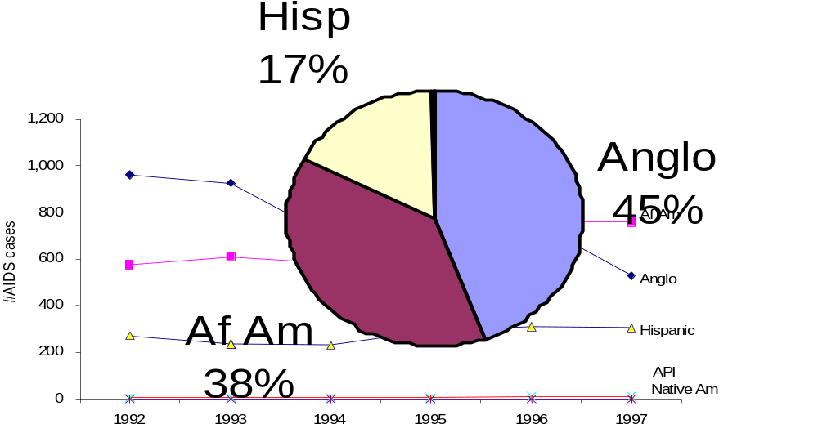Year

Newly diagnosed AIDS cases are decreasing among males and increasing among females. Still in 1998 there are 5 times the number of males living with AIDS. | Figure 5 further indicates that while the number of newly diagnosed AIDS cases among males is declining, the number of newly diagnosed AIDS cases among females is increasing. From 1992 to 1997, the number of newly diagnosed male cases declined by 23%. However, from 1992 to 1997, the number of newly diagnosed female cases increased by 94%. Still, as shown in the framed pie chart in Figure 5, even with the increased number of females, in 1998 there were five times as many males newly diagnosed with AIDS as females.
Figure 5 AIDS Cases by Year of Diagnosis by Gender
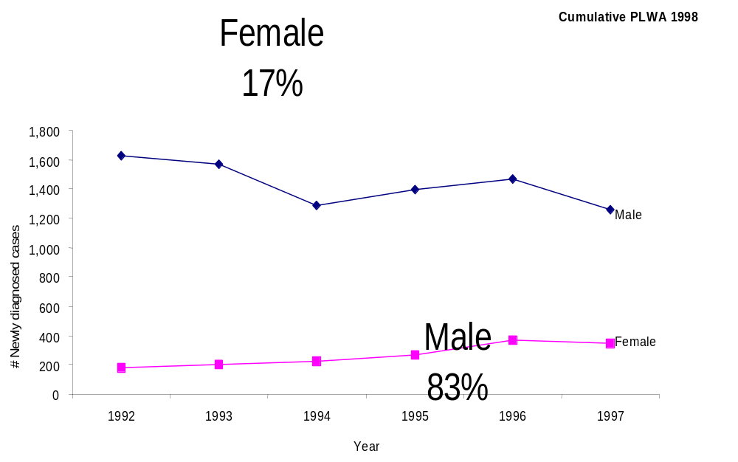

MSM show the greatest decline in number of new AIDS cases reported. | Figure 6 shows an unequal decline in diagnosed AIDS cases for exposure groups. Men-who-have-sex-with-men (MSM) show a significant decline in number of AIDS cases diagnosed yearly, while IDUs, MSM/IDU, and heterosexuals show an inconsistent pattern.
MSM has shown a significant drop in the number of AIDS cases diagnosed, while heterosexual cases have increased. | In 1992, MSM/IDU had a larger number of cases diagnosed yearly than heterosexuals. However in 1994, heterosexuals had more cases diagnosed yearly than MSM/IDU. Notably, there was a significant change in the profile of AIDS cases being diagnosed. In 1992, MSM constituted over 63% of known cases diagnosed yearly. By 1997, MSM decreased to 44%, while heterosexuals increased from 7% to over 17%.
In 1998, MSM constitute the majority of all PLWA. | Despite the large drop of newly diagnosed MSM AIDS cases, as shown in the framed pie chart in Figure 6, even in 1998 MSM continue to be the majority (53%) of all PLWA. This is consistent with the national data reported by CDC that MSM had the majority (45%) of all PLWA. Preliminary results from 1998, as shown in Attachment 1, indicate that the number of newly diagnosed cases will continue to drop among MSM and remain relatively constant among other risk groups.

Figure 6 AIDS Cases by Year of Diagnosis by Risk Group
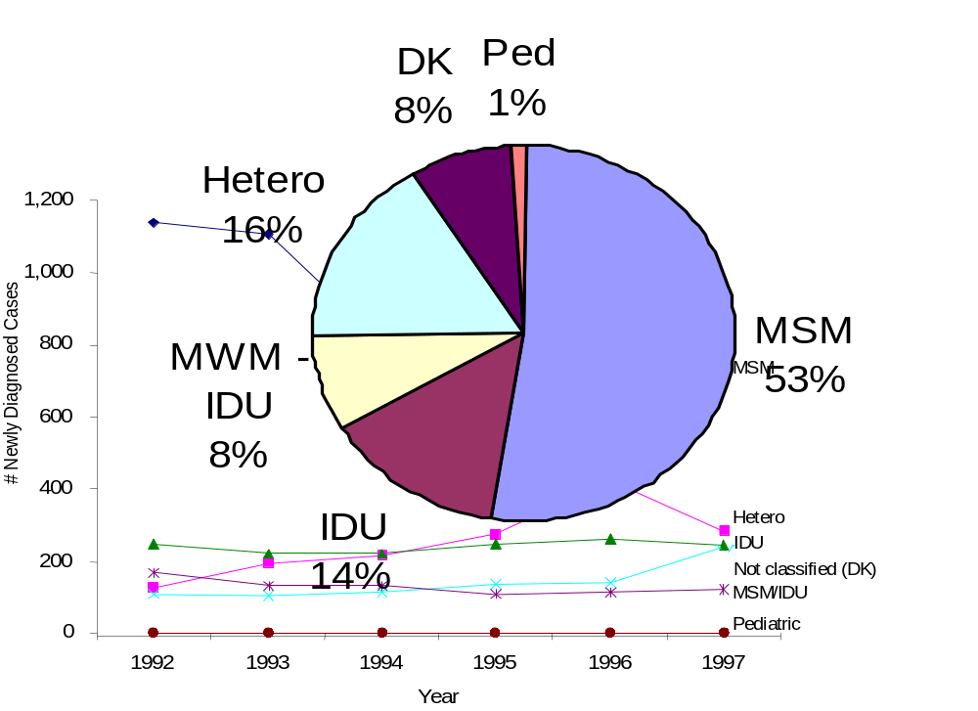
 | Fatality and Death Rates
Death rates are substantially higher among African Americans than Anglos or Hispanics. | As a decline in diagnosed AIDS cases and increase in those living with AIDS is observed, it is not surprising to see that the overall death rate (defined as rate per 100,000) has declined as measured by the crude death rate per 100,000. As shown in Figure 7, the death rate is substantially higher among the African American population, and while it has declined faster than that of the Anglo and Hispanic populations, it continues to be between three or four times the rate of the Anglo and Hispanic death rate.
Figure 7 HIV/AIDS Deaths by Ethnicity per 100,000 of Houston Area Population
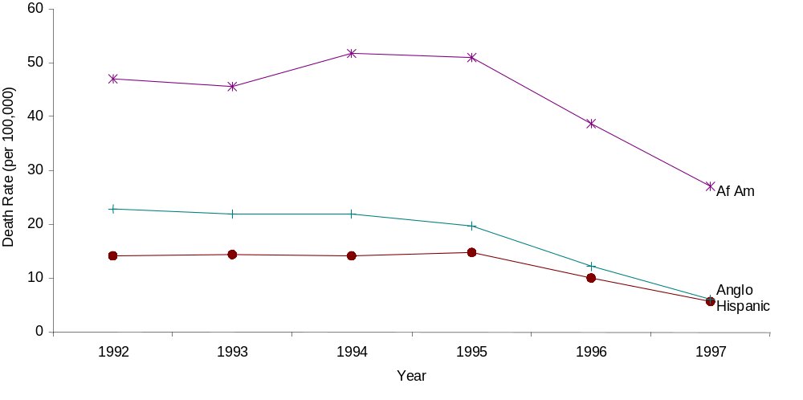
Those African Americans who have entered the system of care appear to have about the same fatality rate as Anglos or Hispanics. | This large discrepancy between African Americans and other ethnic populations is somewhat moderated by the fatality rates shown in . This “fatality rate” measures the death rate among a cohort diagnosed with AIDS during a certain calendar year and tracked by TDH. Unlike the rate per 100,000, these PLWA have entered the care system and are tracked by TDH. Case fatality rates are expected to decline for more recently diagnosed cases because of improved care and shorter periods of time with AIDS, but they are useful for comparing between groups how lethal it was over time to be diagnosed with AIDS.
 | indicates that fatality rates have declined among all ethnic groups at about the same pace. In 1998, Asians have the lowest fatality rates, followed by Anglos and African Americans. Hispanics, taking an upward turn, increased from 10% to 11%.
 | One likely explanation for the difference in the death rates among the cohort and all those reported for AIDS is that many African Americans may not be entering the system of care until a very late stage of the illness. However, the small difference in fatality rates among ethnic populations in the cohort may suggest that those African Americans who access the system are surviving at the same rate as Anglos and Hispanic persons living with AIDS.

Figure 8 % Deceased by Year of People with AIDS in a Cohort Tracked by TDH
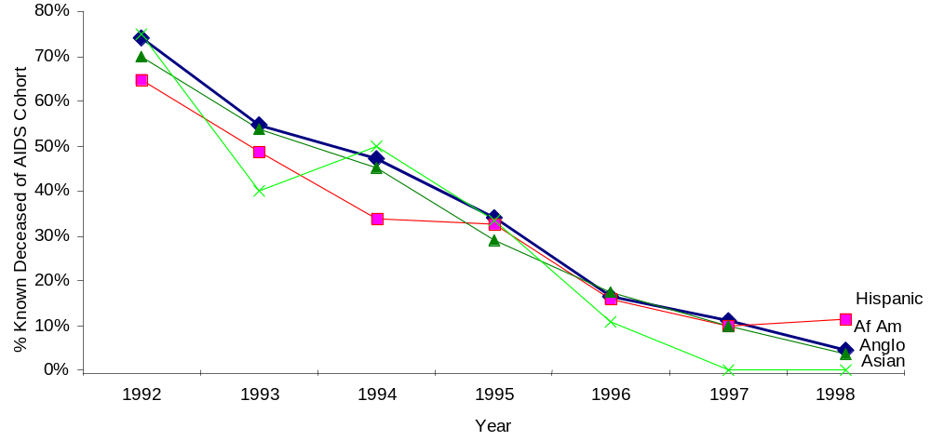
 | People Living with AIDS
There is a dramatic increase of PLWA. | With the decreased mortality rates, there is an increase in the number of people living with AIDS. As shown in , the number of PLWA increased from 1,731 in 1992 to 7,538 in 1998. The increase in PLWA is consistent across all ethnic populations ( Figure 10) and risk groups (). The counties outside of Harris generally show an increase in PLWA (Chambers County only had a few AIDS cases and therefore, they cannot be reflected on the graph) ).

Figure 9 Living with AIDS: Houston EMA and Harris County
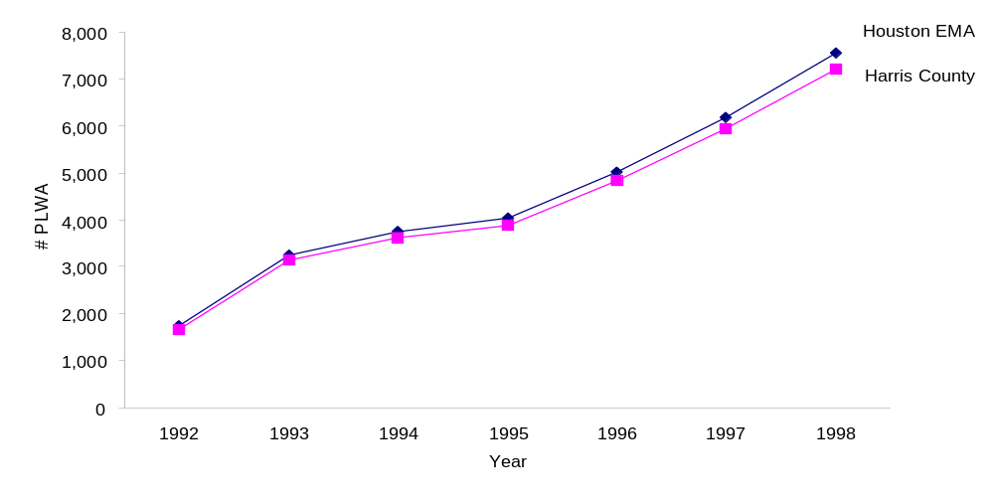

Figure 10 Living with AIDS by Ethnicity
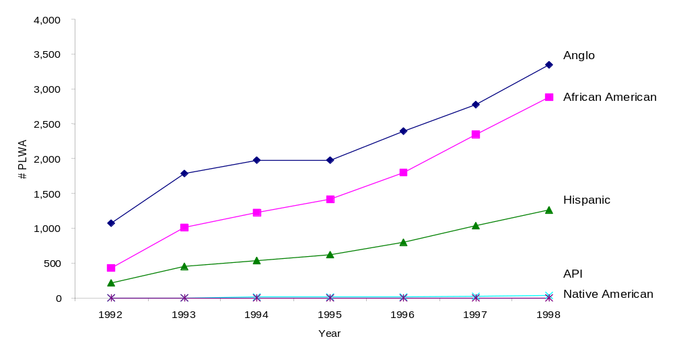
Figure 11 Living with AIDS by Risk Group
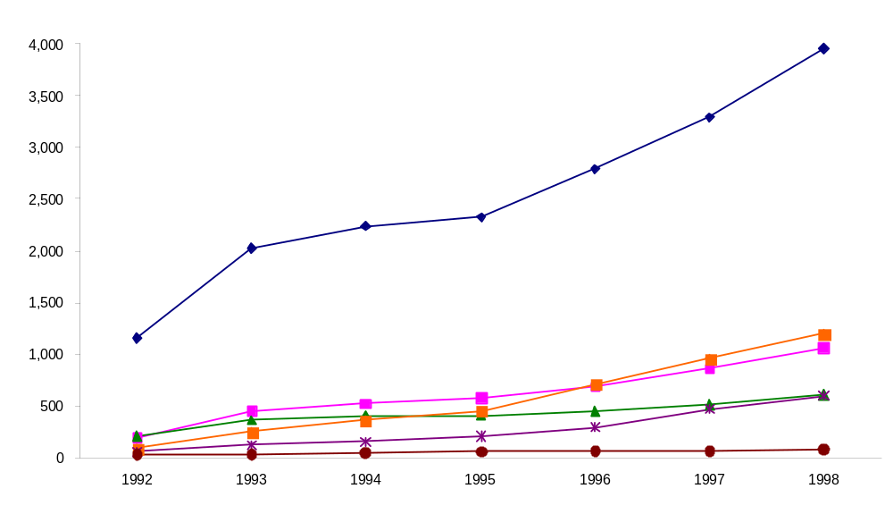
MSM
IDU
Heterosexual
MSM/IDU
Not Classified
Pediatric

Figure 12 Living with AIDS by Counties
(Note: Chambers had 1 case each year from 1992 – 1997 and 3 cases reported in 1998.)
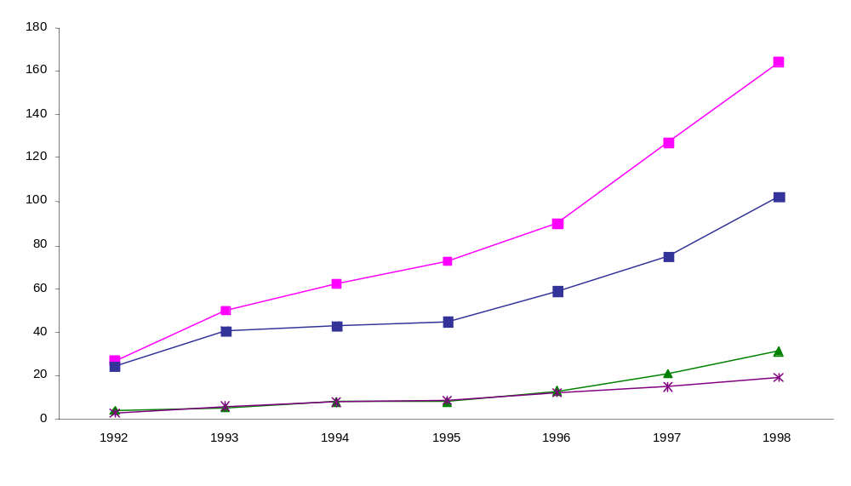
Liberty
Fort Bend
Montgomery
Waller

The rate of change in increase of PLWA is highest among the African Americans. | The rate of change in the increase of those living with AIDS is lowest among Anglos when compared to African Americans and Hispanics. Between 1995 and 1998, the rate of change substantially decreased for African Americans and Hispanics ( Figure 13).
Figure 13 % Increase in Living with AIDS from 1992-1998 by Race
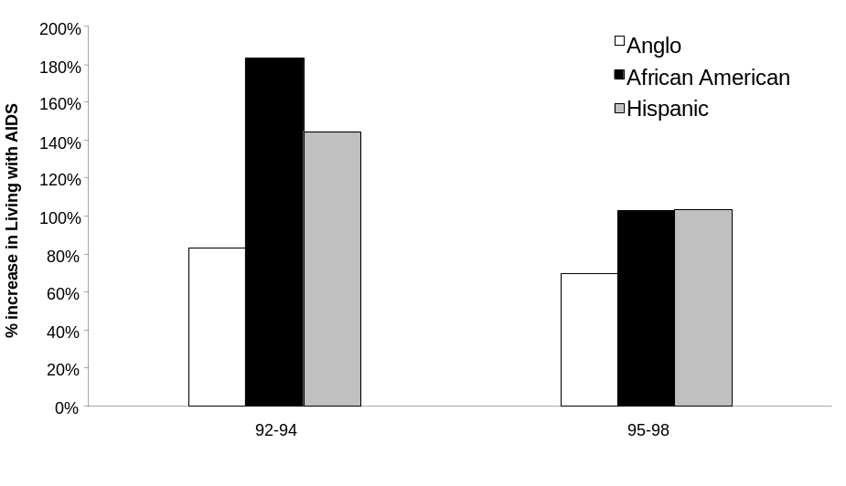
As seen in Figure 14, of all the risk groups, heterosexuals show the greatest percentage increase of those living with AIDS from 1992 to 1994, but it was consistent with other groups from 1995-1998. In terms of actual numbers, 97 heterosexuals living with AIDS in 1998 remain relatively low.
Figure 14 % Increase in Living with AIDS from 1992 - 1998 Risk Group
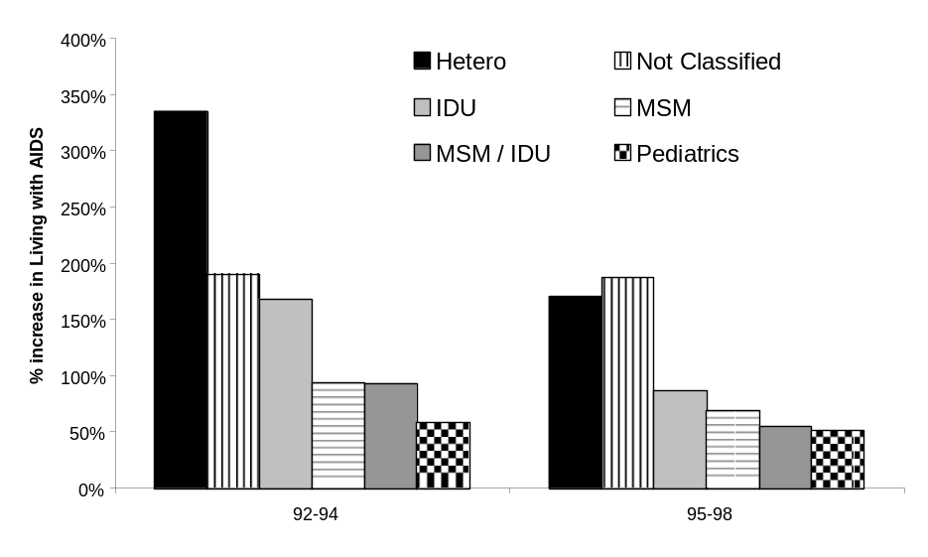

MSM will continue to be the majority of PLWA for several years. African Americans and Anglos will be the two largest ethnic groups with AIDS. | The profile of persons living with AIDS will change slowly because of the decreasing number of persons diagnosed with AIDS and the low mortality. The percentage of Anglos (44%) who are living with AIDS in 1998 indicates that they will continue to be the largest number of those living with AIDS at least until 2003. However, the profile of those living with AIDS will begin to shift slowly toward African Americans. The majority of MSM (53%) in 1998, suggest they will be the dominant risk group for the foreseeable future. Overall, the trend toward increased numbers of PLWA should be sustained provided the efficacy of triple therapy continues.
 | Projecting the Number of AIDS Cases Diagnosed Each Year
There is no agreed upon formula for estimating future AIDS cases. | There is no agreed upon formula for estimating future AIDS cases. Provided the efficacy of treatment continues, fewer persons will die due to AIDS and fewer people will progress from HIV infection to AIDS as currently defined. In addition, there are different patterns of progression among different ethnic populations and risk groups. More widespread and earlier use of prophylactic treatments has delayed the onset of opportunistic infections (OI’s) and the decline in T-cell counts. With the continued use of combination therapies people living with HIV are likely to maintain a higher T-cell count and low viral loads, and avoid the progression to AIDS.
There is some evidence of increased failure rates of medication. | There is growing evidence of increased failure rates in some medication and the potential for adverse side effects of medication for long-term survivors. Still, with new medications in the pipeline and the increased likelihood of early detection, the current trend in delay to AIDS will probably continue for the next several years.
There are many unknown elements in estimating AIDS cases. | While new treatments provide a more optimistic outlook for those infected, the impact of these new treatments on the number of AIDS cases is uncertain. As shown above there is already a trend toward fewer diagnosed cases each year. Yet, there are many unknown factors that make valid projections of AIDS cases unreliable, including:
 | - the percentage of people living with HIV that will not be able to tolerate anti-retroviral treatments,
 | - the continued efficacy of treatments, and
 | - the access and availability of the treatments among the different communities most affected by HIV.
 | Given the great uncertainty, simple projections based on past history, plus some educated guesses about the progression of the disease is likely to be as accurate as more complex models based on equally uncertain assumptions. For the projected number of PLWA, three models are proposed.
Cases diagnosed each year will continue to decline. | In the first model (Figure 15), a linear trend line is projected based on the decline from 1992-1998. The number of AIDS cases diagnosed each year in the Houston EMA is projected to decline from 1,806 cases in 1992 to about 900 in 2003. This is an unlikely scenario, however, because the current level is presently 930 new cases a year. Empirically, the correlation (R²) is relatively low showing that the linear relationship is not strong. Still, as seen in Figure 15, the epidemic in Houston has not shown a straight downward trend in the past. The recent evidence of an increase in infection rates among young MSM nationally could be reflected in an increase in the number of AIDS cases if there is a high failure rate in medication or poor adherence to medical regimens.
Figure 15 Linear Trend for New AIDS Cases by Year of Diagnosis for Houston EMA
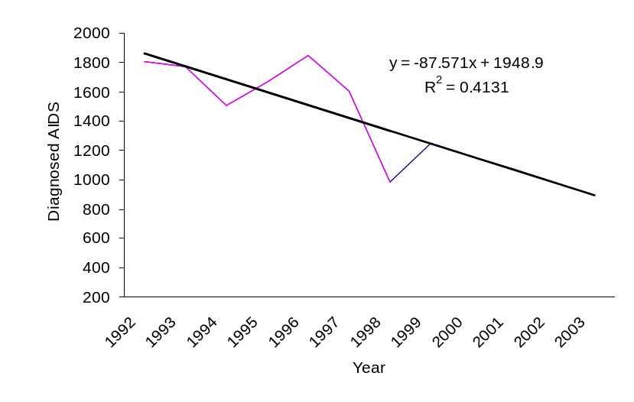
A second model, shown in Figure 16, shows a loglinear projection based on the years from 1996 to 1998. A loglinear projection is used because of the leveling off of newly diagnosed cases. Only the last three years are used because since 1996 there has been a consistent decline in the number of newly diagnosed cases that is likely to be the pattern given the efficacy of the medications. The “fit” is much improved as indicated by the high R² of .84 shown in Figure 16.
Figure 16 Loglinear Projection of Newly Diagnosed AIDS Cases (Reported 1998 data)
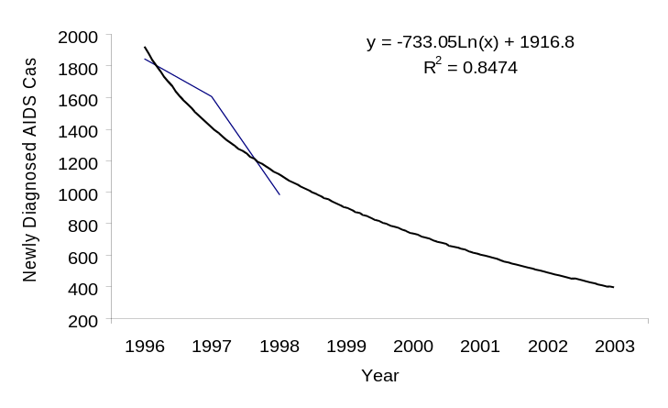

Because 1998 newly diagnosed cases have not been fully reported, the decline may be less steep than suggested in Figure 16. The same loglinear projection is made in Figure 17 assuming that the rate of decline in 1998 will be the same as it was in 1997. Since the decline would not be as steep, there would be just under 1,000 newly diagnosed cases projected for the year 2003.

Figure 17 Loglinear Projection of Newly Diagnosed AIDS Cases (Trend of 1998 cases based on 1996-1997 data)
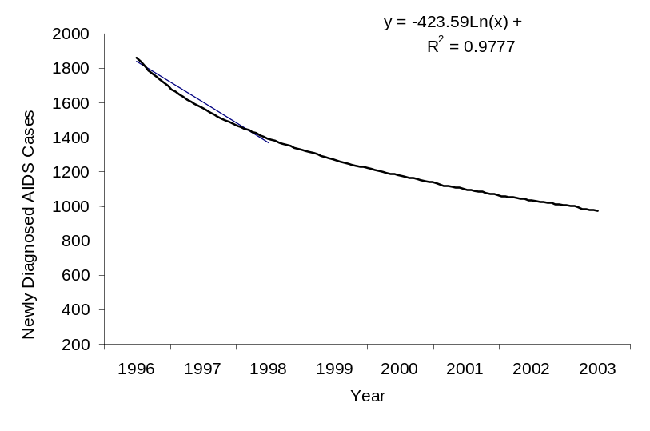

Models show the decline in yearly-diagnosed cases from 1996 to 2003. | A fourth model, provided in Figure 18, projects the trend of declining AIDS cases diagnosed. The decrease in newly diagnosed AIDS cases is assumed to accelerate slightly, but not linearly. This is based on the assumption that new medications will prove more effective thus slowing the trend of progression from HIV to AIDS, but that for some persons the medications will be ineffective. The explicit assumptions are that in 1999 new cases will decline by 13%. In this scenario, the cases diagnosed from 1992 to 2003 will decline from 1,628 to between 700 and 500 newly diagnosed cases each year for the Houston EMA.

Figure 18 “Best Guess” Trend of Cases by Year of Diagnosis for Houston EMA
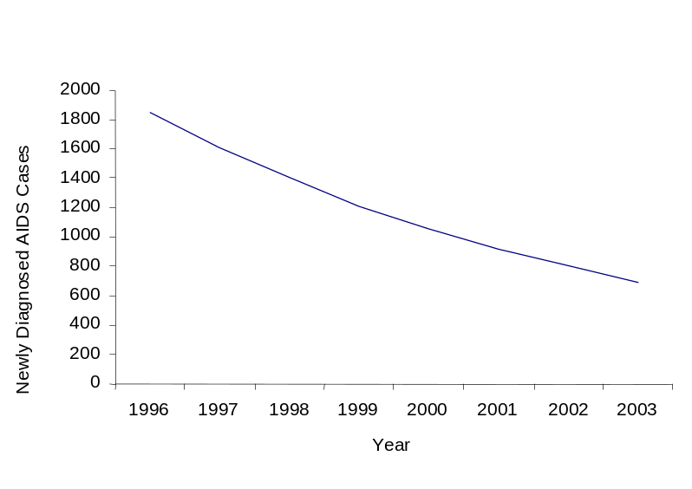

 | Projecting the Number of People Living with AIDS
Yearly cases decline while the number living with AIDS increases. | At the same time, the number of people living with AIDS will continue to increase, as mortality rates continue to decline. Two models are presented. The first is a logarithmic projection until 2002 based on the 1992-1998 data (Figure 19). It assumes that PLWA will continue to grow, but at a slowed rate because while fewer people die, fewer persons are also being diagnosed with AIDS. The estimates are that the cumulative number of PLWA will increase from 1,731 PLWA in 1992 to about 14,344 PLWA in 2003.
The projections assume continued effective treatment. | The second model ( Figure 20) assumes that 90% of those living with AIDS will continue to live in 1998. This will increase to 95% in 1999 and 2000 and further increase to 98% in 2001-2003. Given the fewer number of persons projected to progress to AIDS, this model projects that cumulative PLWA will increase from 1,731 persons in 1992 to about 10,845 in 2003.
 | The projected model assumes a greater efficacy of treatment and both models assume a relatively low mortality rate.

Figure 19 Trend for PLWA in Houston EMA: Loglinear Model
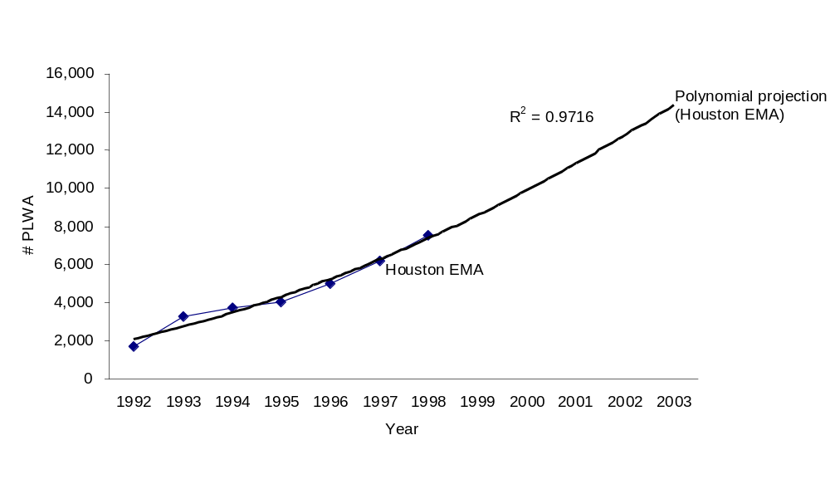

Figure 20 Trend for PLWA in Houston EMA: Revised Model
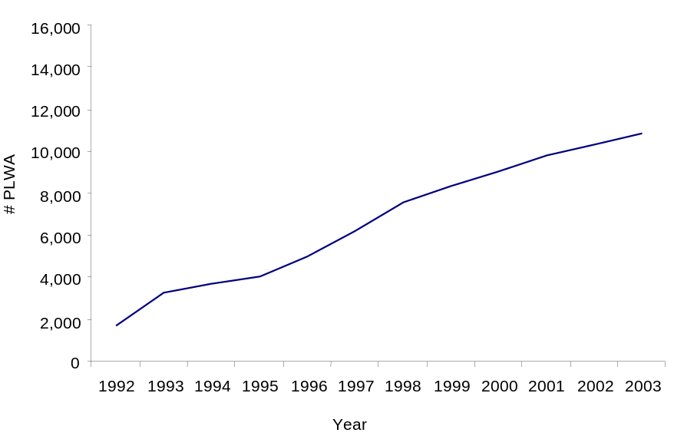

 | PEOPLE LIVING WITH AIDS IN 1998
 | Ethnicity, Sex, and Risk Group
7,538 people were living with AIDS at the end of 1998. | The profile of PLWA is detailed below for 1998. The total number of living AIDS cases at the end of the 1998 was 7,538. Mode of exposure, race, and age, divided by sex, are shown in – Figure 23.
83% PLWA were male.  Heterosexuals are 55% female. IDUs are 36% female. | About 83% of the cases are male, representing 6,285 cases, and 17% are female, representing 1,243 cases. As shown in , more than half the PLWA are MSM. There are slightly more heterosexuals than IDUs. There are 651 females and they are the majority of the heterosexuals (55%). Females are a minority of the IDUs (36%), with 388 cases. The majority of females living with AIDS (68%) are African American.

Figure 21 PLWA through 1998 by Risk Group and Sex
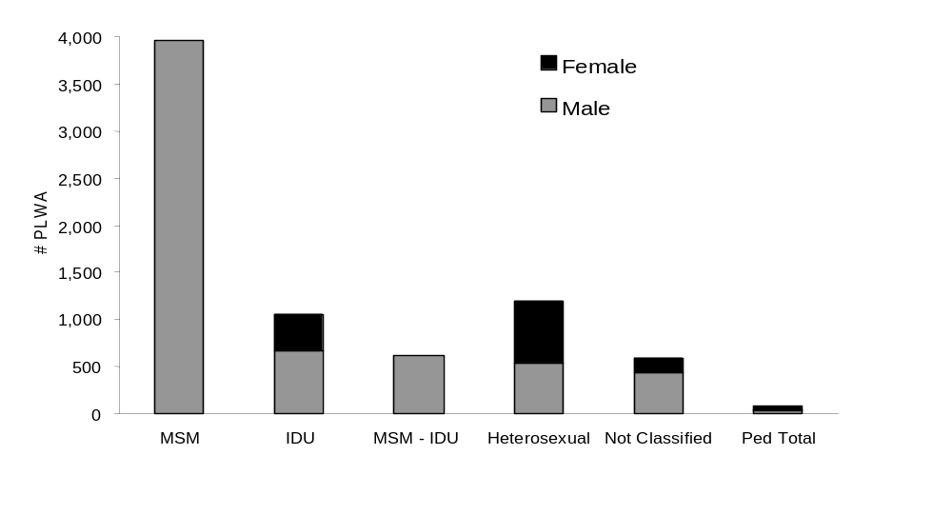

Compared to the general population, PLWA are disproportionately African American. | indicates that the 3,350 Anglos living with AIDS constitute about 44% of all those living with AIDS, followed by 2,883 African Americans (38%). The proportion of Anglos in the epidemic are less than the proportion of Anglos in the general population (44% Anglos living with AIDS versus 60% in the general population). In contrast, the 44% representation of African Americans among PLWA is significantly greater than their 15% representation in the general population. There are 1,267 Hispanics living with AIDS. There are proportionately fewer Hispanics living with AIDS (17%) than Hispanics in the general population (20%).

Figure 22 PLWA through 1998 by Ethnicity and Sex
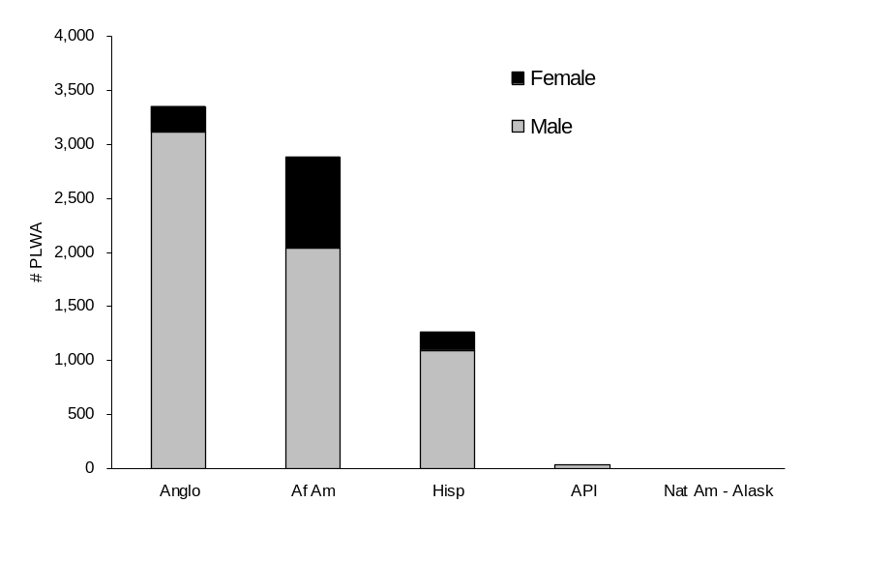

84% of those living with AIDS are over 25. 8% are over 50 and 8% are under 25. | Figure 23 shows that the vast majority (84%) of those living with AIDS is between 25 and 49 years of age. About 8% of the PLWA are over 50 and 8% are under 25. There are 37 infants living with AIDS, 28 between the ages of 2 and 12, and 88 adolescents (13-19).

Figure 23 PLWA through 1998 by Age Group and Sex
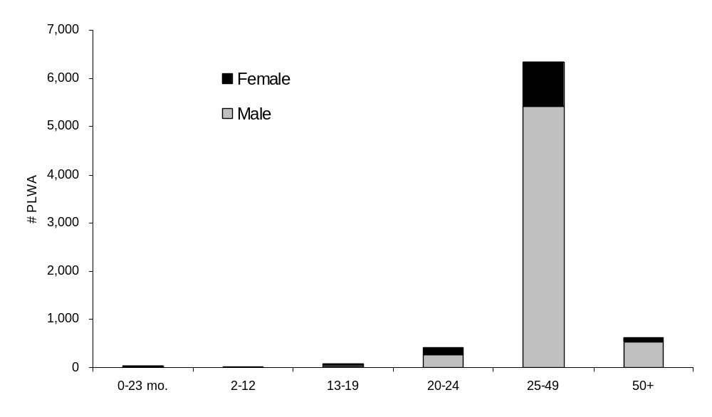
 | In 1998, more adolescent. PLWA are African American (59 out of 88 cases) than other ethnic groups. Fifteen (15) adolescents living with AIDS are Hispanic and 13 are Anglo.
 | The profiles of the risk groups are different. Figure 24 indicates that:
MSM are more likely to be Anglo. | - MSM living with AIDS are more likely to be Anglo (2,333) than non-Anglo (African American (928), Hispanic (681) and Native American (3)).
IDUs are more likely to be African American. | - IDUs are more likely to be African American (703) than Anglo (251) or Hispanic (113).
Heterosexuals are more likely to be African American. | - Over 60% of heterosexual cases are African American (721) followed by Hispanics (244) and Anglos (222).
 | As shown in Figure 24, about 53% of those living with AIDS are MSM. Heterosexuals represent about 15% and IDUs represent about 14%. MSM/IDUs comprise 8% of those living with AIDS. There are 79 PLWA who had perinatal exposure to HIV and 29 PLWA who have contracted AIDS through blood or blood products.

Figure 24 PLWA in 1998 by Risk Group and Race
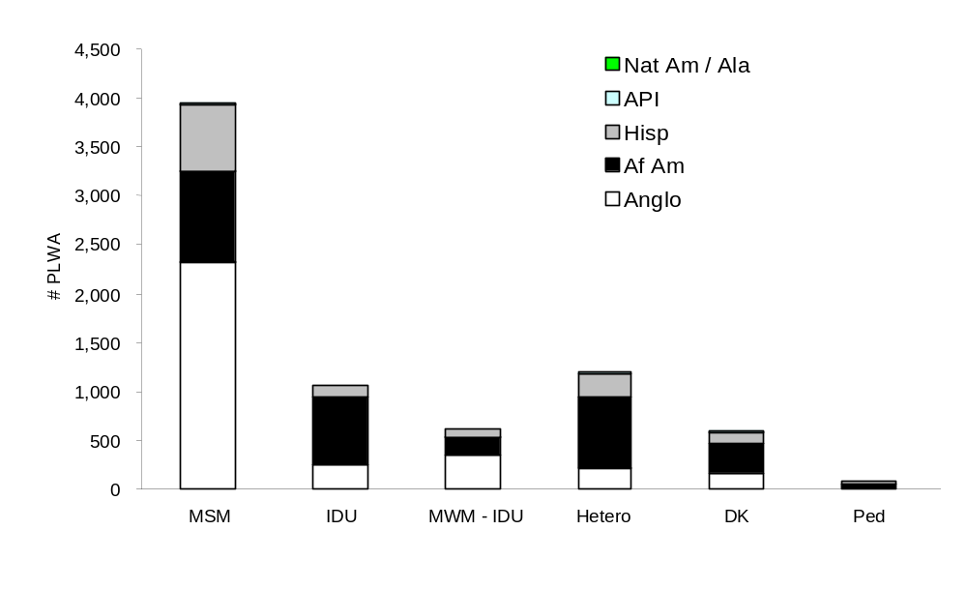
Harris County accounts for 96% of PLWA in the EMA. | As shown in Figure 25, over 96% of the PLWA in 1998 come from Harris County. Fort. Bend has about 2% and Montgomery has about 1.5%. The remaining counties in the EMA have less than 1% of the PLWH/A. Figure 26 indicates that 96% of the cases are urban.

Figure 25 PLWA by County in 1998
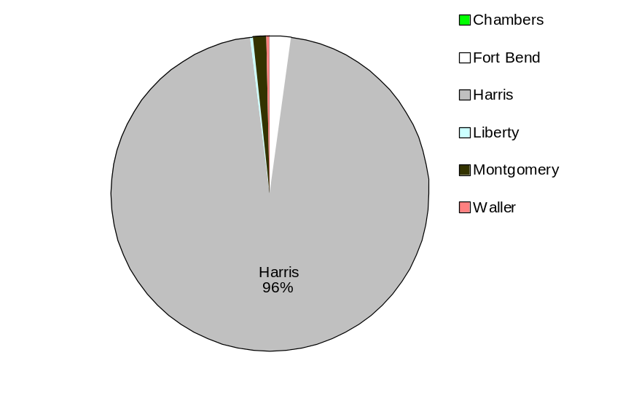

Figure 26 PLWA by Urban Rural in 1998
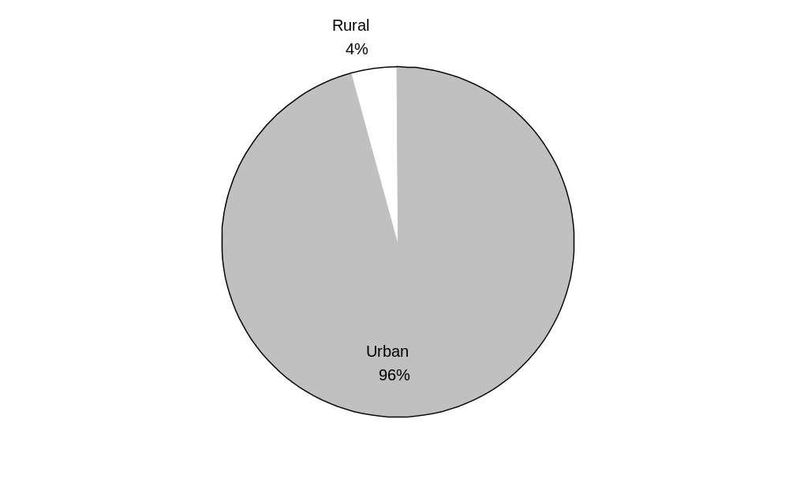

While the number of cases in the rural counties is small, as shown in Figure 27, the four counties with more than 30 cases, Harris, Fort. Bend, Montgomery, and Liberty have similar profiles. Waller County reports only 19 cases and Chambers County reports only three cases.

Figure 27 PLWA in 1998 by County and Risk Group
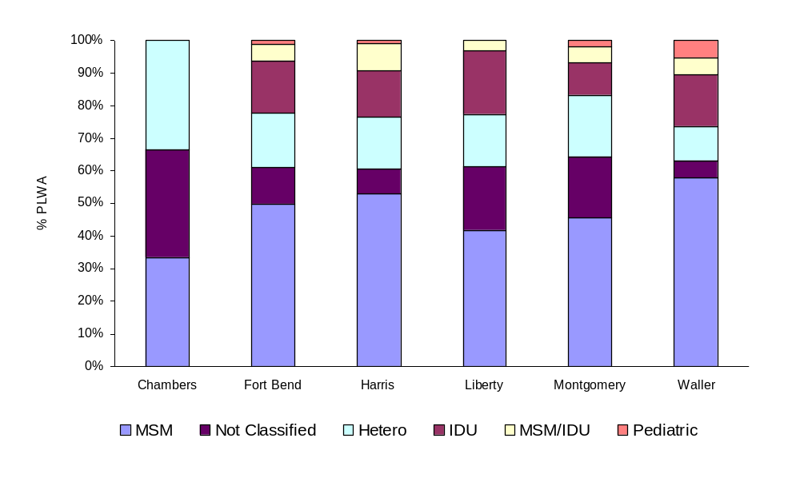

 | Subpopulations with Small Numbers of People Living with AIDS
In 1998, there were 88 persons between the ages of 13 and 19 living with AIDS. They had a wide range of risk factors. | Adolescent and pediatric PLWA have special needs. There are 88 adolescents with AIDS between 13 and 19 years old. These adolescents have a wide range of risk factors. As shown in Figure 28, 57% report heterosexual transmission, while about 19% report MSM, and 7% report IDU transmission. Indicating a growing survival rate for infants living with HIV, 17% of the adolescents indicated becoming infected as an infant (Pediatric).

Figure 28 Young Adults and Adolescents (Between 13 and 19 Years Old) Living with AIDS in 1998: Risk Factors
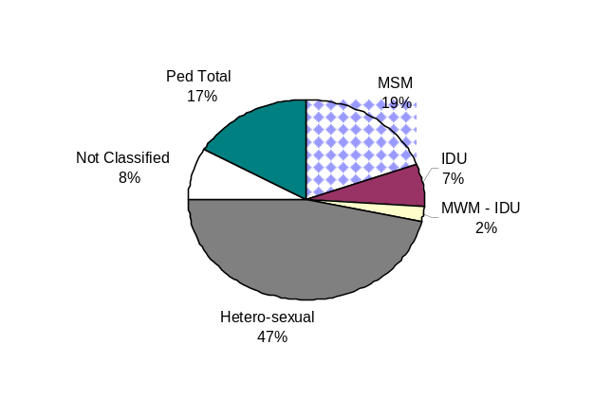

There were 37 infants with AIDS in 1998 and 28 two to twelve year olds living with AIDS. | In 1998, 37 infants age 0 to 23 months were reported living with AIDS, and there were 28 two to twelve year olds diagnosed with AIDS. Figure 29 indicates that the majority of the 28 young persons living with AIDS are African American, followed by Hispanics. About half the young persons living with AIDS are male and half are female.

Figure 29 People less than 13 Years Old Living With AIDS by Race
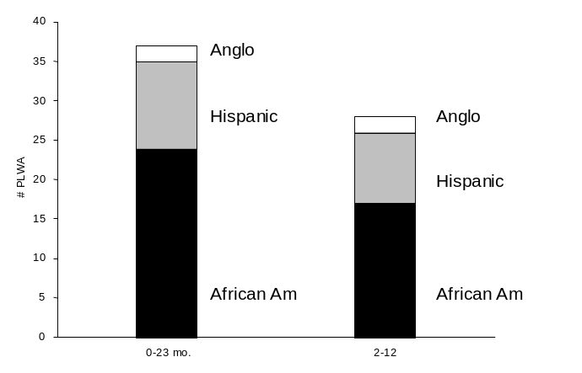

 | Other PLWA Subpopulations
In 1998 there were 33 PLWA who were API and 5 Native Am. | Other small groups of PLWA included Asian-Pacific Islanders (API) with 33 cases and 5 Native Americans living with AIDS. Of the 33 APIs, 15 are MSM and 12 are not classified.

 | HIV ESTIMATES
 | Estimates of HIV infection are important in planning HIV services and AIDS care because they are an indicator of the magnitude of cases that will need to be treated in the future, and early treatment intervention is recommended to stop the progression to AIDS.
 | The challenges of estimating HIV were well put in a recent correspondence with Sharon King, head of the HIV/STD Epidemiology Monitoring Branch of the Texas Department of Health. She writes:
Valid estimates of HIV infection are impossible to estimate due to many unknown factors. | The prevalence [of HIV] depends on two factors: new HIV infections and deaths, the recent advances in triple combo therapy have thrown everything into disarray. It will affect the number of AIDS cases reported. [This] will affect the number of deaths. As you [Dr. Cohen] mentioned, if more people are living with HIV, there are that many more chances for the virus to be transmitted unless the situation is ameliorated by prevention and clear evidence that lowered viral load is a big factor. Also we cannot predict what will happen with regimen compliance and with mutation of the virus to be resistant to the new drugs. We cannot predict if drug research will keep ahead of the virus. So almost any figure you [PCH] come up with is a really wild guess divined from sheep entrails. I always feel like putting on my “Merlin” outfit when I do these estimates.
 | It is clear that persons continue to be at risk. About 28.5% of the PLWA interviewed for the 1997 Greater Houston EMA/HSDA HIV Community Needs Assessment indicated that they had not used condoms during the last time they had either vaginal or anal intercourse. While over 60% reported that their partner was HIV positive, about 15% stated that their partner was HIV negative and 23% reported that they did not know the HIV serostatus of their partner. Although transmission rates cannot be estimated, this data indicate the continued risk of seroconverstion.
PPG and CDC HIV estimates, and HHSC population estimates are .used together to estimate HIV. | This report presents several alternative models for estimating the number of HIV infected individuals in the Houston EMA. In the text below, the HIV seroprevalence estimates made by the Prevention Planning Group (PPG) from Public Health Region 6 (PHR6), from various counseling and testing studies, and by CDC statisticians have been applied to population estimates of the Houston EMA. In addition, a new estimate is given based on applying the rates from the cohort studies at clinics in Houston and applying logistic regression and odds ratios, a statistical technique that provides the likelihood that HIV will infect different populations. They should be viewed as rough estimates that suggest trends in infection. Given the many unknown factors above, the infection rates could change substantially over the next few years.
 | At-Risk Population Estimates
 | HIV Estimates re: Holmberg / CDC with the Interim IDU Estimates
 | Dr. Scott Holmberg from CDC presented the most detailed estimates of at-risk populations living in the Houston Metropolitan Statistical Area (MSA) in an article “The Estimated Prevalence and Incidence of HIV in 96 Large US Metropolitan Areas”. His population estimates are shown in Table 2.
Table 2 At-Risk Population Estimates by Holmberg
 |  | Holmberg | % of pop | Census pop estimate | TSDC², 1999 pop estimate
 |  | Total Houston MSA (EMA)¹ |  | 3,551,775³ | 3,931,269
 |  | IDU | 1.84% | 65,200 | 72,166
 |  | MSM | 1.35% | 48,000 | 53,129
 |  | Heterosexual | 2.29% | 81,400 | 90,097
 |  | Total at risk | 5.48% | 194,600 | 215,392
- The Houston EMA (a HRSA designation) is the same as the Houston MSA (a census bureau designation). Each has the six counties shown in the Attachments.
- Texas State Data Center
- Census estimate from Holmberg
When the figures presented by Holmberg were reviewed by the Houston Department of Health and Human Services (HDHHS), current experience with the incidence of HIV and AIDS suggest that Holmberg’s estimate of IDUs was unrealistically high. The HDHHS believes that:
- If Houston had the number of IDUs Holmberg projected, the epidemic would have shown a dramatic increase in the proportion of IDUs being diagnosed with AIDS, as shown in EMAs with a higher proportion of IDUs at risk.
- In comparison to similar size EMAs, the number of IDUs in substance abuse programs is lower than would be expected if there were the number of IDUs projected by Holmberg.
- The proportion of MSM in comparison to other at-risk populations is shown in the Holmberg’s paper to be lower in Houston than in any other Texas EMA. There is no known reason why Houston would have a significantly different profile of at-risk populations than other Texas EMAs, i.e., the proportion of MSM at-risk should be much higher than the proportion of IDUs.
 |  | The consensus of a group of experts in the behavioral sciences and substance abuse fields is that there are no accurate data available on the number of injection drug users in the Houston EMA. The HDHHS staff is reviewing data from other EMAs to ascertain whether any accurate projections can be made from existing AIDS case data to estimate potential numbers of HIV-infected individuals by risk group. In the interim, a number half of the Holmberg estimate for IDUs at-risk is used for modeling projections. While this change is not empirically based, the HDHHS staff agrees that it is a more realistic estimate but that it may still significantly overestimate the extent of the IDU population in the Houston EMA. As a result, half the Holmberg estimate would result in 32,600 IDUs at-risk for HIV. Table 3 summarizes the estimates based on the revised IDU at-risk population.

Table 3 Interim At-Risk Population Estimates
 |  | HHSD | % of pop | Census pop estimate | TSDC², 1999 pop estimate
 |  | Total Houston MSA (EMA)¹ |  | 3,551,775 | 3,931,269
 |  | IDU | 0.92% | 32,600 | 36,083
 |  | MSM | 1.35% | 48,000 | 53,129
 |  | Heterosexual | 2.29% | 81,400 | 90,097
 |  | Total at risk | 4.56% | 162,000 | 179,309
- The Houston EMA (a HRSA designation) is the same as the Houston MSA (a census bureau designation). Each has the 6 counties shown in the Attachments.
- Texas State Data Center
 |  | The Prevention Planning Group has also presented an estimate of HIV infection as part of the Regional HIV Prevention Plan for Public Health Region Six. The percentage of population at risk estimated by the PPG is applied to the 1999 Texas State Data Center (TSDC) population estimate of the EMA in Table 4
Table 4 At-Risk Population Estimates Recommended by PHR6
 |  | PPG | % of pop | PHR6 Pop estimate | TSDC, 1999 pop estimate
 |  | Total Pop PHR6 |  | 3,690,742 | 3,931,269
 |  | IDU | 0.68% | 25,200 | 26,842
 |  | MSM | 1.09% | 40,300 | 42,926
 |  | Heterosexual | 0.97% | 35,800 | 38,133
 |  | Total at risk | 2.74% | 101,300 | 107,901
- The Houston EMA (a HRSA designation) is the same as the Houston MSA (a census bureau designation). Each has the 6 counties shown in the Attachments.
- Texas State Data Center

 | The TSDC population estimate and the percentage of at risk population derived by Holmberg with the HDHHS interim IDU correction are the basis for all HIV projections provided in Table 5 and Table 6. The HIV estimates include PLWA.
Using CDC methods, in 1999 there were between 16,876 and 19,420 people with HIV infections. | Table 5 provides the estimated number of HIV infections for the Houston EMA based on Holmberg with an interim IDU estimate. It uses the “high” and “low” number of new infections estimated by Holmberg and adjusts it for TSDC estimated 1999 population. Table 6 uses the Holmberg estimate adjusted by the interim IDU estimate, but applies the 1999 population estimates supplied by TSDC. Notably the “low” 1999 estimates based on projected new cases (16,876) shown in Table 5 is lower than those shown in Table 6 that are based on population estimates (17,537) because of the impact of a substantially greater population.
Table 5 HIV Rates Based on the Interim IDU Estimate Using Holmberg’s “Low” and “High” Estimates for New Infection
 | Houston MSA:  3,551,775 | Estimated At-Risk for HIV | HIV Cases per 1000 | % of at risk population infected | Est # HIV positive 1995 | New infections per yr. |  | HIV positive 1999
 |  |  |  |  |  | Low | High | Low | High
 | IDU | 32,600 | 61 | 6.10% | 2,000 | 110 | 413 | 2,440 | 3,152
 | MSM | 48,000 | 260 | 27.0% | 13,000 | 70 | 350 | 13,280 | 14,400
 | Heterosexual | 81,400 | 11 | 1.1% | 900 | 64 | 242 | 1,156 | 1,868
 | Total |  |  |  | 15,900 |  |  | 16,876 | 19,420

Table 6 HIV Rates for Houston Based on the Adjusted Estimate of Holmberg Updated with 1999 TSDC Pop Estimate
 | Houston EMA | Estimated at-risk for HIV 1999 | Percent of at-risk population infected | HIV positive 1999
 | IDU | 36,083 | 6.1% | 2,201
 | MSM | 53,129 | 27.0% | 14,345
 | Heterosexuals | 90,097 | 1.1% | 991
 | Total | 179,309 |  | 17,538
 | 1999=3,931,269 total population

Population growth and trends greatly affect HIV projections. | Although both Table 5 and Table 6 use Holmberg assumptions, it is particularly instructive to note the impact of population growth on projected seroprevalence, holding constant the infection rate to 1995 levels.
 | HIV Estimates Based on Logistic Regression re: Cohort at Testing Centers
 | As a third estimate, the rate of HIV infection is determined by the logistic regression analysis using the database from the City of Houston HHSD. The database contains information of three STD clinics and one community-based clinic (1991-1998). There are four clinics represented, one in a service area frequented by predominately gay/bisexual men and the others in service areas that have lower socio-economic clients.
 | Although the clinics do not capture a random sample of respondents, the different clinics allow a reasonable estimate of at-risk populations based on the demographics of the cohort as described below. It is likely that those being tested perceive themselves to be at higher risk, and the results would be over-estimating infection rate.
 | The characteristics of people testing for STDs at the three clinics (N=40,621 over 8 years) that are used to estimate the heterosexual and IDU rates are as follows:
 | - About 8.4% of the subjects are White, 74.9% Black, 15.1% Hispanic, .8% Asian, .2% Native American, and .2% others.
 | - About 80% of the subjects are within the age range of 20 to 34.
 | - About 2.7% of the subjects are HIV positive.
 | - Over 95% are heterosexual.
 | - About 1.7% of the clients are MSM.
 | - 1.7% of the clients are IDUs.
 | - About 55.6% are male and 44.3% are female
 | The characteristics of the community-based clinic that are used to estimate the MSM rate are described below. The clinic is located in a traditionally gay area in Houston and serves a large number of MSM. The sample size of the Cohort over 8 years is 9,500. The demographic profile of all clients includes:
 | - About 63% are White, 20% Black, 14% Hispanic, 2% Asian, .1% Native American and .3% others;
 | - About 76 % are within the age range of 20 to 39;
 | - About 13% are HIV positive;
 | - About 38% are heterosexual;
 | - About 34% are MSM;
 | - Over 75% are male;
 | - Only .3% are IDUs.
 | A logistic regression is used to estimate the rate of HIV based on the probability of the various at-risk populations being infected (the odds ratios between MSM and non-MSM; IDU and non-IDU; heterosexual and non-heterosexual; male and female; White, Black, and Hispanic).
 | Based on the data from the clinics, the HIV positive rates are identified as follows:
Table 7 Probability Estimates Based on City Cohort
 | Risk Group | Average Rate 1991-1998 | Average Rate 1997-1998
 | IDU | .0531 | .0509
 | MSM | .3064 | .2193
 | Heterosexual | .0219 | .0161

Table 8 summarizes the estimates based on the 1991 to 1998 and 1997 to 1998 average HIV positive probability.
Table 8 Estimates of HIV for Subpopulations for 1999 Based on Clinic Data from the City of Houston HHSD
 |  | At-Risk Population estimate | % population PLWA in 1998 | Estimate HIV positive based on 1991-98 clinic data | Estimate HIV positive based on 1997 & 98 clinic data
 | IDU Total | 36,083 | 100% | 1,916 | 1,837
 | IDU Male | 22,660 | 62.8% | 1,203 | 1,154
 | IDU Female | 13,423 | 37.2% | 713 | 683
 | IDU African American | 23,743 | 65.8% | 1,263 | 1,209
 | IDU Anglo | 8,480 | 23.5% | 450 | 432
 | IDU Hispanic | 3,825 | 10.6% | 203 | 195
 | MSM Total | 53,129 | 100% | 16,279 | 11,502
 | MSM African American | 12,432 | 23.4% | 3,809 | 2,692
 | MSM Anglo | 31,293 | 58.9% | 9,588 | 6,775
 | MSM Hispanic | 9,138 | 17.2 | 2,800 | 1,978
 | Heterosexual Total | 90,097 | 100% | 1,973 | 1,460
 | Het. Male | 40,814 | 45.3% | 894 | 661
 | Het. Female | 49,283 | 54.7% | 1,079 | 799
 | Het African American | 54,509 | 60.5% | 1,194 | 883
 | Het Anglo | 16,758 | 18.6% | 368 | 272
 | Het Hispanic | 18,470 | 20.5% | 405 | 299

Projection of HIV Rate
As noted above, any estimate of HIV infection is, at best, a “guesstimate.” Yet for planning purposes, the Council requested that PCH provide an estimate for 1999 and 2003. The assumptions are:
- The overall population will grow from 3,551,775 in 1996 to 3,931,269 in 1999 and 4,196,400 in 2003 (based on the estimate from the Texas State Data Center, respectively.
The population increase indicates:
- There will be more gay and bisexual men in Houston. The number of gay men dying of AIDS is likely to decrease significantly and the number living with HIV will increase. If persons living with AIDS are infectious, there may be an increase in infection among MSM, but it is unlikely to be dramatic among gay men over 35 because they are likely to have fewer sexual partners. At the same time information from the sexually active young MSM show an increase in infection rates, especially among African Americans. Overall, the infection rate among MSM is likely to remain fairly constant.
- The relatively constant percentage of African Americans and the increase in percentage of Hispanics in the Houston EMA means that proportionately there should be a slight decline in rates of infection through injection drug use.
- The rate of heterosexual transmission of HIV will continue to increase, especially in African-American Women. The absolute number of HIV positive heterosexual and IDUs will be significantly smaller than the number of HIV positive MSM.
Based on these assumptions, Table 9 indicates the estimated HIV infection for 1999 and Table 10 provides HIV estimates for 2003. Four different approaches are used. The first uses the PHR6 estimate of at-risk populations and multiplies them by Holmberg’s projected 1995 rate of infection. The second is based on Holmberg’s 1995 HIV infection rate adjusted by the interim IDU estimate and TSDC population projections. The third estimate uses the average HIV estimate from the City clinics multiplied by the interim estimate and the adjusted TSDC population estimates. The fourth estimate is based on the average City clinics’ HIV infection rates for the 1997 and 1998 multiplied by the interim estimate and TSDC adjusted population estimates.
Table 9 Estimated HIV Positive Prevalence Based on 1999 Estimated Population
 | At Risk Population | Based on PHR6 estimated Population | Based on TSDC estimated Population | Based on City’s Clinics 91-98 | Based on City’s Clinics 97-98
 | IDU | 1,637¹ | 2,201² | 1,916³ | 1640⁴
 | MSM | 11,590 | 14,345 | 16,279 | 11,502
 | Heterosexuals | 419 | 991 | 1,976 | 1,460
 | Total | 13,646 | 17,537 | 20,171 | 14,602
 | - From Table 2, take the TSDC adjusted PPG population estimate of 26,842 and multiply it by Holmberg’s estimate of .061.in Table 3.
 | - From Table 4, take the TSDC adjusted Holmberg population estimate of 36,083 and multiply it by .061, Holmberg’s estimate in Table 3.
 | - From Table 5, take the City Cohort probability from 91-98 average estimate of .0531 and multiply it by the TSDC adjusted Holmberg population estimate of 36,083.
 | - From Table 5, take the City Cohort probability from 97-98 average estimate of .0510 and multiply it by the TSDC adjusted Holmberg population estimate of 36,083.
 | Table 10 Estimated HIV Positive Prevalence Based on 2003 Estimated Population
 | At Risk Population | Based on PHR6 estimated Population | Based on TSDC estimated Population | Based on City’s Clinics 91-98 | Based on City’s Clinics 97-98
 | IDU | 1,740 | 2,355 | 2,050 | 1,969
 | MSM | 12,350 | 15,295 | 17,358 | 12,265
 | Heterosexuals | 448 | 1,057 | 2,104 | 1,547
 | Total | 14,538 | 18,707 | 21,512 | 15,781

After examining the approaches, we recommend that the estimates based on the City’s clinics 1997-98 data be used because the data can closely reflect the epidemic of the Houston EMA. However, we also want to recommend a range (from high to low) for the estimates based on the trends of the data from 1996 to 1998. Table 8 summarizes the range of the estimates. The data suggest that the estimated number of people living with HIV in 1999 ranges from 13,014 to 20,376, and in 2003 the number of people living with HIV range from 13,811 to 22,016.
Table 11 Range of Estimates of HIV Positive for 1999-2003
 | Year 1999: At Risk Populations |  | Highest City Cohort 96-98 | Average 97-98 City Cohort | Lowest City Cohort 96-98
 | IDU | 38,583 | 2,165 | 1,964 | 1,034
 |  | Rate from City Cohort | (.0561) | (.0509) | (.0268)
 | MSM | 53,129 | 16,688 | 11,502 | 10,593
 |  | Rate from City Cohort | (.3141) | (.2193) | (.1994)
 | Heterosexual | 90,097 | 1523 | 1,460 | 1,387
 |  | Rate from City Cohort | (.0169) | (.0161) | (.0154)
 |  | Total | 20,376 | 14,926 | 13,014
 | Year 2003: At Risk Populations |  | Highest City Cohort 96-98 | Average 97-98 City Cohort | Lowest City Cohort 96-98
 | IDU | 38,607 | 2,165 | 1,965 | 1,035
 |  | Rate from City Cohort | (.0561) | (.0509) | (.0268)
 | MSM | 56,651 | 17,794 | 12,265 | 11,296
 |  | Rate from City Cohort | (.3141) | (.2193) | (.1994)
 | Heterosexual | 121,696 | 2,057 | 1,547 | 1,480
 |  | Rate from City Cohort | (.0169) | (.0161) | (.0154)
 |  | Total | 22,016 | 15,777 | 13,811

 | CO-MORBIDITIES
 | STDs
High STD rates are an indicator that risk of HIV infection is high. | Gonorrhea and syphilis rates indicate the level of unprotected sexual contact, and, in theory, should provide an early warning system for increased HIV infection. It is also known that individuals who have a history of STDs are more vulnerable to HIV infection.
STD rates are not a good predictor of AIDS. | Empirically, the relationship between STDs and AIDS is less clear. Given the latency period of AIDS, at best, increases in STDs may indicate an increase in AIDS over several years in the future. Other factors such as treatment of HIV and other medical factors make establishing a clear relationship difficult.
Even with increased HIV rates, it is not clear if these cases will progress to AIDS with the current medication. | Figure 30 STDs and AIDS plots the incidence of STDs from 1992 to 1997. Given the lag between infection and AIDS diagnosis, the decline in newly diagnosed AIDS in 1996 and 1997 may reflect the 1992-1993 decrease in gonorrhea and syphilis. If there is a relationship, a continuous drop in newly diagnosed AIDS will be seen for three more years.
 | The current increase in the rate of syphilis and gonorrhea rates between 1996 and 1997 send a warning that there may be more unprotected sex that could result in a rise of HIV. Given the current treatment alternatives, it is uncertain individuals diagnosed with HIV will progress to a diagnosis of AIDS.
Figure 30 STDs and AIDS
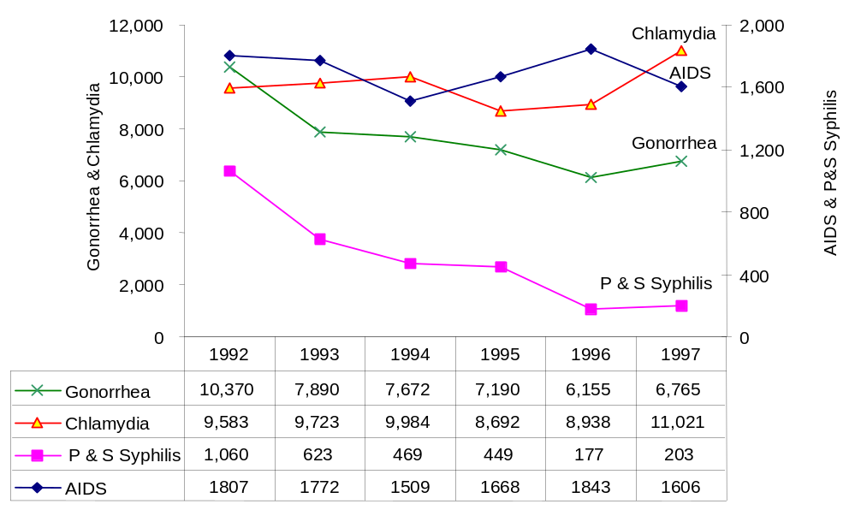

 | As shown in Attachment 4, the rate of gonorrhea varies by county and type of infection. However in Harris County, this accounts for 96.5% of those living with gonorrhea, and there has been an overall decline in STDs from 1992 to 1997.
Chlamydia rates are rising. While not related to the prevalence of AIDS, it is a co-factor in susceptibility to HIV infection. | Chlamydia, while an indicator of sexual activity, is not necessarily an indicator of unprotected sex. Yet, chlamydia is known as the "silent epidemic" because 75% of women and 50% of men have no symptoms of disease. The increasing rates of chlamydia (Figure 30) are of concern as individuals with sexually transmitted diseases (STDs), both male and female, are believed to be at a three- to five-fold increased risk of acquiring HIV if exposed to that virus.
 | Tuberculosis (TB)
 | TB is much more likely to be contracted by persons with compromised immune systems. According to the statistics of the TDH, Harris County contains over 90% of all TB cases in the Houston EMA.
Between 15% and 16% of those infected with HIV have TB. | The data support that the co-morbidity rate in the TB / AIDS decreased from 1993 and the rate stayed the same from 1995 to 1997. In 1997, there were 623 new cases of TB in Harris County. Of these, 98 (15.6%) were infected by HIV/AIDS. In 1996, there were 607 new TB cases, 95 (15.6%) were infected by HIV/AIDS. In 1995, there were 786 new TB cases, 123 (15.6%) were infected. In 1994, there were 747 new TB cases, 143 (19.1%) were infected. In 1993, there were 728 new TB cases, 142 (19.5%) were infected (TDH).
The majority of new TB cases are among Latino and Asian immigrants. | The majority of TB cases in the Houston EMA occur among the foreign-born population which is predominately Hispanic/Latino and Asian. Although these populations have fairly low HIV rates, with the continuing population growth in these populations in the EMA, it is quite possible that the number of TB cases among those who are HIV positive will increase.
 | The survey of PLWH/A that is currently being conducted will provide further information on the incidence and profile of TB cases.
 | Substance Use and Abuse
There is little valid information about non-injection drug use co-morbidity with AIDS. | There is little available information that would provide a valid estimate of the co-morbidity of injection and non-injection drug abuse and AIDS. The survey among PLWH/A currently in process will provide more in-depth data on co-morbidities between drug use and HIV infection.
 | According to the TCADA’s report on Substance Abuse Trends in Texas, “as of September 30, 1998, the proportion of adult and adolescent AIDS cases related to injecting drug use has risen from 15 percent in 1988 to 23% in 1998. Of these, in 1988, 6 % of the cases were IDUs, and 9 % were MSM/IDUs.” As shown in Attachment 1, in 1998, over 14% were among IDUs and over 8% were among MSM/IDU.
The actual incidence of HIV among IDUs is unknown because there has been no generalizable sample of IDUs studied. From the Cohort reported earlier in this report for estimating HIV prevalence, the average incidence of HIV among drug users in three clinics between 1991 and 1998 was 5.3%. The average rate between 1997 and 1998 was 5.1%. The estimate used by Holmberg reported earlier was 6.1%. In a recent study conducted in two drug treatment centers in Houston for TCADA by Dr. Michael Ross, University of Texas, (in press), he found that the rate of HIV among those seeking treatment varied widely. In one center he found the rate to be 6.2% and at the other he found the rate to be 0.7%. In a study conducted by Williams (1990), he found that the HIV seroprevalence was 8.4% in a sample of 921 heterosexual male IDUs in Houston who were not in drug treatment at the time of the study. He also indicated that 10% of the Black males in the study were HIV positive compared to only 7% for White males. The study also indicated that Black males were 2.8 times more likely to be HIV positive than Hispanic males.

Furthermore, in a recent study in Houston using a sample of not-in-treatment drug users (n=514), Williams, et al (1996) found that the odds that women would test positive for HIV infection were 1.8 times higher than for men. The study indicated that 15% of the women were HIV positive compared to only 9% for men. The study also found that 14% of the Blacks were HIV positive, 5% were Hispanics and 3% were White. Additionally, the study found that the odds that the subjects who tested positive for syphilis would also test positive for HIV were 3.46 times higher than those who were tested negative for syphilis. Moreover, the study indicated that women IDUs who reported having sex with women or who self-identified as lesbian or bisexual had 2.64 greater odds of testing HIV positive than did heterosexual subjects. The odds for MSM IDU would test HIV positive were 3.77 times greater than heterosexual.
 | Homeless
 | There is little available information that would provide a valid estimate of the co-morbidity of homeless and AIDS. The current survey needs assessment will provide additional information regarding homelessness and HIV.
 | There have been two studies done on adolescents that are homeless. Based on the information from these two studies, the rate of HIV infection among adolescent homeless in Houston ranges from 1.25% to 2.2 %. The CDC conducted one study in 1994, and the Houston figures are extracted from a national cross-sectional study to assess risk behaviors for HIV infection among homeless and runaway youth at four urban shelters. One of the sites was based in Houston. The data indicate that 1.25% of the homeless subjects were infected with AIDS.
 | The second study conducted in 1997 by the HDHHS was based on data from a homeless and runaway adolescent health clinic from 1990 to 1996. Of the 1,005 male subjects, 2.2 percent (n=22) were HIV positive. Of these 22 male adolescents, 3 were White and 19 were African American. Among the female adolescents, 1.3% (n=10) were HIV positive. Of the 10 female subjects, 2 were white and 8 were African American. The results from this study suggest that, among adolescents, that the percentage of homeless HIV positive adolescents is much higher among African Americans.
 | Mental Illness
 | There is little available information that would provide a valid estimate of the co-morbidity of mental illness and HIV/AIDS. According to the statistics produced by the Mental Health and Mental Retardation Authority of Harris County (MHMRA) (Johnson, 1999), only 15 HIV positive cases were identified between 1988 and 1999. However, Johnson (1999) indicated that this number is not a valid reflection of the exiting HIV/AIDS cases as MHMRA does not conduct HIV testing for their clients. The information was based on the self reports from clients. According to Johnson (1999), Jeffery Kelly at the University of Wisconsin Medical college estimated that the prevalence of HIV positive cases among people with mental illness was about 6.5% or 3% higher than the national norm. Further research is needed in this area. The Needs Assessment survey being conducted through June 1999 will provide additional information for estimating co-morbidity between HIV and mental illness.

 | CONCLUSION
Estimating the number of PLWH and PLWA is necessary in planning for HIV/AIDS services. | The number of people living with HIV and the number of people living with AIDS provide the best estimates for determining the needed capacity for HIV/AIDS services. Those with a diagnosis of AIDS are eligible for a greater number of services and have greater need for acute care services than those who are diagnosed with HIV. However, current treatment protocols are emphasizing early treatment for those diagnosed with HIV. In addition one outcome in the continuum of care is to prevent the progression from HIV to AIDS among those with HIV. These suggest increased services are needed among those living with HIV, and an expanded effort to identify those who are HIV positive.
From 1992 to 1998 the number of PLWA increased from 1,592 to 6,285. | Despite the declining number of newly diagnosed AIDS cases, the care system will be confronted with a growing number of PLWH/A. The declining mortality rate and longer life expectancy of those with AIDS demonstrates the effectiveness of the care system.
 | Overall, the profile of PLWA is likely to continue to be about the same as it is now. There will be some shift toward African Americans. The newly infected are likely to continue to be MSM, but the shift to African American MSM and the increasing heterosexual PLWH will be noticeable.
There is likely to be 10,500 PLWA in 2003. | From 1992 to 1998 the number of persons living with AIDS has increased from 1,592 to 6,285. As fewer PLWA die, the number of PLWA is expected to continue to increase to over 10,500 cases in 2003.
Most PLWA will continue to be MSM and MSM with AIDS will become more African American | Over 80% of the PLWA are male, and over 60% are MSM. MSM will continue to constitute the majority of PLWA for the foreseeable future, with over 4,000 cases in 1998. The proportion of Anglo MSM will decrease as African Americans are more likely to progress to AIDS. However, this will be offset by the increased likelihood of Anglo MSM to live longer with AIDS. Successful outreach in the African American community could substantially increase the number of African Americans living with AIDS who need to access care and services.
 | IDUs will continue to represent between 14% and 16% of PLWA with between a third and 40% being women.
Heterosexuals will represent 14% - 16% of PLWA. | Heterosexuals will also represent between 14% and 16% of PLWA. The majority will be female, and the majority of those will be African American.
Over 95% of PLWA lived in Harris County. | At the end of 1998, there were 7,538 PLWA in the Houston EMA. Most reside in Harris County, with 319 (4.2%) living in the remaining five counties that define the EMA. Of those five counties, Fort Bend had 164 and Montgomery had 102 PLWA.
The number of PLWH/A is likely to increase 10% to 22% between 1998 and 2203. | There is no way of knowing exactly how many persons will be HIV positive in the future. Using several methods of estimation, and given no dramatic change due to vaccines or medication, it is estimated that in 1999 there will be between 13,014 and 20,376 person living with HIV infection. By 2003 there will be a 6% to 8% increase in the number of PLWH/A. This translates into between 13,811 to 22,016 PLWH/A in the Houston EMA.
 | Although there are relatively a small number of heterosexuals presently infected, the proportion of HIV positive persons is likely to increase at a faster rate among heterosexuals than MSM. Still, MSM will remain a majority of the HIV positive persons for the foreseeable future.
The number diagnosed with AIDS each year will decline dramatically. | The good news is the number of persons diagnosed with AIDS each year is decreasing and is likely to continue to decrease provided that treatments continue to be effective. Over the past few years the average decrease has been 9.8% and from 1996 to 1997 the rate of decrease was about 13%.
Anglo MSM have the greatest decline in new AIDS diagnosis. | The largest number of newly diagnosed AIDS cases will continue to be among MSM through 1998. However, the largest decrease in newly diagnosed AIDS cases is also among MSM, and if current trends continues, heterosexuals may have more newly diagnosed cases by the turn of the century. The number of women, who make up the majority of heterosexual AIDS cases, will increase. However, this trend toward heterosexual AIDS cases may not reflect HIV infection rates, as most national data show a substantial increase in HIV infection rates among young gay men, and the MSM population continues to be significantly more at-risk because of the large pool of currently infected people living with HIV.
African Americans are the most likely to be diagnosed with AIDS. | Reflecting the large Anglo MSM population, all Anglos have shown a dramatic drop in newly diagnosed cases since 1996. In 1996, African Americans surpassed Anglos in the number of newly diagnosed AIDS cases. From 1994 to 1996, there was an increase in newly diagnosed cases among African Americans, and only since 1997 has there been a decline. The number of Hispanics cases has always been lower than Anglos and African Americans, but has shown only a small decline in new cases.
African Americans enter the care system later and die sooner than Anglos or Hispanics. | African Americans appear to be accessing services much later in the continuum of care. While death caused by AIDS is decreasing for all populations, in 1998, the death rate for African Americans is over five times that of Anglos and Hispanics. Death rates for Anglos have fallen from 18.6 per 100,000 AIDS cases to 5.7 per 100,000 AIDS cases between 1992 and 1998. Hispanic death rates have fallen from 14.4 per 100,000 AIDS cases to 4.1 per 100,000 AIDS cases. African Americans have had a decline in death rate, but it continues to be much higher at 35.3 per 100,000 than other ethnic populations.
Once in the care system, African Americans have about the same fatality rate. | The higher death rate does not necessarily translate into inferior service from the AIDS care system. In a TDH “cohort” of those with AIDS who were in care (see page 8), the fatality rate of African Americans is similar to other ethnic groups. This indicates that those entering care earlier have a similar declining likelihood to die from AIDS.
More females are being diagnosed with AIDS each year; still they are a small percentage of new cases. | There is a trend for an increase in newly diagnosed cases among females and a decrease among males. Still, for the foreseeable future, males will far exceed females in newly diagnosed cases. In 1997 there were 348 newly diagnosed female AIDS cases and 1,258 newly diagnosed male cases.
 | Overall, the epidemiology suggests several messages for those planning HIV services:
 | - The HIV/AIDS care system will have to build capacity to serve more people living with AIDS and an even higher number of people living with HIV.
 | - There will be a shift in services as mortality decreases to less acute care and more prevention of acute disease.
 | - The AIDS epidemic will continue to be largely a MSM epidemic. The profile of infected MSM will shift slowly from Anglo to African American and Hispanic over the next five years.
 | - African Americans are at greater risk than other populations of becoming infected, progressing to AIDS, and dying of AIDS. They enter the system later than other populations.
 | - From a service planning prospective, knowing the number and profile of persons living with HIV will be critical. To date there is little generalizable information available to make those estimates. Not only will the system have to serve substantially more persons living with AIDS over the next five years, the profile of services will change as the system will deal with the long term side effects of medication.
 | - If the care system is to successfully prevent to progression from HIV to AIDS, in addition to the increased number of PLWA, the system is likely to need to serve twice the number of people living with HIV as those with AIDS.

Attachment 1 TREND DATA 1992-1998 AIDS Cases and PLWA

Attachment 2 Cumulative AIDS Cases Reported

Attachment 3 PLWA Through 1998
Attachment 4 STD Rates

Because there is often a year or more lag in reporting all AIDS cases, trends are reported through 1997. Attachment 1 shows cases reported through 1998. Readers should note that 1998 figures will increase as more cases are reported.
The most accurate data to report for PLWA is the latest cumulative figures. Consequently, cumulative PLWA figures through 1998 are used.
The trend data are presented in graphic form in the text. The source data for the graphs are shown in Attachments 1–3, and they include cumulative AIDS cases.
Effective January 1, 1993, the AIDS case definition expanded and included HIV-infected persons who had severely impaired immune function based on having a CD4+ cell count under 200, pulmonary tuberculosis, recurrent pneumonia, or invasive cervical cancer.
The numbers reported in Figure 2 are very small. In theory the addresses provided are the actual addresses where people live, however some persons may give false addresses in order to qualify for services, and therefore numbers these small may not accurately represent trends.
The mortality rate, or rate of death per 100,000 reflects everyone who was recorded by a doctor on the death certificate as dying of AIDS-related disease for a specific year. The mortality rate captures trends in current deaths due to AIDS whether or not they were ever reported to TDH as a person with AIDS and regardless of when they were diagnosed.
TDH notes that the PLWA tracked is a cohort in the sense that it applies to people diagnosed with AIDS during a certain calendar year. They actively pursue death reports on reported AIDS cases, doing matching with Bureau of Vital Statistics death certificates and receiving reports of deaths from our local sites. Each AIDS case is not actively followed.
The rate is based on the difference between the number of newly diagnosed AIDS cases in 1996 and 1997.
Calculates the least squares fit through points by using the following equation: y = 47.19x² + 499.05x + 1559.6 and represents the natural logarithm function.
General population figures are for 1997 in the Six County EMA as estimated by the Population Division of the U.S. Bureau of the Census, Washington, D.C.
American Journal of Public Health, May 1996 (Vol. 86, No. 5).
Public Health Region .Six includes the Houston EMA counties plus Austin, Colorado, Brazoria, Galveston, Walker and Matagorda Counties. As the vast majority of HIV and AIDS cases are in Harris County, using PHR6 estimates may not be very precise, but it is one of the only available methods.
A logistic regression is used when the outcome variable contains nominal data. In this instance, the outcome that is being predicted is HIV status. The logistic regression includes two steps. First, the analysis will identify the overall relationships between the predictor and outcome variables. Second, the logistic regression will identify the effect of an predictor variable on the outcome variable when sexual id, race and gender are controlled. These include a maximum likelihood estimate procedure is used for the calculations.
The Needs Assessment Survey being conducted in the spring of 1998 among PLWA will provide more accurate co-morbidity rates for HIV and STDs.
As reported during a satellite symposium in November 1997, presented by the Centers for Disease Control and Prevention in cooperation with the American Social Health Association and the National Association of Nurse Practitioners in Reproductive Health. Notably the rise in the chlamydia is, in part, due to an increase in the number of TDH reporting centers by 27%.
Given the conclusion that IDUs will continue to represent between 14% and 16% of the PLWA, it would appear that Holmberg’s estimates is far too high for the IDU population.

